COURSE INFORMATION
Course Number and Title | CH E 310: Computational Methods in Chemical Engineering
Semester | Spring 2019
Class Meetings | Tue/Thu 2:10-3:30 PM in Carver 0294
Instructor Philosophy Statement | Welcome to ChE 310! This course will focus on the numerical (computer) tools that will help you solve the bulk of your engineering problems. It is my goal to give you a full toolbox to use for your remaining time at IA State and, more importantly, as you enter the workforce. In industry there is no clean answer key and no single solution method to a problem; instead there are pressing deadlines and a lot of messy data that needs to be transformed into accurate data-based decisions. As such, in this course you will find a lot of the exam questions are open-ended as to the method you use to derive an answer. My goal is to strengthen your ability and speed to chart a course to a satisfactory answer.  As you progress in your career at Iowa State and beyond, I would be very interested to hear about any difficult engineering problems that were not addressed by the tools you acquired in this course. It will be my task to take this feedback and update the tool set we give future students, so they will be better prepared.  I am looking forward to a great semester with you. – Dr. Reuel
Catalog Course Description | Numerical methods for solving systems of linear and nonlinear equations, ordinary differential equations, numerical differentiation and integration, and nonlinear regression using chemical engineering examples.
Learning Outcomes | By the end of this course you should be able to:  - Write algorithms to solve chemical engineering problems  - Convert differential equations to finite differences approximations  - Apply root-finding methods to solve chemical engineering problems  - Solve systems of linear and nonlinear equations numerically  - Fit curves to data  - Apply numerical integration to solve chemical engineering problems  - Apply numerical differentiation to solve chemical engineering problems
Prerequisites | The prerequisites for this course are CH E 160, CH E 205, CH E 210, MATH 265.  Course prerequisites will be enforced according to University policy: http://catalog.iastate.edu/informationaboutcourses/. This means that students who are enrolled in this course but have not met the prerequisite requirements must drop the course. The instructor will not grade any coursework submitted by a student who has not met the course prerequisites and if the student does not drop this course, the student will earn an “F” grade for this course.  Students who do not meet prerequisites but do have equivalent preparation may submit a request for a prerequisite waiver to the instructor. Waivers are available on the CBE website.
Section Changes | Multiple sections of this course are being offered this semester. If you are contemplating changing sections, the deadline for doing so is Friday, Jan 25. No section changes will be permitted after this date.
INSTRUCTOR INFORMATION
Primary Instructor | Dr. Nigel Reuel  3051 Sweeney  reuel@iastate.edu  515-294-4592  Office hours: 3:30 to 5:00 PM on Tuesday in Sweeney 1150, noon-1:00 PM Friday in 3051 Sweeney (by appointment, let me know in advance if you’d like to meet)
Instructional Assistant | Jared Dopp  dopp@iastate.edu  Office Hours: 4-6 PM on Wed in Sweeney 1150  [Additional hours – 3-4PM on Wed Sec B TA also in Sweeney 1150]
TEXTBOOKS AND SUPPLIES
Required Textbooks | Applied Numerical Methods with Matlab for Engineers and Scientists,  Steven C. Chapra, McGraw Hill 3rd Edition, 2012. [Newer editions are fine as well].
Required Software | We will make extensive use of MATLAB and some Microsoft EXCEL in this course. For this course you will need to have these installed on a personal laptop. Bring your computer to class each day, charged and ready to use. A few laptops are available from the department if you are unable to provide your own. Please contact Colin Richey (crichey@iastate.edu) if you need this.  MATLAB: MATLAB is available as a free download from the College of Engineering (https://it.engineering.iastate.edu/how-to/installing-matlab/) for student use.  Excel: Microsoft Excel is available as part of Microsoft Office 365, which is free for students at ISU (https://www.it.iastate.edu/services/software-students) and must be installed on your laptop computer.
Web Access | All course content will be managed on the following class webpage:  http://www.reuelgroup.org/numerical-methods-che-310.html  We will be using a preferred program of tech startups for team collaboration and code sharing in class – Slack. You will need to join the class team here and create a profile with a current photo. Jared and I will be using this to grade your in class assignments, weekly team problem, and term project.
ASSIGNMENTS AND EVALUATION
In-Class Problems | A simple problem will be given at the start of each course period to reinforce the assigned reading for that day and connect to the previous lecture. A new hyperlink to submit answers will be written on the board. No late submissions will be accepted (i.e. must come to class on time, have computer up and running and submit answers by 2:25). If you have read through the materials, the answers will be obvious and 10-15 minutes will be sufficient. I will drop the lowest TWO quiz scores to accommodate absences and tech mishaps.  Additionally, during the class, we will create VERY USEFUL code (m-files and scripts) that can be used in your problem sets and exams. This code is not turned in at the end of class, but it would behoove you to attend all of class and understand how the algorithms work. In this manner the pieces of code become tools in your toolbox to tackle future problems.
Homework | One problem set is assigned (2-5 problems) per week. It will be posted on the course website at 5:00 PM each Thursday and will be due the following Wed by midnight. These problems will reinforce the materials from the previous lectures, so you can get started on them immediately after they are posted on Blackboard (no need to wait for Tuesday lecture).  Submission is done electronically via BOX link. Submit a separate M-file or Excel file for each problem. These should all be placed in a folder, zipped, and then uploaded to the link shown in the PSET (one zipped file submission per student). There will be no hard copy submissions for this course. Materials will be graded and commented on electronically as well.  If your M-file program is unable to derive the answer (e.g. MATLAB m-file is not running correctly), first seek help from others (see collaboration note below and office hours above). If you still cannot get the program to run, write up WHY you think it is not working by using comment lines within your code. Detail the mental process you are trying to accomplish computationally to get to the answer. This is the only way partial credit will be assigned.  If an Excel solution is submitted, the VBA scripts, macros should be contained in the file submitted and the answer clearly shown. If steps were taken (e.g. using a solver) to derive an answer in a cell, specify with text what was done.
Teamwork/ Collaboration | In your career, you will rarely work independently. (Sorry, Simon and Garfunkel enthusiasts—no, “I am a rock, I am an island” in real life.) You should get used to breaking a large problem into parts for group application, as well as seeking and giving help in a group. As such, from the first day of class you will be assigned to a 3-4 member ‘company.’ I will try and group you as best I can according to the industry you want to join after graduation. You will sit together in classes and work together on in-class examples. In addition, you will have one weekly problem to collaborate on and one end of term project (see schedule below). The term project should be a NEW set of code that solves a pressing numerical problem in your field of interest. This is intentionally very open-ended and we will discuss more as the class progresses.  For all group tasks, Jared and I will be using Slack (link here) to evaluate each member’s level of participation. I will demo how this platform can be used during the first class.  Your involvement as a group and use of Slack can extend beyond assigned group tasks. I encourage students to work together on ALL problem sets but not to copy letter for letter the same program code. Use each other as sounding boards, lifelines, and guides when you undoubtedly get stuck or your code doesn’t run properly.  A lot of the tools (i.e. code) will be written together in class and copied throughout your problem set M-files. However,our in-class tools are only pieces of the larger solution. An individual’s final problem set M-file should bear unique features (syntax, variable naming, code conciseness, etc.). Thus, I will be able to detect very quickly if a problem set file has been copied in its entirety from one person to the next. If this is detected, we will meet to discuss the similarities. Those found cheating on homework will receive a zero. So, write your own solution, run it on your own computer, and turn it in as your own work. This will only help you on exams where you will be tested on your own proficiency to weave together pieces of code. Plus, the points matter a whole lot more when you’re flying solo (see break down below).
Professionalism | My expectation is preparation for future career. Be on time, be attentive, be courteous, and be engaged.
Exams | There are two in-class mid-term exams (see schedule for dates) and one comprehensive final (Tuesday May 7 from noon to 2:00 pm). All exams are administered on computers and are open note, open book, and open toolbox (i.e. all the code you have written to date can be accessed) but NOT open neighbor and NOT open internet. You will need to move fast in the exams; there will not be time to learn from the book on the spot. Having code already developed (from in-class work and problem sets) will give you a strong edge.  NOTE: Problem set keys will be posted as scanned images, so you will not be able to lift this content during an exam. You will need to prepare ahead and have your own tools written and ready.
Grading | Point break down as follows  Midterm Exam 1 = 20%  Midterm Exam 2 = 20%  Final Exam = 30%  Daily start of class questions = 5%  Individual Weekly Problem Sets = 10%  Team Weekly Problems = 5%  Team Project = 10%  The minimum grade assignments will be:  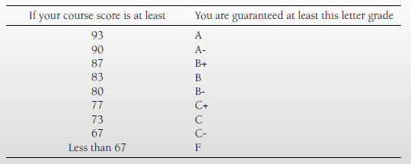  However, I reserve the right to adjust this scale in your favor, depending on the overall performance of the class.
COURSE POLICIES
Attendance | Formal attendance is not taken, but start-of-class quizlets would necessitate being on time. If you cannot make a course for an approved reason (see University Policies below), please contact me at least 48 hr in advance to accommodate getting you class notes and allowing you to make up the daily quiz.
Late Assignments | Not accepted. You have a full week to submit. The deadline for each problem set is Wed at midnight for each week. If there are extenuating circumstances, please contact me ahead of time and I will do my best to accommodate.
Requests for Regrading | If you feel a problem set or exam has a grading error, please allow 48 hr. to pass before approaching the instructor or TA. This will allow you adequate time to look at the posted answer key.
Computer Use | Computers are to be used only for coursework. Do not peruse the internet; use email, Facebook or any other social network; play games; or indulge in other diversions. Again, during class we develop the tools (code) together that can be used in problem sets and exams. It is to your advantage to follow along and write your own tool set.
General Expectations | You are expected to spend an average of nine hours per week preparing for class and completing homework assignments.  - Complete the reading assignment prior to class.  - Bring your book, calculator, pencil, and paper to each class.  - Ask questions if you do not understand the material.  - Be on time to class. If you must be late to class, please enter quietly  - Mute cellphones and any other electronic devices.
UNIVERSITY POLICIES
Academic Dishonesty | You are expected to practice academic honesty in every aspect of this course and all other courses. Information on academic misconduct and the  consequences can be found on the Dean of Students webpage  (http://www.dso.iastate.edu/ja/academic/misconduct.html). Students who engage in academic misconduct are subject to university disciplinary procedures, as well as consequences with regard to this course. Here is an online video guide - https://www.youtube.com/watch?v=U3DxTWybvlQ  Consulting a solution manual, student solutions from a previous semester, or using any unauthorized assistance from other people or resources (including the internet) is strictly prohibited. You are encouraged to seek help from the primary instructor, the teaching assistant, and your classmates to complete homework assignments and in-class problems. If you do seek help from your classmates, then you must acknowledge this help at the end of the assignment with the following statement:  “Problem x.x was completed with assistance from [classmate’s name].”
Disability Accommodations | Iowa State University complies with the Americans with Disabilities Act and Sect 504 of the Rehabilitation Act. If you have a disability and anticipate needing accommodations in this course, please contact the primary instructor to set up a meeting within the first two weeks of the semester or as soon as you become aware of your need. Before meeting with the instructor you will need to obtain a SAAR form with recommendations for accommodations from the Disability Resources Office, located in Room 1076 on the main floor of the Student Services Building (http://www.dso.iastate.edu/dr/). Retroactive requests for accommodations will not be honored.
Harassment and Discrimination | Iowa State University strives to maintain our campus as a place of work and study for faculty, staff, and students that is free of all forms of prohibited discrimination and harassment based upon race, ethnicity, sex (including sexual assault), pregnancy, color, religion, national origin, physical or mental disability, age, marital status, sexual orientation, gender identity, genetic information, or status as a U.S. veteran. Any student who has concerns about such behavior should contact his/her instructor, Student Assistance at 515-294-1020 or email dso-sas@iastate.edu, or the Office of Equal Opportunity and Compliance at 515-294-7612.
Religious Accommodations | If an academic requirement conflicts with your religious practices and/or observances, you may request reasonable accommodations. Your request must be in writing, and your instructor will review the request. You or your instructor may also seek assistance from the Dean of Students Office at 515-294-1020 or email dso-sas@iastate.edu, or the Office of Equal Opportunity and Compliance at 515-294-7612 or email eooffice@iastate.edu.
Dead Week | This class follows the Iowa State University Dead Week policy as noted in section 10.6.4 of the Faculty Handbook  http://www.provost.iastate.edu/resources/faculty-handbook  For each Fall and Spring semester, the last full week of classes before final examinations is designated as Dead Week. The intent of this policy is to establish a one-week period of substantial and predictable study time for undergraduate students. During the Dead Week period, regular lectures are expected to continue, including the introduction of new content, as deemed appropriate by the instructor. The restrictions established by this Dead Week policy are:  • Due dates for mandatory graded submissions of any kind that fall within Dead Week must be listed on the syllabus provided at the start of the course.  For ChE 310, there will be mandatory submissions of start of class questions and the last problem set (due Wed)  • Mandatory final examinations may not be given during the Dead Week period except for laboratory courses or courses that meet weekly and for which there is no contact during the normal final examination week.  In ChE 310, the Final Exam will be in class on Thursday Dec. 14 from 12 to 2:00  • Registered ISU Student Organizations may not hold any meetings, functions, or sponsored events during the DeadWeek period.  Any exception to these restrictions must be authorized in advance by Office of the Dean of Students.
COURSE SCHEDULE
See attached schedule below

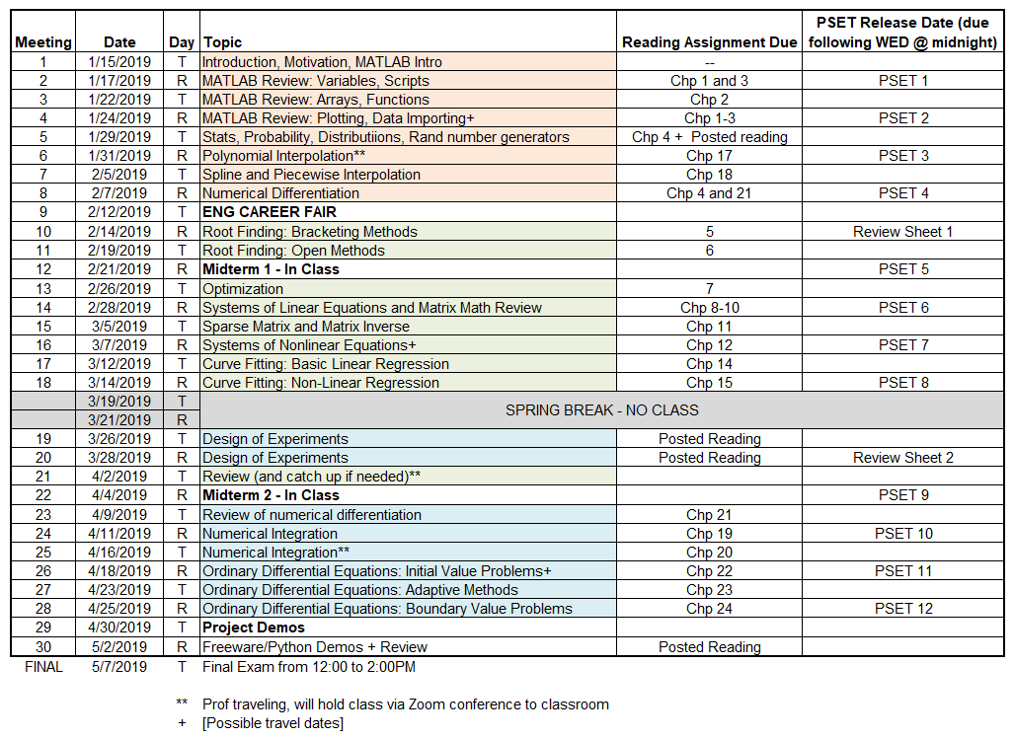

Team Project Deadlines and Details

2.21.19 – Memo to boss describing topic of interest and a few possible numerical problems to solve. Cite sources (popular press is fine, journals are good, but interviews with actual industry is best). What data will you use? [2% grade]

4.4.19 – Two Page Project Proposal – Outline problem that your team will tackle and how the work will be divided among your company. What are the responsibilities of each team member? What is the deliverable? Show that you have access to data necessary for this problem. [3% grade]

4.30.19 – Eight-minute presentation and demo of your product to the class. What was the problem? How did you develop a solution? What is the result? [5% grade]

