Class 10 – Root Finding – Bracketing Methods (Chp 5)
ChE310_Sec1_F2019 / 9.26.19
http://www.reuelgroup.org/numerical-methods-che-310.html

Announcements:
Oct 1: Phase 1 (Memo to Reuel) / Oct3: Midterm 1 (posted help)
Warm Up Group Activity: submit to SLACK by 2:25pm
Practice with histograms:
- Download univariate data ‘Dist.xlsx’ of rates
- Make a histogram with 8 bins. Label axes.
- Assume normal distribution. Fit PDF parameters.
- Simulate 5 random measurements from this PDF.
- Plot PDF on histogram
- What is probability of finding rate > 0.017?

Outline for Class 10 Lecture
- Root finding
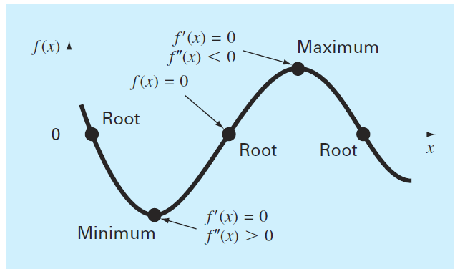
- Example: implicit equations; solving for friction factor using Colebrook equation:
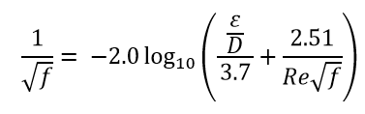
- Graphical method (simple, not automated)
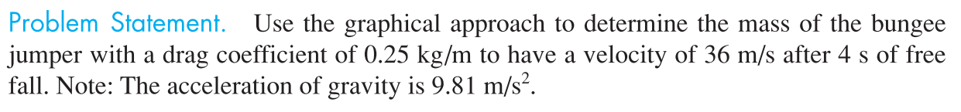
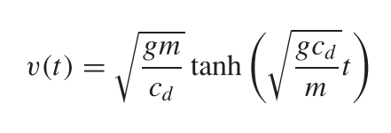
- Bracketed vs. open methods
  - String demo

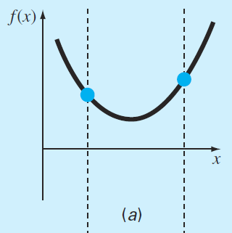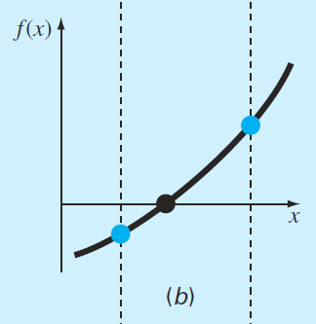
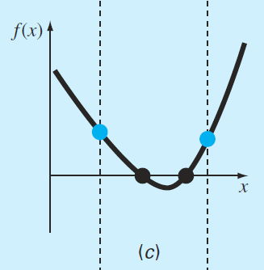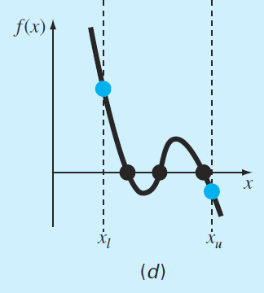
- What ideas do you have to accomplish this?
- Incremental search:
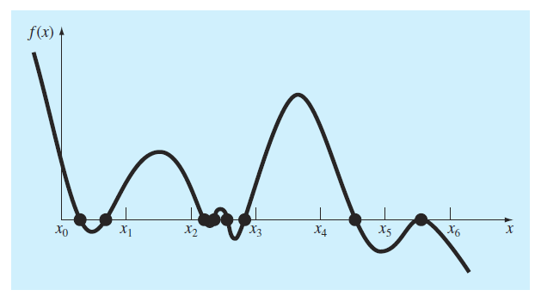
- Bisection (Natl. Instrument Interview)
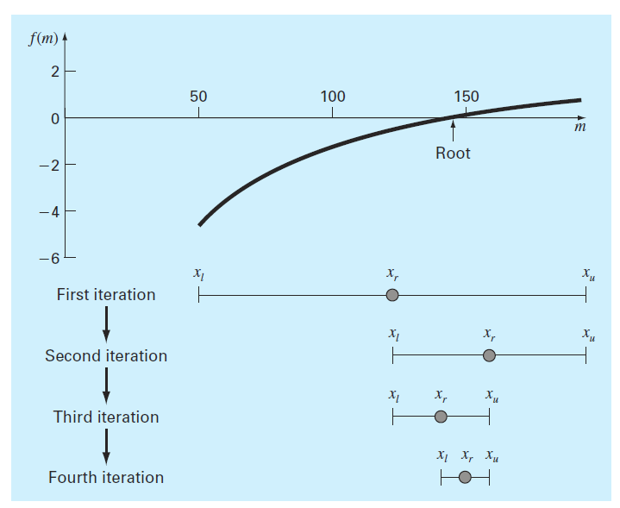
Objective Criterion: 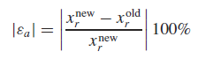
# Iterations: 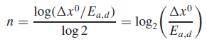
- False Position
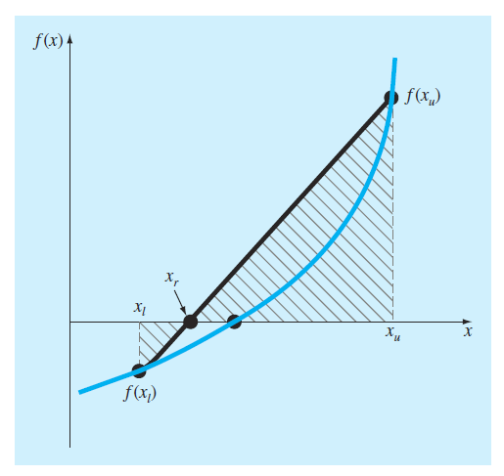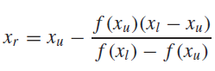
Examples: Problems 5.5, 5.6, and 5.20 from textbook.

- Example of Excel Solver for root finding

