Class 11 – Root Finding – Open Methods (Chp. 6)
ChE310_Sec1_F2019 / 10.1.2019
http://www.reuelgroup.org/numerical-methods-che-310.html

Announcements:
- Midterm 1 – Oct 3, 2019 in class
- Phase 1 of project (Memo to Reuel TODAY)
Warm Up Group Activity: submit to SLACK by 2:25pm.

For the function f(x) = sin(x)*cos(x)/(x²), find the first root > 0 using the following methods:
- Graphical
- Incremental search
- Bisection
Comment on which method is most efficient.

Outline for Class 11 Lecture
- Bracket vs. Open [analogy: robots]
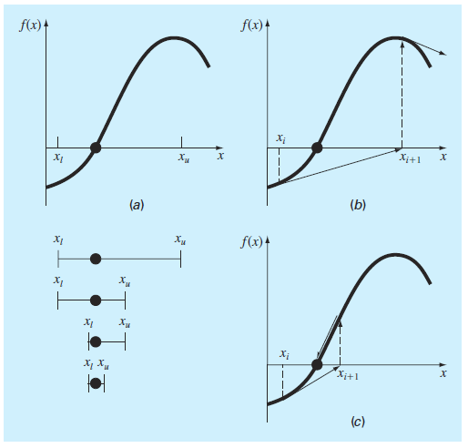
Bracket: Two points, converges, not efficient
Open: One point, Potential to diverge (fig b), much more efficient
- Fixed Point Iteration (successive subst.)
Rearrange f(x) = 0 to a form of x = g(x) (see picture)
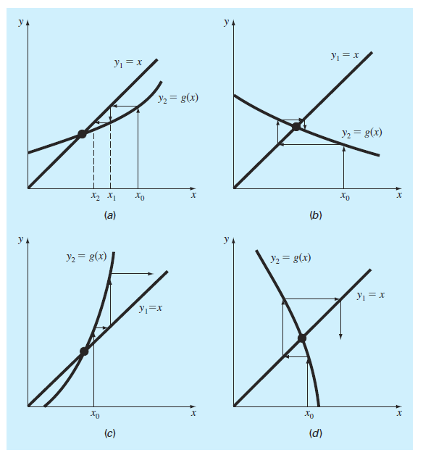
a, c = monotone / b,d = spiral/oscillating
|g’| > 1 it will diverge
End criteria needed: 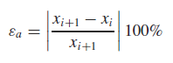
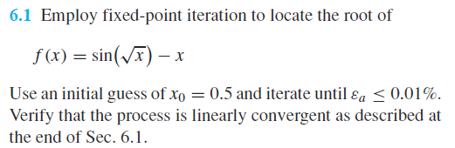
- Newton Raphson Method (use analytical slope)
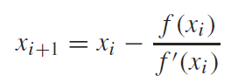
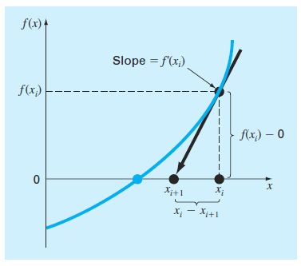
- Accuracy doubles with every iteration
- Can diverge (see picture)
- Pick good initial point, close to root
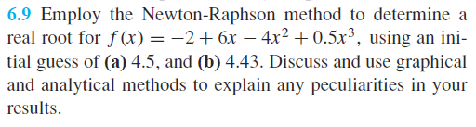
- Secant Methods
- Approximate first derivative with BackFinDif
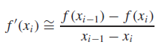 and sub in NRM
- 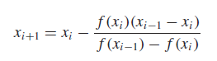[two guesses]
- 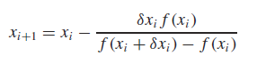[one guess]
- Useful for code based functions
- Brent’s method (hybrid bracket and open)
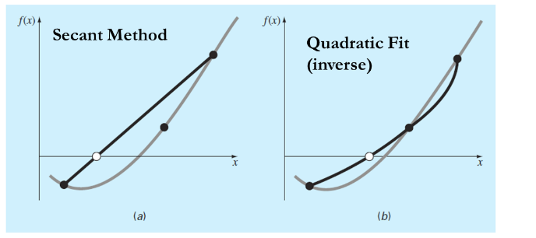
- Inverse quadratic interpolation
BracketOpen, if divergeBisect, then go to open
Written by Cleve Moler [2004]
- Matlab built in functions [show with 6.9]
  - fzero
  - roots (coeffroots)
  - poly (rootscoeff)
- Example of Excel Solver for root finding

