Class 13 – Optimization (Chp 7)
ChE310_Sec1_F2019 / 10.8.19
http://www.reuelgroup.org/numerical-methods-che-310.html

Announcements:
- Test grades released today, discussion on performance
- Office hours: Wed in 1126
Warm Up Group Activity: submit to SLACK by 2:25pm.

For the function f(x) = 2x²+4x+6x³-7, find the single, real root using the following methods:
- Newton Raphson
- roots function
- fzero function

Outline for Class 13 Lecture
- Engineering = Optimization
  - ‘Well it depends’ answer…
  - Balance of cost and functionality
  - Competing variables (Temp, P., Time)
  - Balance of your time
- Optimization ≈ Root finding
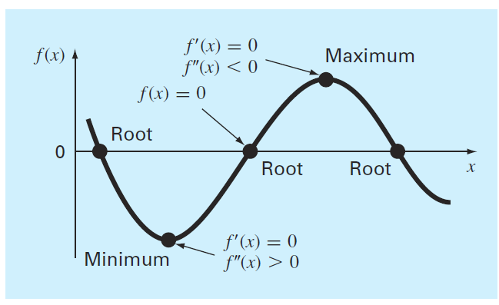
- Very similar to root finding, in that if the first and second derivative can be found, the max or min can be solved for as a root.
- However, in real life functions do not have simple derivatives, hence numerical methods.
- Optimization features
  - One or multiple variables
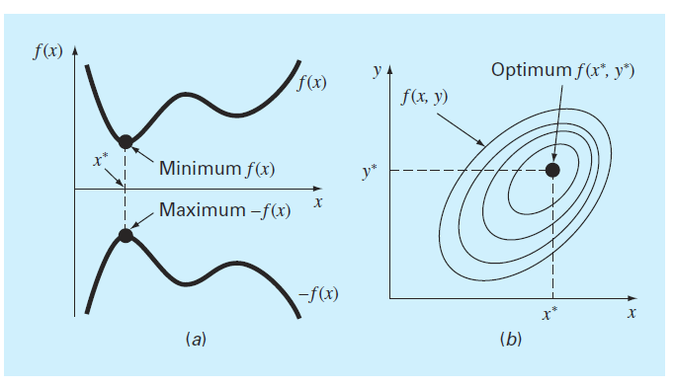
  - Global vs. local [hiking picture]
- 1D: Bracketed: Golden Search
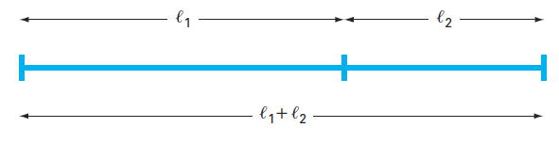
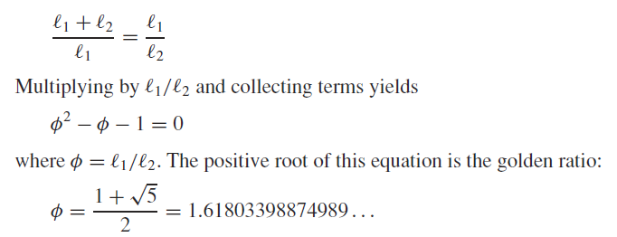
  - Example problem 7.9 in text (w/ code)
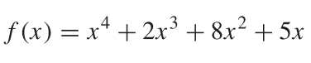
- 1D: Bracketed: Parabolic Interpolation
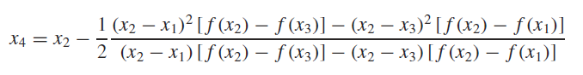
- 1D: Bracketed: fminbnd
  - find minimum of single variable on defined search interval
  - Also invented by Richard Brent
  - Combines slow golden search w/ parabola fit, once in tight window
- 1D or nD: Open: fminsearch
  - Nelder-Mead method, direct search with function values (no analytical derivatives.)
  - Handles non-smooth objective functions
  - Multiple variables must be inserted as array
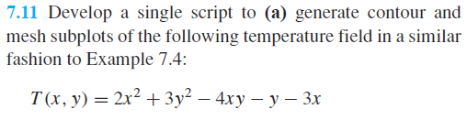
  - Passing parameters
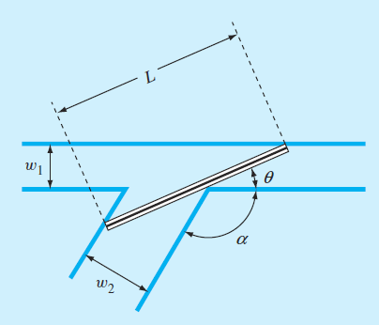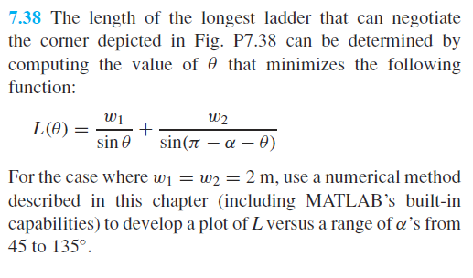
- 1D or nD: Open: fmincon
  - Ultimate Swiss Army Knife to find min!
  - Included in ‘Optimization Tool Box’
  - find minimum of constrained nonlinear multivariable functions
  - Example 1 – Himmelblau’s function
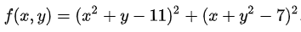
  - Example 2 – Rosenbrock’s function
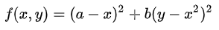
- Remind: How do you find a maximum?

