Class 14 – System of Linear Equations (Chp. 8-10)
ChE310_Sec1_F2019 / 10.10.19
http://www.reuelgroup.org/numerical-methods-che-310.html

Announcements:
- Supplemental instruction to boost test performance is available. Contact Dr. Reuel if you would like to join.
Warm Up Group Activity: submit to SLACK by 2:25pm.

F(x,y) = 4*exp(- ((x - 27/10)^2)/2 – ((y - 19/5)^2)/2)
Plot a contour plot of the function [x and y from 0 to 5]
Find the maximum in this same region.

Outline for Class 13 Lecture
- Chp. 8 Matrix math and setting up systems of linear equations (you review)
- System of linear equations and \ command

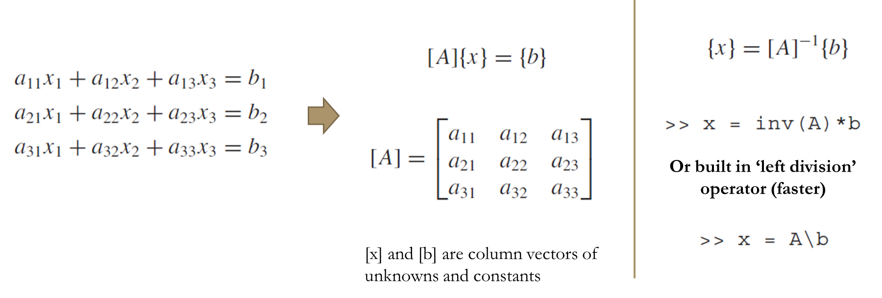
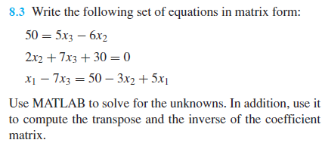
[demonstrate it is faster using tic toc]

- Why condense Chp. 9 and 10?
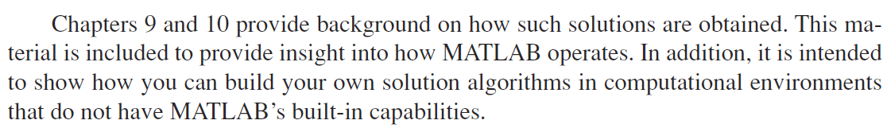
Dr. Reuel, “You will NEVER have to do this. At end of semester I will show you free Matlab clones.”
- Condition and Determinants
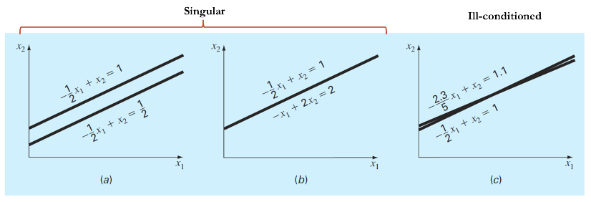
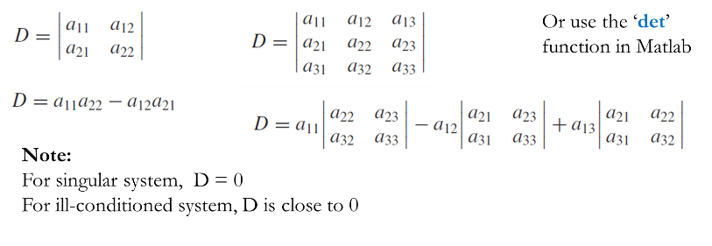
- Cramer’s Rule [inefficient variables > 3]
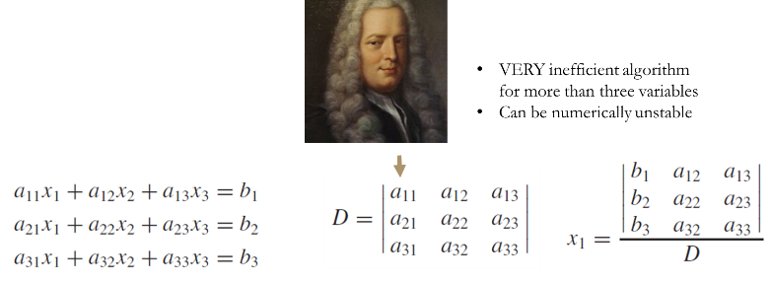
Example (problem 9.6)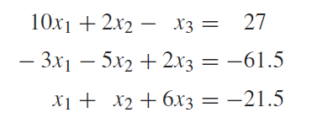
- Under the hood of \
  - Gauss Elimination
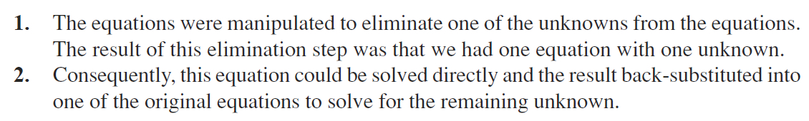
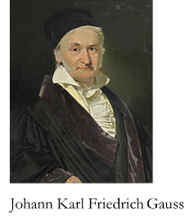
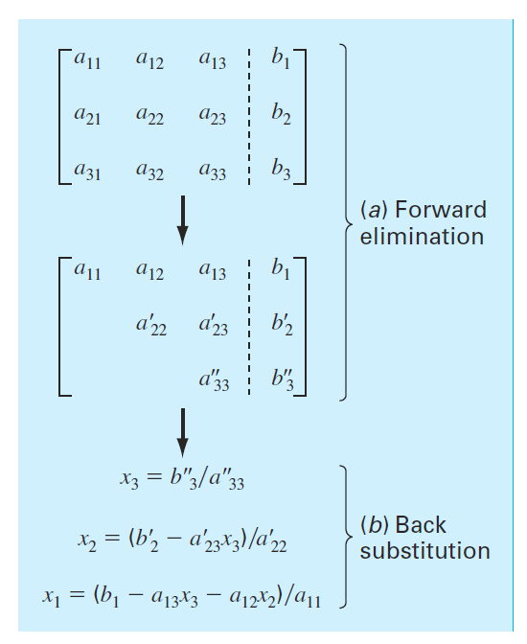
[GaussNaive, GaussPivot]
  - Partial Pivoting (move large element 1st)
  - Banded Structures [Chap tridiag w/ changes!]
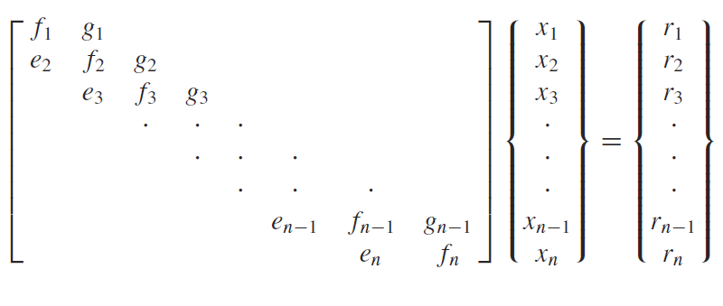
FLOPS scale n^3 for Gauss elimination
FLOPS scale n for this algorithm…much faster for BIG systems
  - LU factorizations [Chp 10]
  - Gauss Elimination as LU Factorization
  - LU with pivoting
  - Cholesky Factorization [Chp 10.3]

- Another Example – distillation columns!
- When \ is used Matlab evaluates your coefficient matrix, and detects if efficient algorithms can be used for sparse, banded, symmetric or triangular patterns. No patterns it reverts to gauss elimination w/ partial pivoting.

