Class 15 – Sparse Matrix, Stimulus-Response (Chp. 11)
ChE310_Sec1_F2019 / 10.15.19
http://www.reuelgroup.org/numerical-methods-che-310.html

Announcements:
- Nov 12, Phase II of project is due.
Warm Up Group Activity: submit to Jared by 2:20 pm.
Solve the following system of equations w/ two different methods.
Outline for Class 15 Lecture
- Compare and review \, LU decomp, and tridiag, also show how to setup a finite element prob.

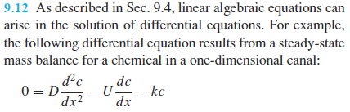
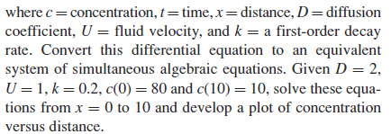
- Matrix Inverse 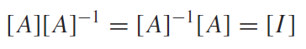
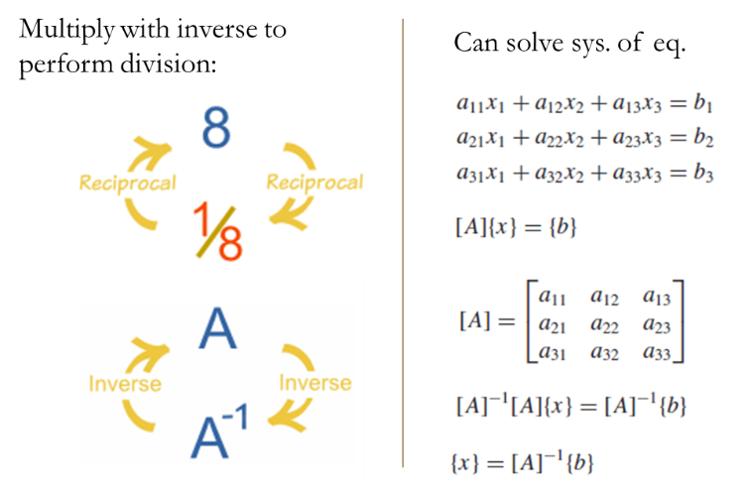
Practical application = computer graphics
  - Calculating inverse (2x2, easy)
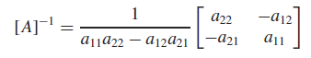
  - Calculating 3x3 or higher, not easy [slide]

- Stimulus Response – a very practical, engineering use of the matrix inverse. Takes a little mind bending to get used to it.
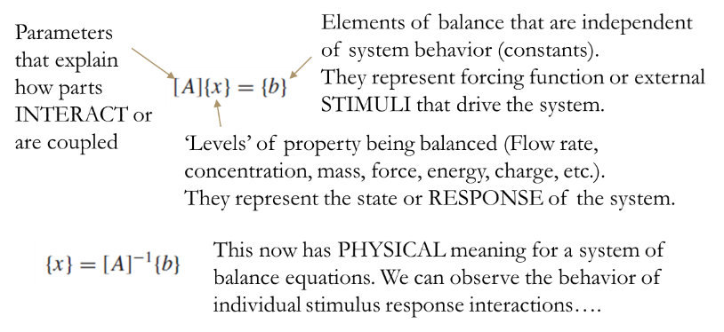
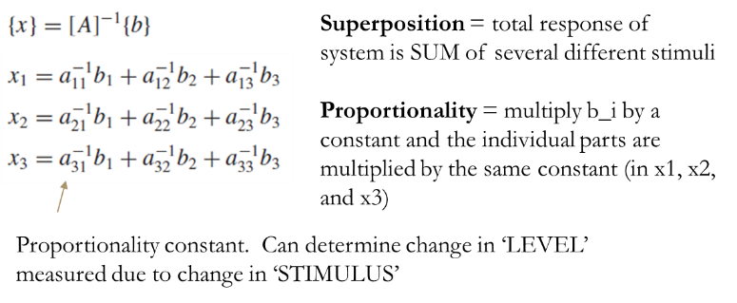
- Example of the terrible restaurant [slides]
- Ill-conditioned system and inverted matrix
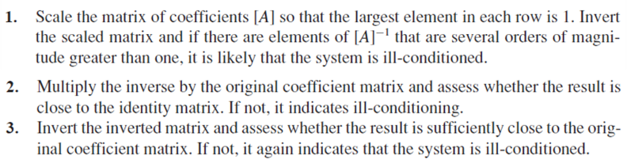
- Norm, way to report magnitude of a matrix
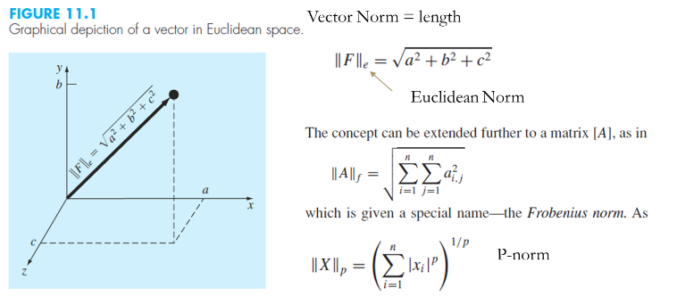
Other norms (e.g. column or row sum norm) see book
Cond[A] = matrix condition number
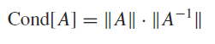
Can be used to determine the precision of the solution to a system of linear equations. If inputs are known to 10^-t precision and Cond[A] = 10^c, then precision of solution is 10^c-t. Matlab has norm and cond built in.
