Class 16 – Systems of Nonlinear Equations (Chp. 12)
ChE310_Sec1_S2019 / 10.17.19
http://www.reuelgroup.org/numerical-methods-che-310.html

Announcements:
- Nov 12 Phase II of project is due.
Warm Up Group Activity: submit to Jared by 2:25 pm.
Return to our stimulus-response problem from last time
How much would I decrease the stimulus to reactor 1 if I wanted to drop the concentration in reactor 2 by 50 g/m³? Check your answer by making this change to the reactor 1 level and comparing to the original solution.

Outline for Class 16 Lecture
- Nonlinear vs. linear – how to spot them
- Method 1: Graphical - Can be difficult because variables cannot always be separated cleanly.
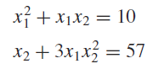
- Method 2: Newton Raphson Method in 2D
  - Review Newton Raphson in 1D
  - Single variable
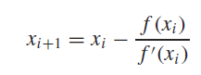
  - Multiple variable
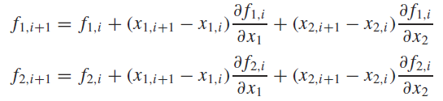
Also written as
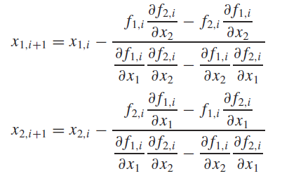
[demonstrate with warm up problem]
- Method 3: Newton Raphson Method for nD
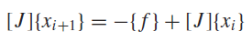
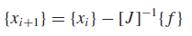
Where J is defined as the Jacobian matrix (a way to map the partial derivatives, or slopes in a given dimension, for the problem. This is recalculated at each iteration.
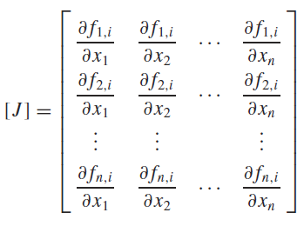 Use newtmult
- Method 4 – fsolve
Use this if convenient, analytical, partial derivatives are NOT possible. Basic syntax:

[VLE Example]
Vapor Liquid Equilibrium:
P = 101kPa, yMeOH = 0.4
Part (a) x is for MeOH
0.4*101 = x*exp(16.59-3640/(T-33.42))
0.6*101 = (1-x)*exp(14.25-2666/(T-53.42))
Part (b)
0.4*101 = x*exp(16.59-3640/(T-33.47))*exp((2.771-0.00523*T)*(1-x)^2)
0.6*101 = (1-x)*exp(14.25-2666/(T-53.42))*exp((2.771-0.00523*T)*(x)^2)

[12.8] x = y = 1.2
- Method 5 – Solver
- Another Linear Equation Method – Gauss Seidel
- System of equations
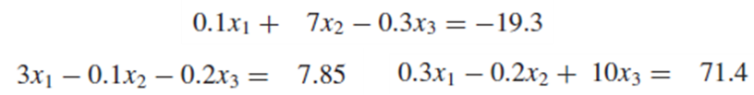
(2a) Arrange so absolute values along diagonal in each are dominant term
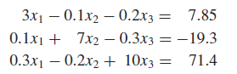
(2b) Solve each equation in terms of x1, x2, and x3
(3) Set x2 and x3 equal to a convenient start point (zero) and solve in succession, replace each old value with new
(4) Terminate at specified criteria
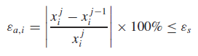
[see picture of how this works]
GaussSeidel program
