Class 17 – Basic Curve Fitting (Chp. 14)
ChE310_Sec1_F2019 / 10.22.19
http://www.reuelgroup.org/numerical-methods-che-310.html

Announcements:
- Nov 12 - Phase II of project is due.
- Contact Dr. Reuel for supplemental instruction
Warm Up Group Activity: submit to Slack by 2:25 pm.
Solve the following system of equations:
12 = 3*x*y + y - z
12 = x + y*x² + z
- 4 = x - y - z
[Good initial guess, try 1, 1, 1]

Outline for Class 16 Lecture
- Remember regression vs. interpolation (comic)
- Example: Pierce 660nm Protein Assay [Excel]
- How does it work?
  - Residual (error)
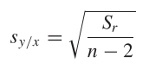
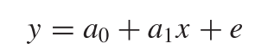
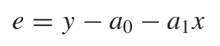

  - Minimize sum of squares of residuals
Standard Error of Estimate
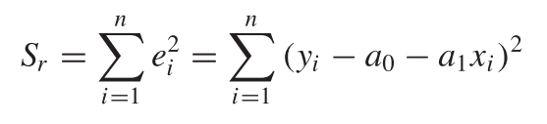
[Find a₀ and a₁ that minimizes S_{r} - least squares method]
These can be solved directly for straight line (pg. 338)
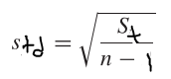
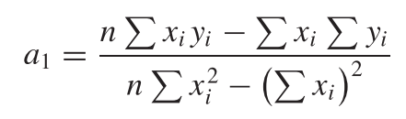
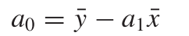 [See Example 14.4]
Standard deviation
- Quantification of error
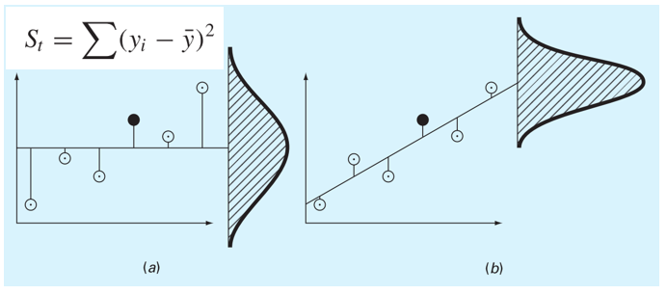
  - r = correlation coefficient
  - r² = coefficient of determination
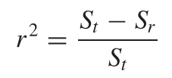
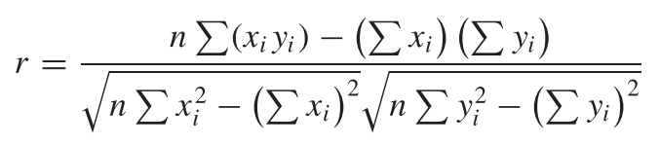
What does r² mean?
“Linear model explains _% of the variability of the data”
- r² Adjusted = account for the number of terms (predictors) in your model. Adding more terms, will always make your fit look better, but this adjusted r² takes this into account. It will ONLY increase if the new term improves the model more than the expected chance.
- Always plot your answer to double check!
[See visual example from Anscombe]
- Excel vs. Matlab
  - Excel: Handy if you have one or two vectors to manage
  - Use Matlab if you:
    - have a lot of data to fit
    - you want more than the six stock options
    - you want to pass the fit parameters as variables
- Handy tools for Matlab
  - polyfit
    - Can be interpolation OR regression
    - Demo with the 660nm data
  - fit
    - Use to extract goodness of fit
    - Can also use to plot confidence

[Fit2, GoF] = fit(x,y,'poly1');
plot(Fit2,x,y,'predobs')
Rsq = GoF.rsquare

  - Confint
    - Use to report custom intervals

confint(Fit2,.99)
- Linearization – pros and cons, see pg. 355 book
- BONUS: How to plot response in 4 dimensions?
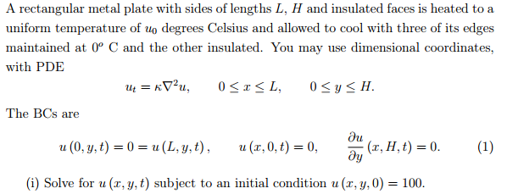
Solution: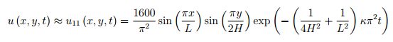
v = videowriter(‘Name.avi’); open(v) Must open the video
for i = 1:10
plot( ……….) this is where you make your plot update
frame = getframe(gcf);
writevideo(v,frame);
end
close(v); Remember this or file will not be saved correctly

