Class 18 – Advanced Curve Fitting (Chp. 15)
ChE310_Sec1_F2019 / 10.24.19
http://www.reuelgroup.org/numerical-methods-che-310.html

Announcements:
- Nov 12 Phase II of project is due.
- Email Dr. Reuel if you want to join Friday supplement
Warm Up Group Activity: submit to Slack by 2:20 pm.
With Matlab, provide linear fit coefficients and the coefficient of determination for the following data. Also plot the data, with the fit and 95% confidence intervals.
x =[1 2 3 4 5 6 7 8 9 10];
y =[5.0 9.6 11.7 15.5 19.4 21.0 25.9 27.2 30.8 34.1];

Outline for Class 18 Lecture
- Polynomial regression (Least squares method)
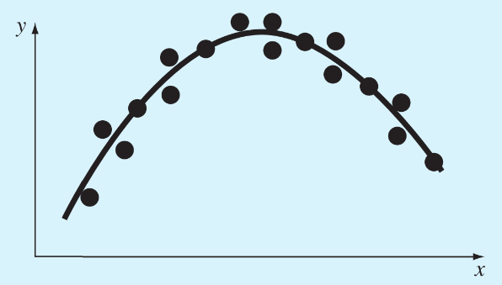
  - Sum of squares of residuals (same as linear)
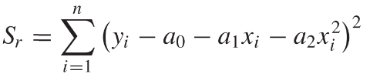
  - Minimize this quantity by taking partial derivative wrt each of the coefficients and setting this equation equal to zero
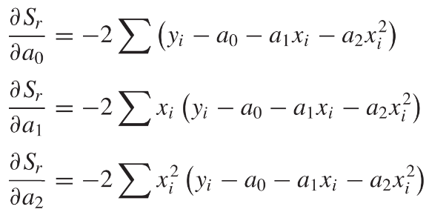
  - Rearrange to find normal eqns
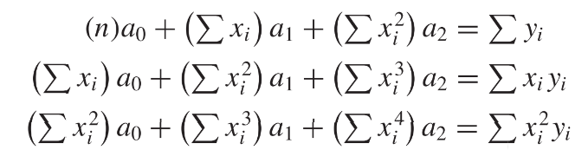
  - Solve as system of linear eqns ( \ )
  - Example 15.1 good walk through (pg. 363)
- Multiple linear regression (fitting a plane)
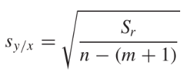
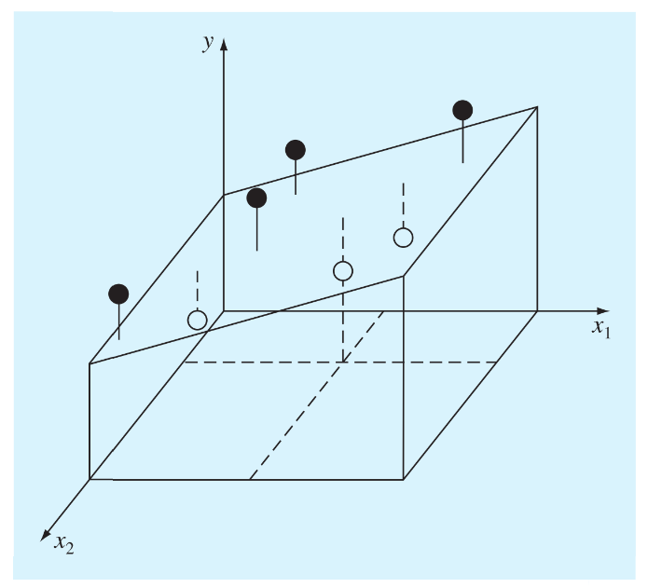Similar to above (Ex. 15. 2)
Standard error
n = # points, m = order polynomial
- General matrix solution - linear least squares
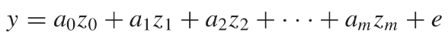
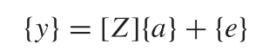
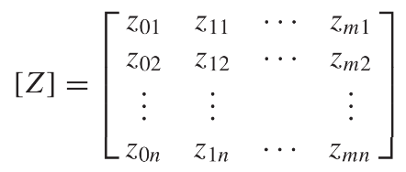
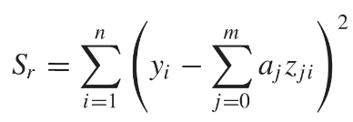
Take partial derivative, set equal to zero:
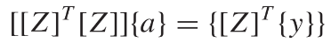
Again, use ( \ ) to solve this system of equations.
Example 15.3
- polyfit which uses QR decomposition (lin. Alg.)
- Nonlinear regression.
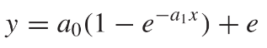
Convert to an objective function for optimization
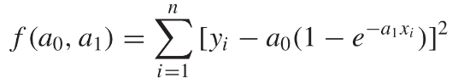
Can use fminsearch as we did before, or…
- fit and fittype
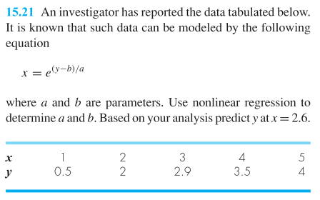
- cftool , powerful GUI
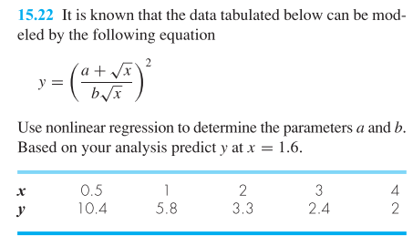
- Practice loops – use Matlab to loop through data and extract parameters
- Let’s say you have run a batch reactor 20 times, and you want to determine how the fill rate varies to appropriately size your pumps.
- ‘Slopes.xls’ contains data.
- Columns = independent trials
- Rows = measurements taken at 10 min intervals
- What is the mean and stdev of the fill rate?
- What are the r² values?
- What tool to use? Matlab or Excel?

