Class 19 – Designed Experiments
ChE310_Sec1_F2019 / 10.29.19
http://www.reuelgroup.org/numerical-methods-che-310.html

Announcements:
- Nov 12 Phase II of project is due. [Go over format!]
- Thursday – interactive class activity!
- No supplement instruction on Friday
Warm Up Group Activity: submit to slack by 2:20 pm.
Fit the following data to the nonlinear model
y = ((x-b)*x^c)/a
x = 1:10
y = [-0.08 0.20 2.42 6.81 19.76 41.31 71.88 99.11… 162.61 249.62];
Plot the data with the fit and 95% confidence intervals.
What is the coefficient of determination for the fit?

Outline for Class 19 Lecture
- Real problem scenario:
  - You’ve inherited a new reactor
  - Pressures can range 10-200 PSI
  - Temp can range from 300 to 450K
  - Residence time range 1-5h
  - You only have budget for 20 runs [$$$]
  - Your boss wants to know optimal conditions ASAP!
  - What do you do!?
- Design of Experiments (DoE)
[most information for fewest number of runs]
  - Measured output is a result of multiple input variables
  - Determine which input variable(s) is(are) significant
  - Determine model for input variables (w/ interaction)
    - NOTE: you would not see these effects if you did traditional testing of one variable at a time
  - Use model to determine optimal set points of variables
  - Do this in the LEAST number of runs while preserving statistical significance [save $$$]
- DoE Roadmap
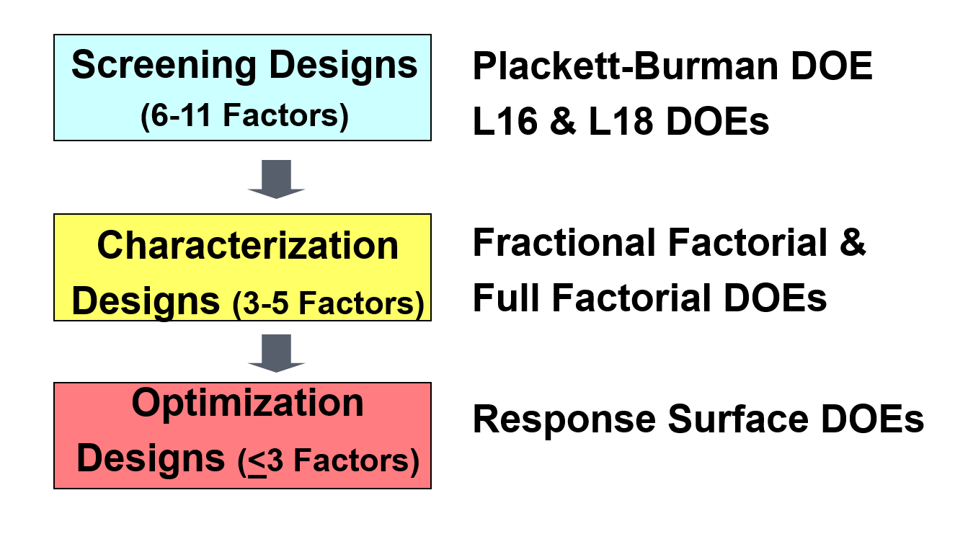
- Screening Designs (not in this course)
- Measure only the main effects
- Plackett-Burman hadamard
- Full Factorials
- Two or more factors
- Discrete high and low levels of each factor
- ALL combinations are tested
- # of Runs = 2^(factors)
- ff2n (2 level design, scalar for number of factors)
- fullfact (specify number of levels for each factor)
- Fractional Factorials
- Carefully chosen subset of the possible full fac. Runs
- ‘sparsity of effects’ principle
- # of Runs = 2^(factors-generators)
- Tabulated (see Wikipedia)
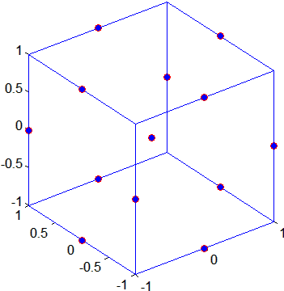
- fracfactgen
- fracfact
- Response Surface Design
- Box-Behnken design (bbdesign)
*Experiment table (randomized)
- Central composite design (ccdesign)
  - Circumscribed (CCC – default), Inscribed (CCI), and Faced (CCF).
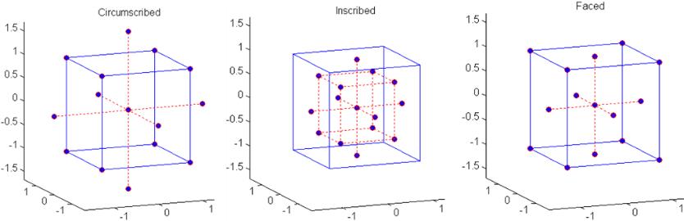
[Note: Run a response surface with least number of factors, typically 2-3, after you know which ones are most significant]

- Fitting the results of a response surface
- Quadratic model is assumed (for three variables):
Y= β0 + β1X1 + β2X2 + β3X3 +
β12X1X2 + β13X1X3 + β23X2X3 + β123X1X2X3 + β11X²1 + β22X²2 + β33X²3 + experimental error
- Main effects
- Interaction terms (two-way, three-way (typically not included on response surface), and quadratic terms
- DoE software also usually drops interaction terms with crossed (squared) factors as these are typically not realized in real systems.
- Plot response as a contour PLOT
- Optimization problems, try the plotSlice command
- Example 1 – Radiator [together]
- Significant Variables:
Distance from radiator: 1 to 1.5 inches
Pitch angle: 15 to 35 degrees
Blade tip clearance: 1 to 2 inches
- We need at least 875 ft³ per minute
- bbdesign
- Measurements = [[837 864 829 856 880 879 872 874 834 833 860 859 874 876 875]
- Example 2 – Reaction simulator – rsmdemo [teams]
- Hydrogen 100 to 470
- nPentane 80 to 300
- isoPentane 10 to 120
- Target reaction rate of 15
- More reading on DoE
- NIST Process Improvement Handbook LINK
- ISU Statistics 512 ‘Experimental Design’

