Class 1 – ChE310_Sec1_S2019 8.27.2019
Group Activity: Follow instructions to introduce your team and create your startup!
First Day of Matlab Boot camp:
- Matlab environment – default view
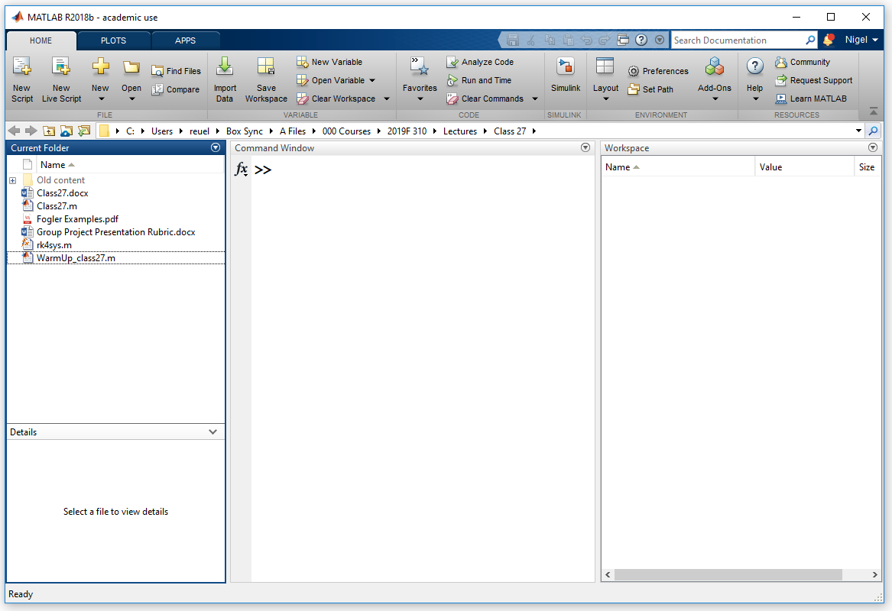
- Matlab environment – Reuel preferred view
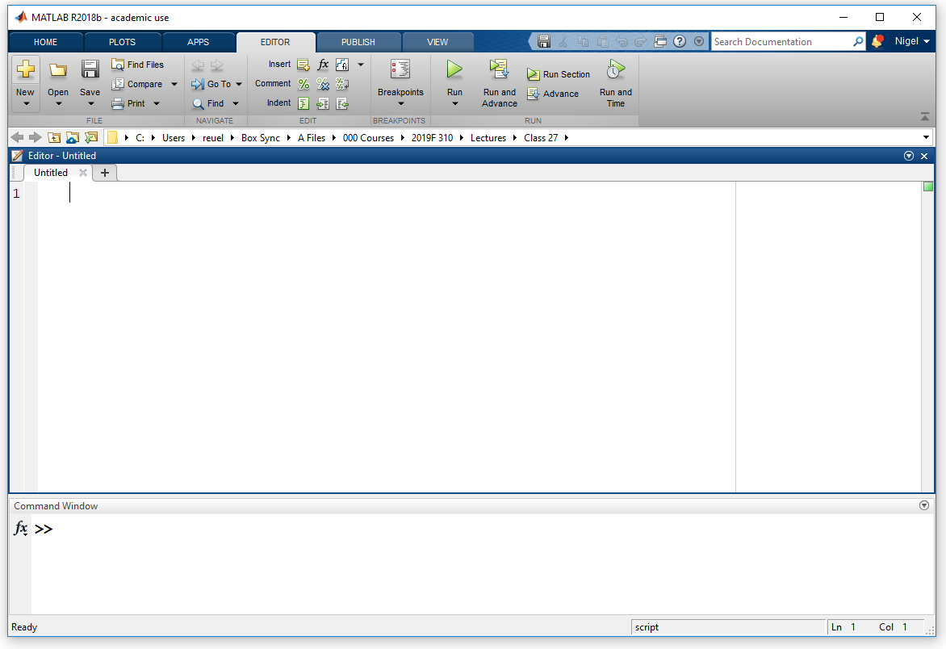
- Working directory
- Important differences between types of written commands:
  - Command prompt entry
    - Single entry
    - Nothing saved long-term
  - Function (in editor)
    - Requires input variable(s)
    - Returns output variable(s)
    - Syntax:
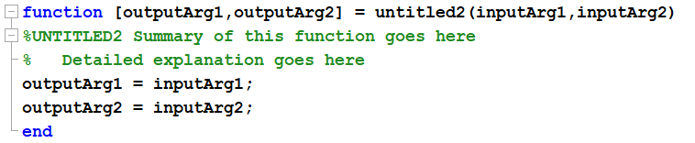
  - Script (in editor)
    - Think of this an executable file, not inputs are needed at start of the program.
    - It can have all steps embedded in the script file OR it can call on other functions.
    - Data can be loaded from a file or can be prompted to user for input (Class 2)
    - Syntax (free-form, just put in header)
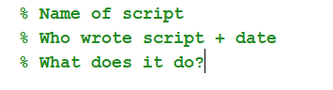
  - Script and functions are saved with *.m (often called m-files)
- Some commands to learn on day 1:
  - Up arrow to access previous commands
  - Use of clc and close all
- ALWAYS insert comments at top of m-files
  - Use comment symbol %
  - Header
    - Name of file
    - Who wrote it and date
    - Short description of what it is
- Saving
  - ALWAYS save your m-file at start
  - Routinely save during programing
  - Make new copy if doing big change
- Entering variables (demonstrate)
  - Unknown/New variable FIRST – left hand side of equality
  - Known values on right hand side of equality
- Simple math operators (demonstrate)
- Build in help is your friend
  - More help (has examples!)
Questions?
Examples?
Office hours today! Matlab review.

