Class 22 – Review of Numerical Diff (Chp. 21)

- Review – numerical differentiation
  - Forward
  - Backward
  - Centered
  - Big ‘O’ notation
  - Taylor series
- Richardson Extrapolation (Romberg)
- Two poor estimates can be combined to form a BETTER approximation. For h2 = h1/2,
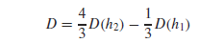 [O(h⁴) for O(h²) inputs]
- See Example 21.2

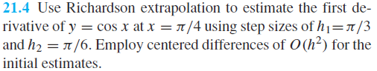

- Recall derivatives from unequal spaced data
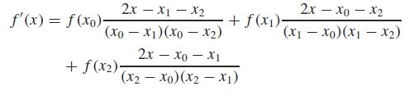

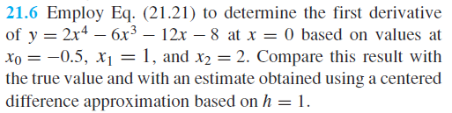

- Derivatives and Measurement Error
  - Derivatives are subtractive, and thus small positive and negative deviations from true measurement
  - values are amplified w/ derivative.
  - Integration is a summation, and thus positive and negative deviations are canceled, minimized
  - To overcome this effect, first fit your data with a least squares regression, and then use this curve for your derivative
    - Example – Jared’s protein data
- Partial Derivative (hold one variable constant). For a function where f(x,y) the following are derived:

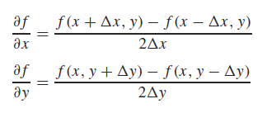
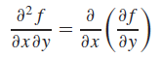
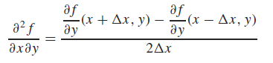

- diff function (MATLAB built in)
  - It will subtract the previous element from the current element and store this in the answer vector.
    - Forward finite difference
  - NOTE: the answer vector will always be one less in length than the input vector. To plot the results, you would use the midpoints of the input vector:
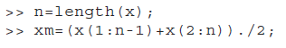

- gradient function (MATLAB built in)
  - First and last values are still computed as difference between adjacent values (as in the diff function).
  - Values in the middle of the vector are calculated with centered differences
  - To return the actual differential value, you need to specify the spacing between points (equal spacing scalar, or h can be vector of unequal spacings):
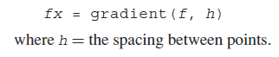

- Visualizing gradient fields with quiver
