**Class 23** – **Review of Numerical Diff (Chp. 21)**

ChE310_SecB_S2019 / 4.9.19

<http://www.reuelgroup.org/numerical-methods-che-310.html>

Announcements:

* PFF classes with Nathaniel Kallmyer (Class 23 + 24)
* Go over end of year (6 lectures left! Yipes.)

**Warm Up Group Activity:** submit to Jared by **2:20 pm**.

I posted some of Jared’s recent DoE data (‘Gluc_v2’) on the course website. Fit this to a quadratic model (the RLU is the model output). Also make a contour plot of the fit. What model parameters should we eliminate?

[w/ Dr. Reuel go over eliminating model parameter]

**Outline for Class 22 Lecture**

1. Review – numerical differentiation
   1. Forward
   2. Backward
   3. Centered
   4. Big ‘O’ notation
   5. Taylor series
2. Richardson Extrapolation (Romberg)

* Two poor estimates can be combined to form a BETTER approximation. For h2 = h1/2,

 [O(h4) for O(h2) inputs]

* Example 21.2

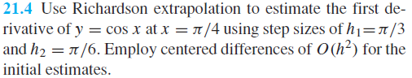

1. Recall derivatives from unequal spaced data

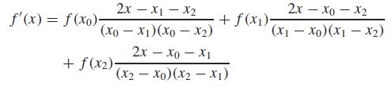

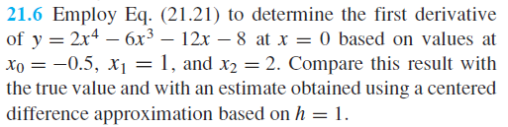

1. Derivatives and Measurement Error
   1. Derivatives are subtractive, and thus small positive and negative deviations from true measurement
   2. values are amplified w/ derivative.
   3. Integration is a summation, and thus positive and negative deviations are canceled, minimized
   4. To overcome this effect, **first fit your data with a least squares regression**, and then use this curve for your derivative
      1. Example – Jared’s protein data
2. Partial Derivative (hold one variable constant). For a function where f(x,y) the following are derived:

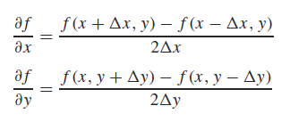



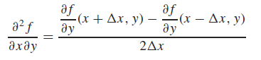



1. **diff** function
   1. It will subtract the previous element from the current element and store this in the answer vector.
      1. Forward finite difference
   2. NOTE: the answer vector will always be one less in length than the input vector. To plot the results, you would use the midpoints of the input vector:



1. **gradient** function
   1. First and last values are still computed as difference between adjacent values (as in the diff function).
   2. Values in the middle of the vector are calculated with centered differences
   3. To return the actual differential value, you need to specify the spacing between points (equal spacing scalar, or h can be vector of unequal spacings):

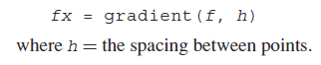

1. Visualizing gradient fields with **quiver**

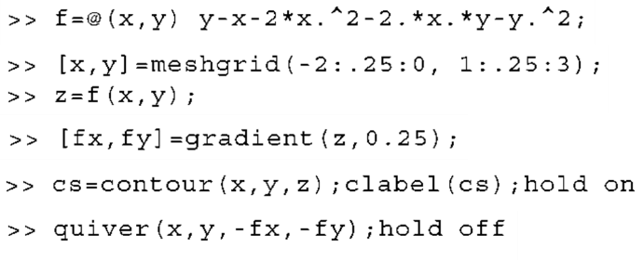

1. Intro to numerical integration – story of rockets
   1. Impulse

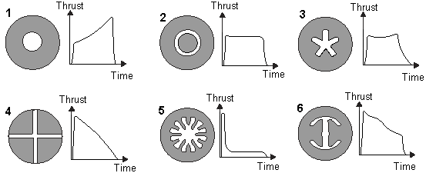

 <https://youtu.be/IohvihUgYk8>