Class 24 – Numerical Integration Part 1 (Chp. 19)
ChE310_SecB_S2019 / 4.11.19
http://www.reuelgroup.org/numerical-methods-che-310.html

Warm Up Group Activity: submit to Jared by 2:20 pm.
The associated file contains recorded altitude values (m) with 1 s time intervals for an unmanned rocket that will be launched into orbit. The safest vertical acceleration a trained pilot can withstand is about 10 x G (98 m/s²).
Determine and plot vertical acceleration with respect to time. Would the pilot be safe?

Outline for Class 24 Lecture
- What is integration?
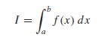Infinite sum [see pic]
- Why do we care as engineers?
  - Summation
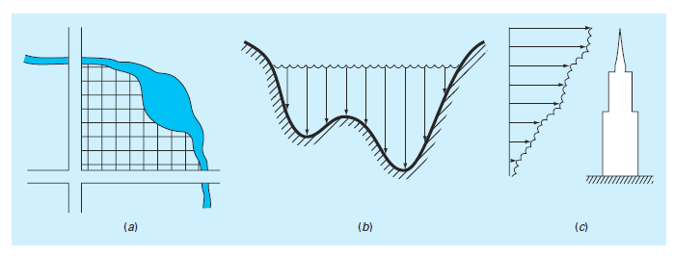
[Also, recall Dr. Reuel’s rockets]
  - Mean value
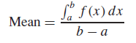
  - Control area or volume
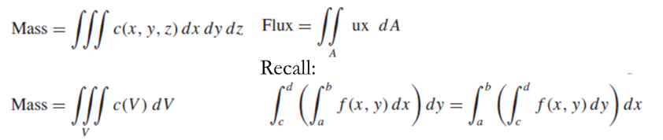
- Approx: Newton-Cotes Formulas
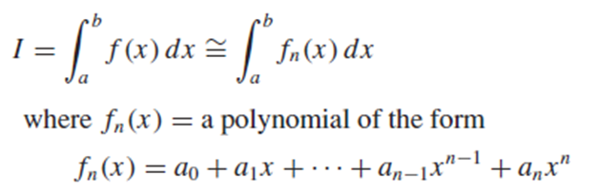[show pic]
- Closed vs. open form of approximation
- Trapezoidal Rule
  - As number of integration points doubles the error is quartered (see derivation pg. 472)
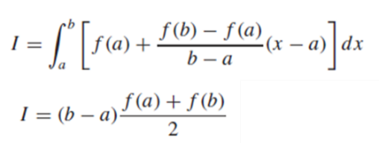
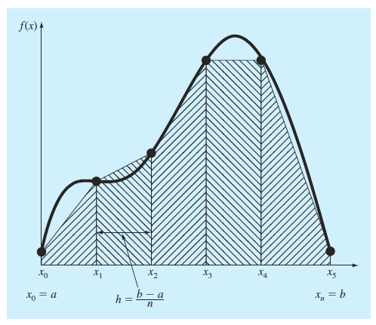
- Example: calc. impulse from Dr. Reuel rocket engine
- Higher-Order Polynomials: Simpson Rules
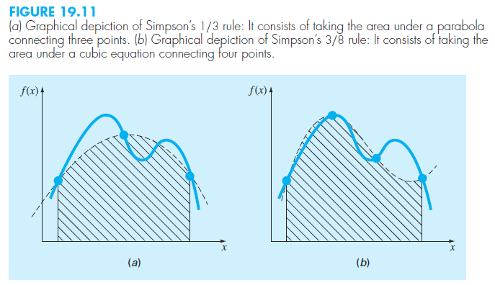
1/3 Rule: 3 points, Second order fit (parabola)
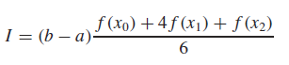
- Where x₁ is midway between a (x₀) and b (x₂)
- Error? Just know that it is more accurate than trapezoid (makes sense, follows curves)

Composite Simpson 1/3
- When to use? Even number of integration points, equally spaced intervals
- [see Picture]
Simpson 3/8 Rule: 4 points,
- Third order fit (Lagrange polynomial)
- The 1/3 form is plenty accurate; however, this form can be used to connect a segment that creates odd number of total points. [see pic]
Higher order (Boole’s rule) [see pic]
- Open methods
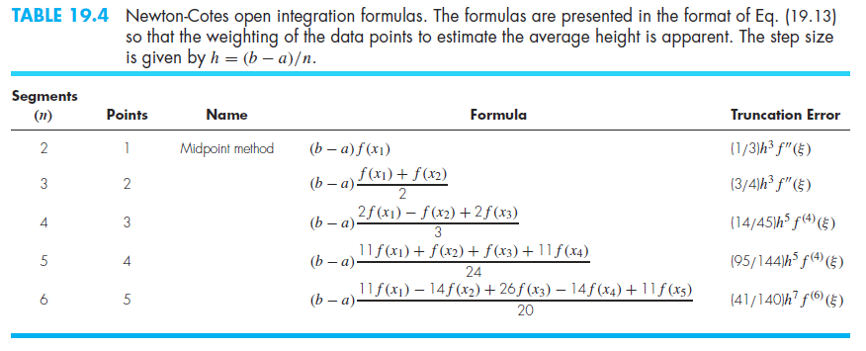
- Matlab built in functions (don’t use Chapra trap)
trapz
cumtrapz
polyint
- Examples: 19.4 and 19.8 from text

