Class 25 – ODEs and Initial Value Problems (Chp. 22)
ChE310_Sec1_F2019 / 11.19.19
http://www.reuelgroup.org/numerical-methods-che-310.html
Announcements:
- Phase II memo returned. Class project due 12.10 for demo!
- Schedule review, Reuel absences in Dec.
- Final is Dec 19 from 7:30 to 9:30 AM

Warm Up Group Activity: submit to Slack by 2:20 pm.
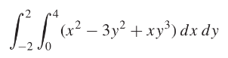
Solve with Matlab:

Outline for Class 26 Lecture
Ordinary differential equations (ODEs)
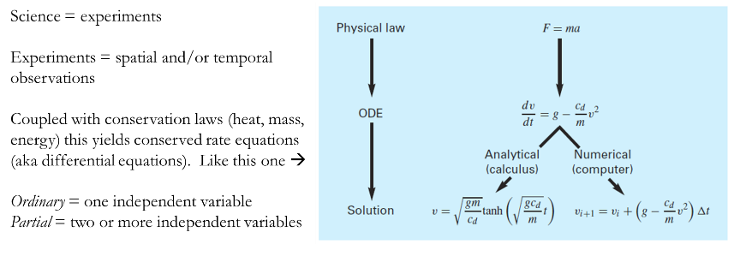
- Order of equations
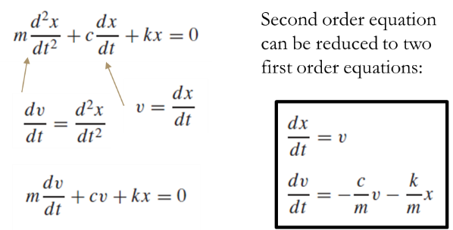
- Need of an initial condition
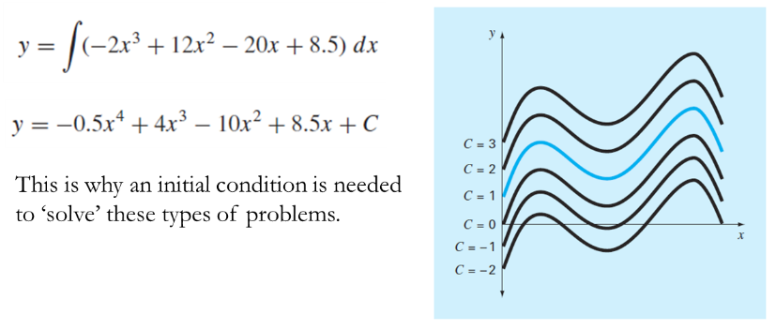
- Runge-Kutta methods (one step methods)
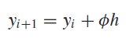
φ = increment function (method to calculate slope in interval)
  - Euler
    - You know $f\left(t,y\right)=\frac{dy}{dt}$so use directly for φ
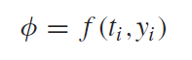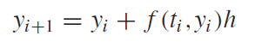
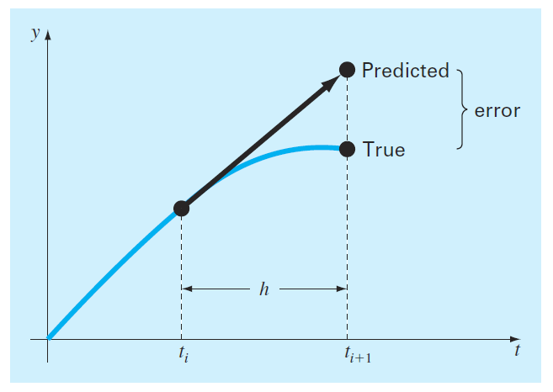How to make better?
  - Huen – iterate on φ to make estimate better
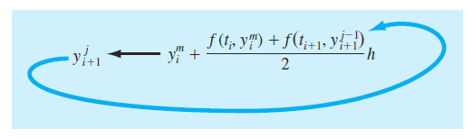
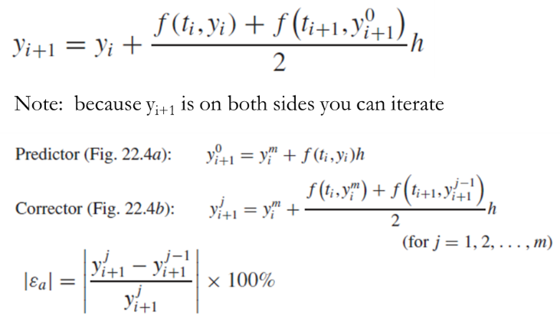
  - Midpoint – use slope of midpoint to improve Euler
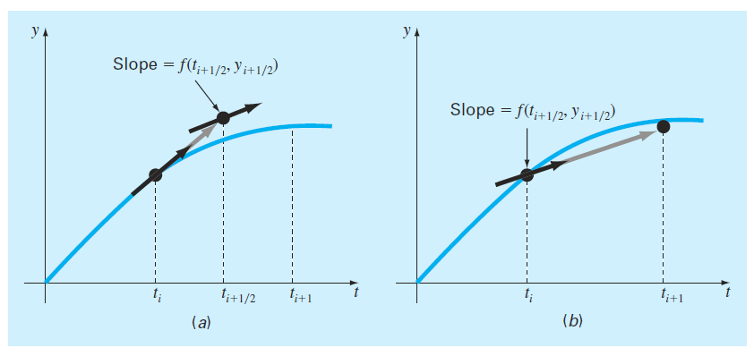
  - Runge Kutta Methods (2nd and 4th Order)
[Concept is to combine slope information at multiple points]
2nd Order
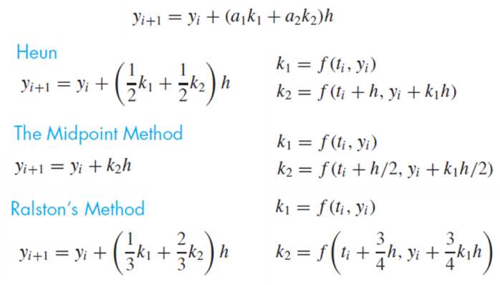
4th Order - Most common (good balance of computational cost and accuracy) called ‘classical fourth order Runge Kutta’
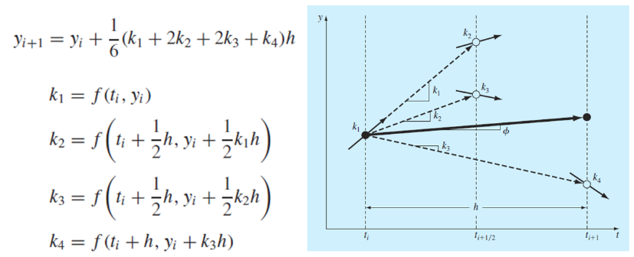
- Systems of ODE
  - Chapra equation – rk4sys
  - Matlab built in – ode45
- Phase plane plots (see handout)

