Class 26 – Boundary Value ODEs (Chp. 24)
ChE310_Sec1_F2019 / 11.21.19
http://www.reuelgroup.org/numerical-methods-che-310.html

Announcements:
- Phase II memo returned. Class project due 12.10 for demo!
- Thanksgiving break! Have a good safe one. Sleep!
- Dec 3 – Recorded Lecture (Reuel flying to Boston)
- Dec 5 – Prof. Roling practice of ODE
- Final is Dec. 19 from 7:30 to 9:30 AM
Warm Up Group Activity: submit to Slack by 2:25 pm.
Solve the following ODE and plot solutions with:
- Analytical method
- Using a 2nd order RK method of your choice
- Using the 4th order RK method (code your own)
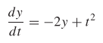 y(0) = 1
Outline for Class 27 Lecture
- Boundary Value Problems vs. IVP
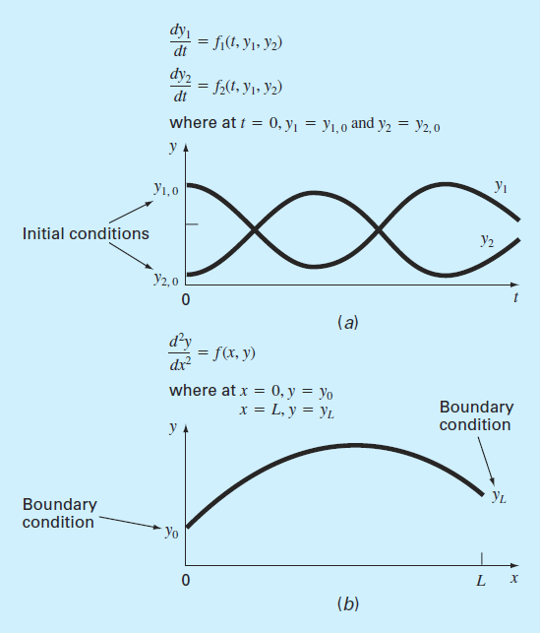
Boundary values
  - Constants (Dirichlet Boundary Conditions)
  - Rates (flux, gradient, insulated)
  - Neumann Boundary Conditions
  - Two ways to solve numerically:
  - Shooting method
  - Finite difference method (mesh w/ nodes)
- Shooting Method
“For linear ordinary differential equations can use interpolation. For nonlinear you can use root finding.”
DEMO - https://phet.colorado.edu/sims/projectile-motion/projectile-motion_en.html
(interpolation as linear, doesn’t work w/ air resistance)
Examples:
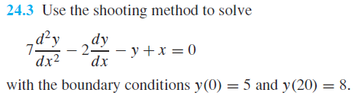
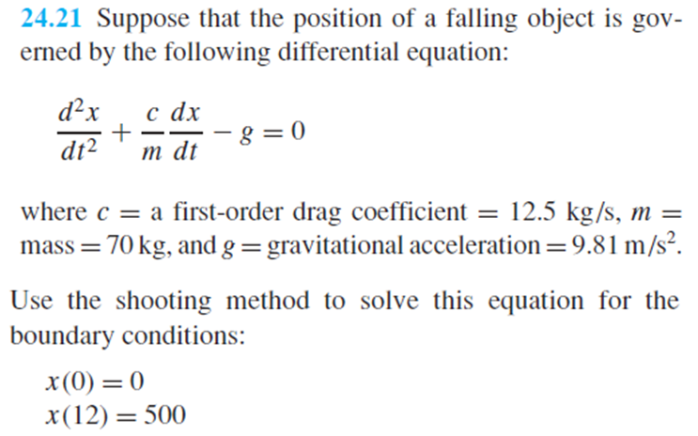
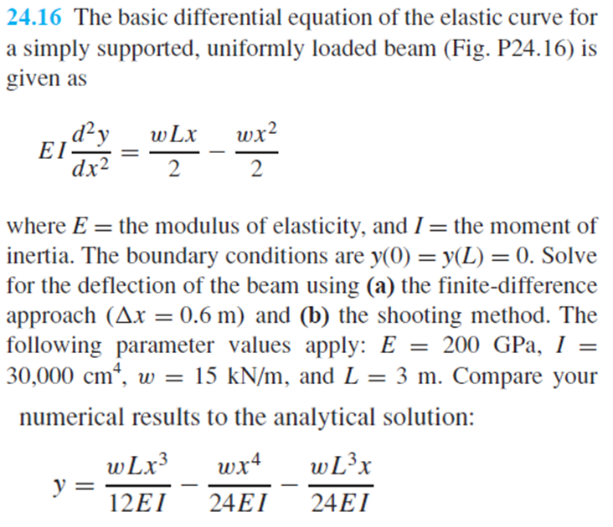
- Finite Difference Method: ODE sys of eqns.
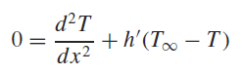
  - These result in sparse matrices (tridiag)
Example (return to the heated rod)
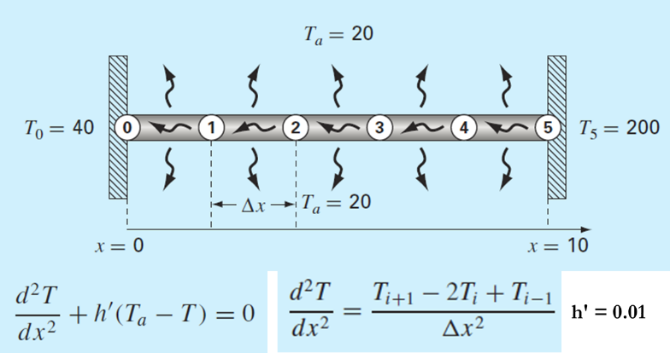
Another example of Neumann Boundary value problem solved with finite difference method (24.14)
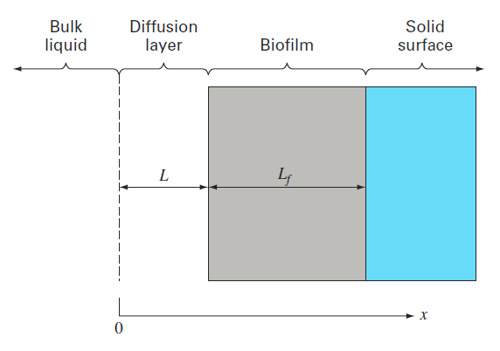24.14 (book)

