Class 27 – ODEs Adaptive and Stiff (Chp. 23)
ChE310_SecB_S2019 / 4.23.19
http://www.reuelgroup.org/numerical-methods-che-310.html

Announcements:
- Class project due 4.30 for demo – show rubric
- Last PSET posted Thursday (shorter, w/ EC problem)
- Course evaluations (ISU + RMP)
- Final 5.7.19 (Tuesday) noon to 2:00 PM w/ Jared
Warm Up Group Activity: submit to Jared by 2:25 pm.
Solve the following ODE and plot solutions with:
- Analytical method
- Using a 2nd order RK method of your choice
- Using the 4th order RK method
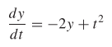 y(0) = 1
Outline for Class 27 Lecture
- Review of ODEs – what are they? Why do we care?
- Review on systems of ODEs
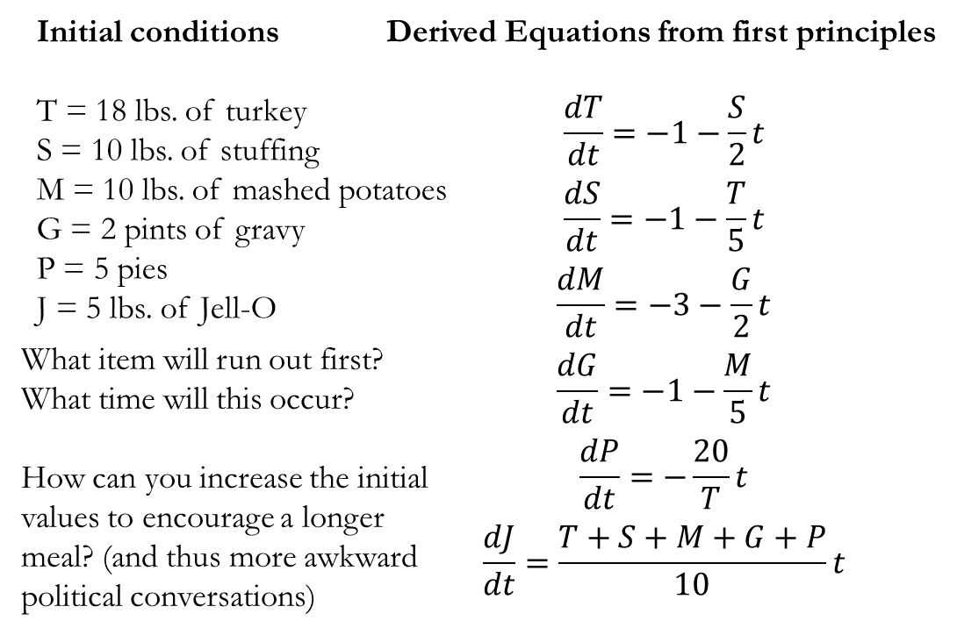

- Example with 2nd Order ODE – Problem 23.10
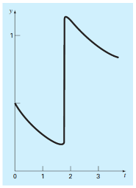
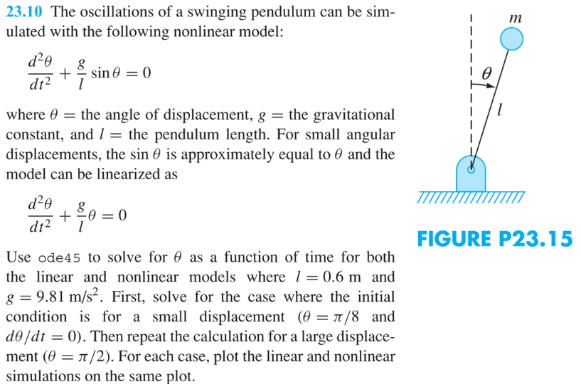

- Adaptive Methods
Useful when the rate equations have abrupt changes.
This can be done in two ways:
- Step-Halving – evaluate at full step and at half the step distance. Evaluate difference. If significant adjust step size.
- Embedded Methods (a.k.a. Fehlberg methods) – error estimated from full step size evaluated at two different order RK methods
Example: BS23 algorithm (Bogacki and Shampine)
- Multistep methods - Retain information from previously solved points and use to inform on curvature to make better prediction of next points. There is a built in ODE function from matlab that is multistep (ode113)
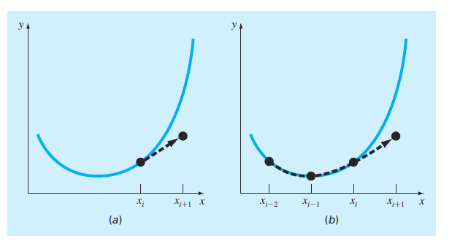
- Stiff Problems
“A stiff system is one involving rapidly changing components together with slowly changing ones. In some cases, the rapidly varying components are ephemeral transients that die away quickly, after which the solution becomes dominated by the slowly varying components.” – Chapra
- They can be a single equation or a system of eqns.
- Apparent when there are sharp transitions when plotting the dependent variables. Solve with implicit (backward step) methods.
- Matlab built in functions – ode15s and ode23s
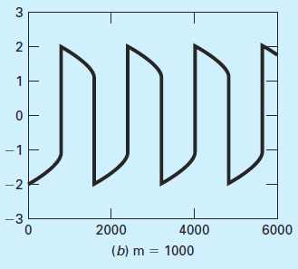
Order to attempt: ode45 ode15s rk4sys ode113
- Examples
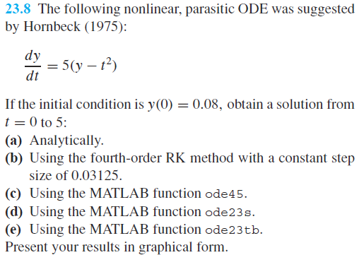
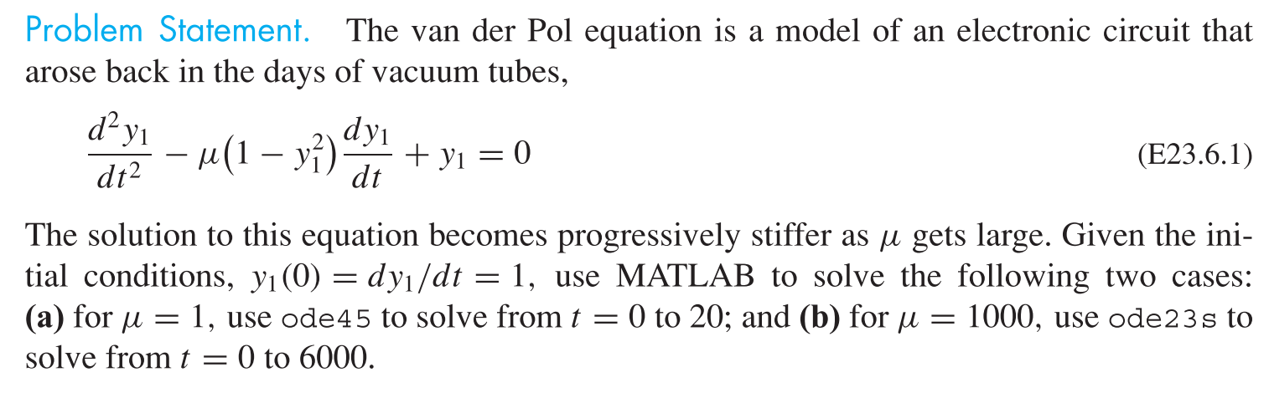
Fogler problems: 6.7 and 6.10

