Class 28 – Boundary Value ODEs (Chp. 24)
ChE310_SecB_S2019 / 4.23.19
http://www.reuelgroup.org/numerical-methods-che-310.html

Announcements:
- Class project due 4.30 for demo – rubric online
- Last PSET posted today (shorter, w/ EC problem)
- Course evaluations (ISU + RMP)
- Final 5.7.19 (Tuesday) noon to 2:00 PM w/ Jared
Warm Up Group Activity: submit to Jared by 2:25 pm.
Use a built in stiff ODE solver to plot the van der pol equation from the problem statement at end of lecture 27 (E23.6.1). Compare this solution to ode45. Does rk4sys work in this case?
Outline for Class 27 Lecture
- Boundary Value Problems vs. IVP
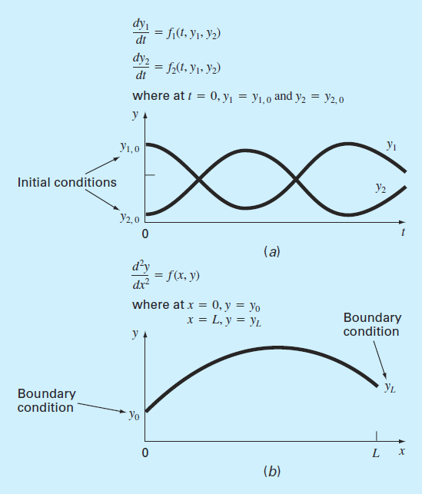
Boundary values
  - Constants (Dirichlet Boundary Conditions)
  - Rates (flux, gradient, insulated)
  - Neumann Boundary Conditions
  - Two ways to solve numerically:
  - Shooting method
  - Finite difference method (mesh w/ nodes)

- Shooting Method
“For linear ordinary differential equations can use interpolation. For nonlinear you can use root finding.”
DEMO - https://phet.colorado.edu/sims/projectile-motion/projectile-motion_en.html
(interpolation as linear, doesn’t work w/ air resistance)
Examples:
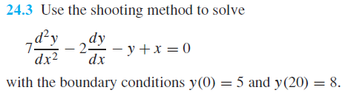
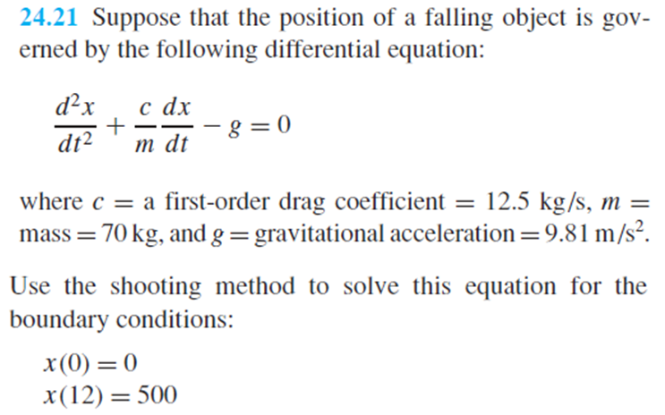
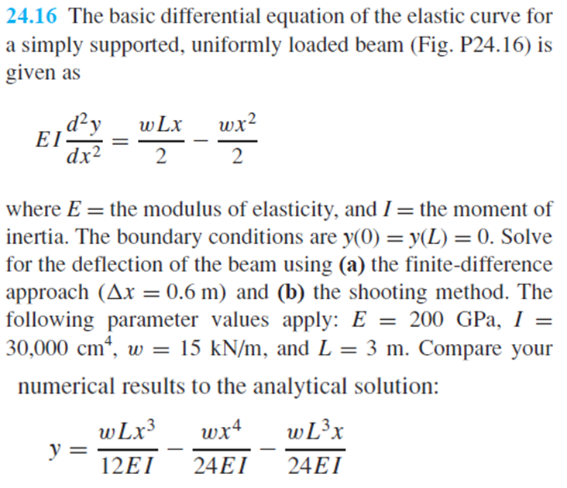
- Finite Difference Method: ODE sys of eqns.
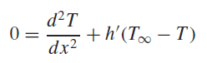
  - These result in sparse matrices (tridiag)
Example (return to the heated rod)
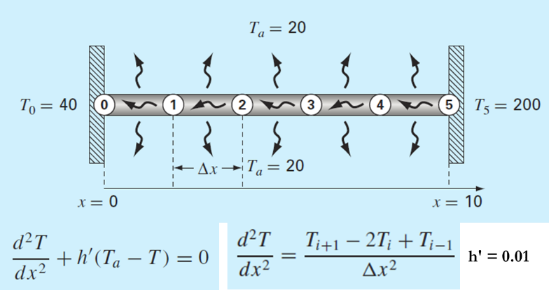
Another example of Neumann Boundary value problem solved with finite difference method (24.14)
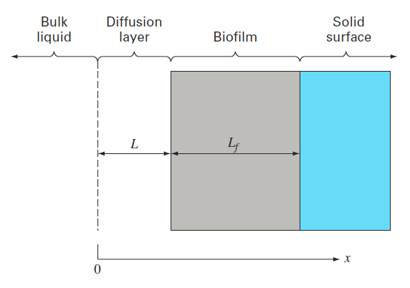24.14 (book)

