Class 30 –Alternatives to Matlab and Review
ChE310_Sec1_F2019 / 12.12.2019
http://www.reuelgroup.org/numerical-methods-che-310.html

Announcements:
- Grading update – everything posted by 12.20 PM, CHECK YOUR GRADES, will submit grades by 12.23.
- Course evaluations (ISU + RMP) – 5 pt. extra in PSET
- Last office hours: noon-1 help on Friday, 2:30-4 Mon and Tues w/ Dr. Roling and Reuel, Wed by apt. with Adam
- Final 12.19 (Thursday) 7:30 to 9:30 AM

Outline for Class 30 Lecture
- How to study for Dr. Reuel’s final
  - Organize materials (code, examples, etc.)
    - Word document
    - One Note
    - Power Point
  - Understand keys (what does every line do? How do functions work?)
  - Answer questions as group
  - Sleep
- Final format
  - 1 closed book section, 10 problems (20pts)
  - 3 free-response, open book problems (60pts)
  - 2 hours, keep moving
  - Gauge time by point value (1 pt =~ 1 minute)
  - Come in 5-10 min early to get set up and relaxed
- Matlab alternative – GNU Octave
  - https://www.gnu.org/software/octave/
  - Free!
  - Syntax is identical to Matlab
  - There are some toolbox features that are NOT available. However, these are being developed (by volunteers/rebels) in Octave Forge.
  - Example: cyst nematode counter
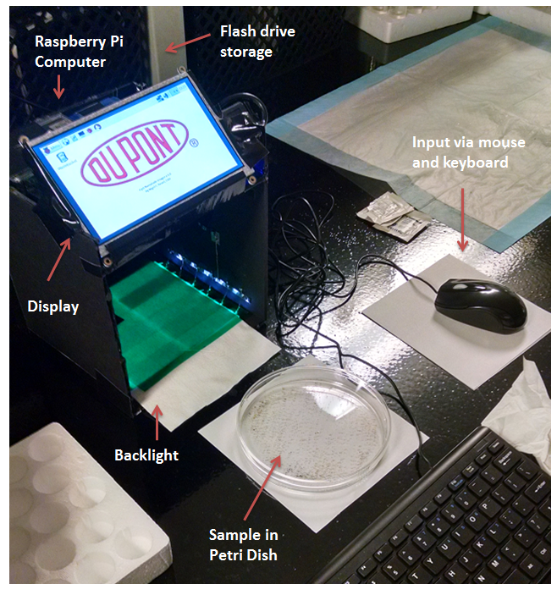
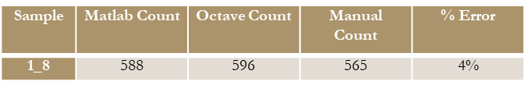

- Matlab alternative – Learn Python
  - MIT EdX Python Course: https://www.edx.org/course/introduction-computer-science-mitx-6-00-1x8
  - Coursera (20 courses): https://www.coursera.org/courses/?query=PYTHON
  - Code Academy: https://www.codecademy.com/learn/python
  - Grok Learning (first 2 modules free): https://groklearning.com
  - Enthought Python Training: https://training.enthought.com
  - Learn Python Programming in One Video: https://youtu.be/N4mEzFDjqtA
  - Udemy (150 courses, 10 free): https://www.udemy.com/courses/search/?q=python
  - MIT OpenCourseWare: YouTube Playlist - https://goo.gl/PaiQhQ
Thanks to Prof. Hedengren @BYU for list

- Python install options
- Version 2.7 vs. 3
- Python from python.org (comes with ‘IDLE’ = Integrated Development and Learning Environment)
  - Shell = command line
  - Editor = where you write and save your scripts/functions
- pip – method to manage and install packages [like Matlab toolboxes]
  - matplotlib and numpy / scipy (https://scipy.org/ )
- Other editors available – like ‘spyder’ from the Anaconda project

- Quick Demo with Python
- Open IDLE
- Show how to install matplotlib
- Plot two vectors, change colors, show labels, etc.
- https://matplotlib.org/users/pyplot_tutorial.html
- Other languages? Become a polyglot!
  - https://www.theregister.co.uk/2019/04/18/microsoft_bosque_programming_language/
  - Arduino / C / C++
  - Java
  - Many good books. Birthday presents for years to come…
- Review Topics
  - How to identify a problem?
  - Other questions?

