Class 3 – ChE310_Sec1_F2019 9.3.2019
http://www.reuelgroup.org/numerical-methods-che-310.html
Group Activity: With your group do the following and submit to Adam on Slack for credit by 2:25pm.
Create a script, ‘DiceGame.m’ that does the following:
- Contains appropriate header information
- Uses input to ask user for a guess of the sum total value of two dice thrown at random (6 sided) and store as a variable.
- Uses random number generator to simulate the values of two thrown dice
- Sums the values of these dice
- Prints the sum value to the screen
- Challenge – how can you check to see if the guess matches? Print to the screen ‘Correct Guess’ or ‘Incorrect Guess!’
Outline for Class 3 Lecture
- Conditions and logical indexing
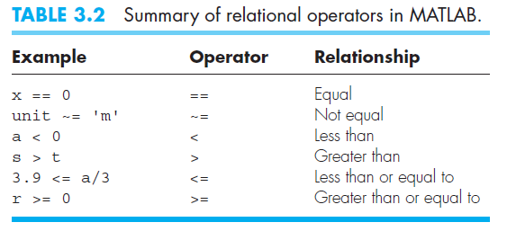
  - if…elseif…else…end
  - && vs. ||
- Catching other errors
  - try, catch, end loops
  - warning [‘display’, but in orange!]
- Use of disp
- Use of fprintf
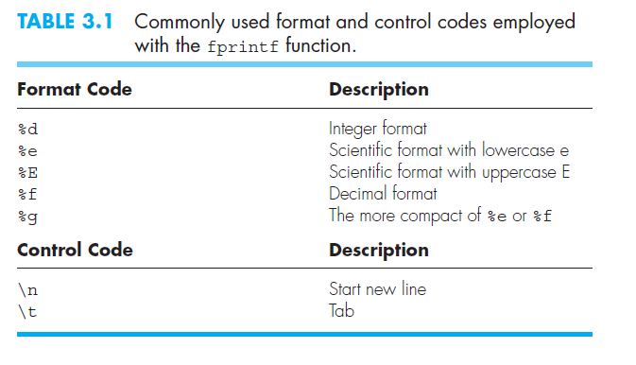
[See pg. 54 of text for good examples]
%.4f [example of common notation, # is digits present in decimal.
- Exporting data
  - csvwrite
  - dlmwrite
  - xlswrite (phasing this one out)
  - writematrix (NEW 2019a version)
  - writecell (NEW 2019a version)
- Loops and Logic in Matlab
  - for…end [if you know number of steps]
  - while…end [loop until condition met]
  - break / continue / return
  - Preallocation of memory
  - Infinite loops, break with ctrl+c
  - pause
  - tic…toc
- Show how to comment out sections of code with %{ and %}
- BREIF intro to Plotting
  - plot
  - semilogx, semilogy, loglog
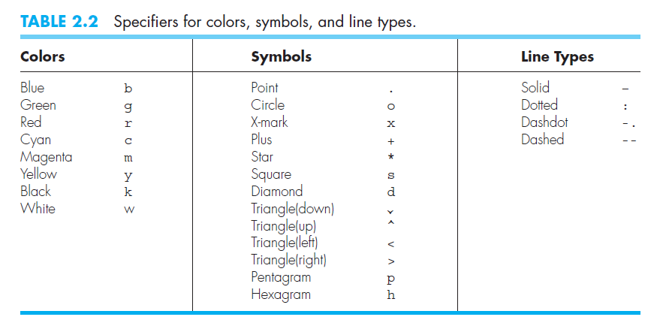

- End of class coding time
Create an M-file that simulates the game of Yahtzee – rolling 5 dice, trying to get all of the numbers the same.
How many times do you need to roll before you get to a Yahtzee?
If you obtained 100 Yahtzee’s, what is the average number of rolls it takes? How does this compare with your understanding of probability?
Random
Degree symbol can be cut and paste in or use the unicode number like this char(176)

