Class 4 – Last Day of Matlab Bootcamp (yeah!)
ChE310_Sec1_F2019 9.5.2019
http://www.reuelgroup.org/numerical-methods-che-310.html

Group Activity: With your group do the following and submit to Adam on Slack for credit by 2:25pm.
Create a script that uses a while loop to determine the number of trials it takes before you throw a Yahtzee (5 dice having the same number, using 6 sided dice).
Now use a for loop outside the code you wrote above to determine the average number of trials it takes to throw a Yahtzee if you attempted it 10,000 times.
How can you check your answer to last question using what you know about probability? (analytical solution)
Outline for Class 4 Lecture
- More practice with loops
  - Finding value of pi – Leibniz formula
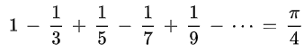
How do we handle this infinite series?
- Set number of iterations
- Error tolerance
- Plotting 2D data – there are MANY kinds of plots, we will only cover a few in class, read more here.
figure to create new figure window
close all at start of code to manage open windows
- Weather data
- Population data
  - plot
    - Line type (see table last notes)
    - Marker type (see table last notes)
    - xlim([xmin xmax])
    - ylim([ymin ymax])
    - title
    - hold on / hold off
  - loglog
  - semilogx
  - semilogy
  - scatter (I just use plot and take off line)
  - errorbar
- Adjusting and Saving plots
GUI – viewproperty editor
saveas(gcf,'FileName.png')
- Discrete Data
- Skill Survey for 310 entrance
  - bar
  - barh
  - bar3(Z) where Z is the discrete data table
    - set(gca,'XTickLabel',{'A' 'AA' '1334'}) to change the column labels
    - set(gca,'YTickLabel',{'A' 'AA' '1334'}) to change the row labels
- Plotting 3D Data
  - plot3 (line plot or points)
    - Example 3D tracking paper
  - Matrix data
- Elevation data
    - contour
    - countourf
    - surf
    - surfc (surface plot with contour)
    - mesh
    - meshc (mesh plot with contour)
- Working with functions
  - Separate files
  - Local function (link) (sub or embedded)
  - Anonymous functions
    - fhandle = @(arglist) expression
    - f1 = @(x,y) x^2 + y^2
  - Function functions
    - fplot
    - ode solvers (unit 3)
- Passing parameters
  - [Out1 Out2 …] = testfunc(X,Y,Z,…)
  - Why is this needed? Matlab only looks at current function, disregards all variables from previous function unless they are passed.

Practice Problem – Compare two methods for binary mixtures. Plot viscosity vs. mass fraction for two oils. Use as an example the following:

- Crude oil = 3.8 centiStokes (@ 60’C)
- Gas oil = 13.9 centiStokes (@70’C)

M1: Gambill method (1959) proposed the following equation for estimating the kinematic viscosity of a two liquid mixture:
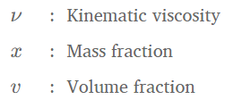
M2: Refutas Equation (slightly more accurate)
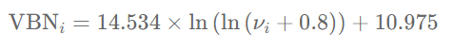
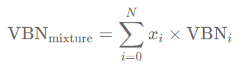
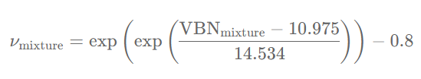
BONUS: You can animate the plot!
- Simple, use pause command (tempprofile.m)
- Also can use videowriter to save (see help)

