Class 6 – Statistics and Probability
ChE310_Sec1_F2019 9.10.2019
http://www.reuelgroup.org/numerical-methods-che-310.html

Group Activity: With your group do the following and submit to Jared Dopp on Slack for credit by 2:25pm.
NOAA equation for calculating wind chill:
Wind Chill (°F) = 35.74 + 0.6215*T -
35.75(V^{0.16}) + 0.4275(V^{0.16}),
where T = Air Temperature (°F),
V = Wind Speed (mph)
Jan30.xlsx contains temp and velocity data (2019)
- Plot wind chill vs. hour
  - Plot DANGEROUS wind chill temps (<35°F) as red circles
  - Plot the rest as blue points
  - Label axes
Outline for Class 5 Lecture
- Statistics Overview in one picture
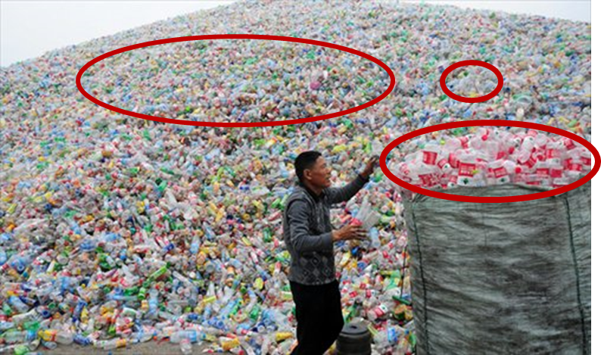
  - Population
  - Sample
    - Generalizable
    - Reliable
    - Independent (free of bias)
  - Once we have good sample, what parameters best describe the population?
- Univariate data
  - Measures of center
    - Mean (mean)
    - Median (median)
    - Example with Bulls1997
  - Measures of spread
    - Standard deviation (std)
    - Interquartile range (iqr)

    - Box and whisker plot (boxplot)
- Histograms for visualization (histogram)
    - 2017 class data (c1 = commute time, c2 = # kids)
- Distributions
  - There are many shapes (link)
  - Probability density function (pdf)
  - Cumulative density function (cdf)
  - Inverse cumulative density func (inv)
  - Distribution fitter function (fitdist)
  - Plot histogram w/ PDF (histfit)
  - Random number generators (rnd)
    - Electronic part lifetime
- Precision vs. accuracy [pictures]
- Error definitions
  - True Error ($ε_{t}$) = (True - Appx)/True
  - Appx Error ($ε_{a}$) =
(PresentVal - PrevVal) / PresentVal
  - Tolerance ($ε_{s}$)
- Error Types
  - Blunders = Gross Errors, Human Error, Machine Malfunction (bugs)
  - Model Errors
  - Data Uncertainty (Measurement error)
- Computer Numbers and Roundoff Error
  - Base 10 vs. Base 2
    - Metaphor – 10 vs. 2 fingers
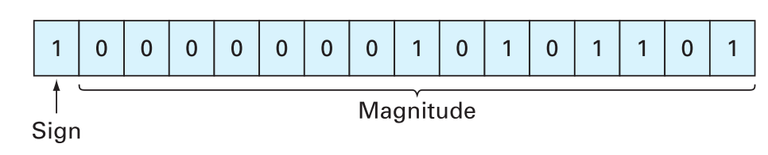
  - Floating point representation (pg. 117)
    - 64 bits: sign (1), exponent (11), significand (mantissa) (52)
    - Range is huge (2^±1024)
  - Computer math errors (subtractive cancellation, large computations, adding a large and small number)
  - Truncation errors
- Hypothesis Tests and ANOVA (I’ll leave this for you to review! Matlab has a lot of built in functions and examples for these.
  - ‘null is dull’, default there is no assoc.
  - Goal is to reject the null hyp with test
    - Hypothesis tests (link)
    - ANOVA (link)
- Debugging in MATLAB and break points

