Class 6 – Polynomial Interpolation (Chp. 17)
ChE310_Sec1_F2019 9.12.2019
http://www.reuelgroup.org/numerical-methods-che-310.html

Group Activity: submit to Slack by 2:25pm.
We need more practice of using for loop with indexing. Create a script that reads in the salary data file, and calculates the amount of taxes using the following formula:

Age < 30, Tax = salary*.07-Age*10
30 <= Age < 60, Tax = salary*.08-Age*20
60 <= Age, Tax = salary*0.09-Age*30

Create a histogram of taxes paid by this population.

Outline for Class 6 Lecture
- Probability EXAMPLE – Antibodies [end class]
  - Random number generator from pdf
  - Fit a pdf
  - Use cdf to predict probability
- Linear regression vs. interpolation
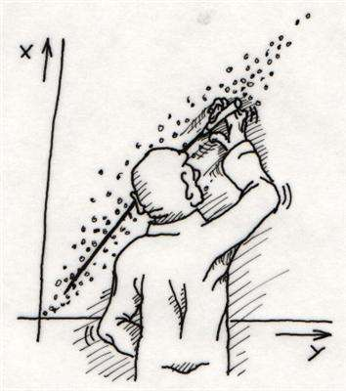
- Polynomial vs. piecewise (Tuesday)
- Examples of tabulated data
  - Optical Character Recognition (OCR)
- Interpolation forms (N.B. for ‘n’ number of points, there is ONE unique interpolation polynomial of order (n-1). However, there are a couple of unique forms:
Matlab – concise, not simple to solve by hand
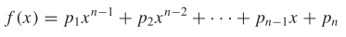
Newton – can add terms to end to increase accuracy without re-computing. Efficient to solve by hand.
b coefficients are found by finite differences (pg. 413)
Algorithm available on pg. 416
LaGrange – visualized as summation of lines
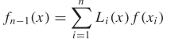
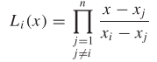
Algorithm on pg. 419, simplest to do by hand
- Polynomial breakdown (higher order)
  - f(x) = 1/(1+25*x^2) (Runge)
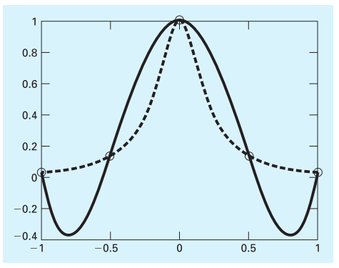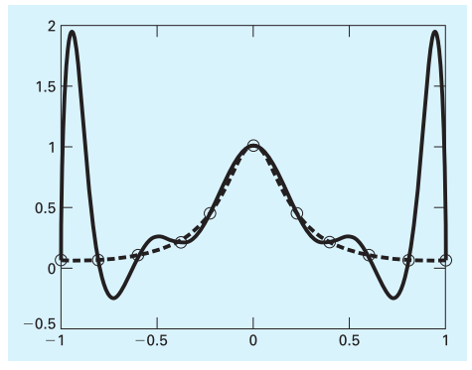
- Extrapolation
  - A past trend does NOT guarantee extension into future state.
  - Avoid extrapolation
  - Understand limits of your data table
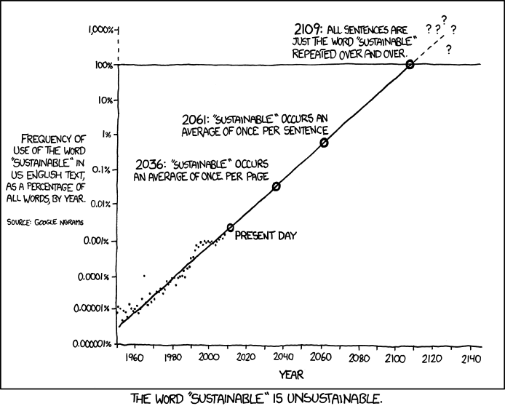
- Using MATLAB to perform polynomial interpolation
  - polyfit
  - polyval
  - Demonstrate with problem 17.11 from textbook.
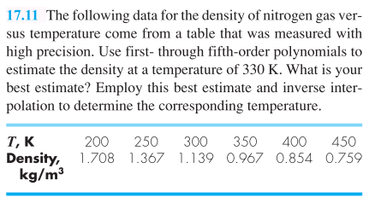
- Discuss inverse interpolation + centering
  - DO NOT simply invert the vectors…why? Spacing of data could create oscillations
  - Always check your interpolated fit, does it make sense?
