Class 7 – Polynomial Interpolation (Chp. 18)
ChE310_Sec1_F2019 / 9.17.19
http://www.reuelgroup.org/numerical-methods-che-310.html

Announcements:
- Next Tuesday is Career Fair (no class)
- PROJECT Phase 1 Memo: Tuesday 10/1 by Midnight

Warm Up Group Activity: submit to SLACK by 2:25pm.
Fit a 4th order polynomial through the following points:
X = [2 4 6 8 10]; Y = [1.1 1.3 1.9 3.2 8]
Solve the following:
- What is the value of Y predicted at X = 7?
- What value of X corresponds to 2.3?
- Can you predict value of Y at X = 11?

Outline for Class 7 Lecture
- Linear regression vs. interpolation (remind)
  - Piecewise interpolation
- Matlab built in interpolation
  - yi = interp1(x, y, xi, ‘method’)
  - Methods:
- ‘nearest’
- ‘linear’ Default
- ‘spline’
- ‘pchip’ or ‘cubic’ – piecewise cubic Hermite interpolation – less overshoot and oscillation
  - Example 18.5 in text
  - interp2 and interp3 are used for 2D and 3D data sets respectively
- Splines
  - History (pictures!)
  - Spline Types
  - End conditions
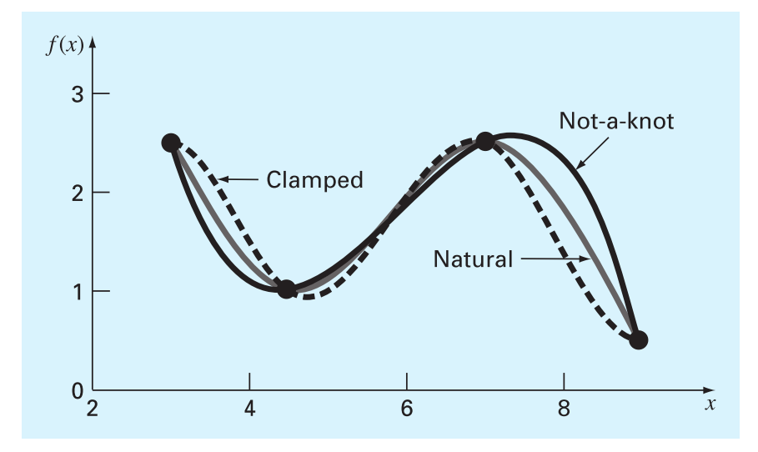
  - yy = spline(x, y, xx)
  - Default is cubic spline
    - Smooth
    - Higher order introduces oscillation
  - Default is ‘not a knot’ end conditions
  - Can force clamped conditions by addition two extra terms in input vector (at first and last position) that denote the start and end slope
  - Can force ‘natural’ end conditions (or other exotic end requirements) with ‘csape’ command
- Practice with splines
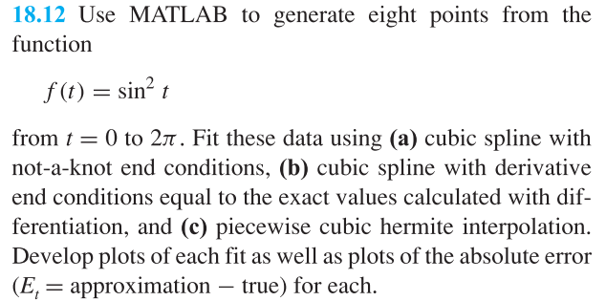
- More on plotting
% Example of a contour plot
F2 = @(x,y) sin(x).*tan(y)./x.^2;
xvec = linspace(1,2,200);
yvec = linspace(.5,1,100);
[xmat,ymat] = meshgrid(xvec,yvec); USEFUL
Z = F2(xmat,ymat);
contourf(xvec,yvec,Z)
% Add a label to the plot
textstring = '\leftarrow this is a an arrow';
text(1.5,.8,textstring);
% Save plot
saveas(gcf,'Output.png')
% Draw line
line([1.2 1.2],[0.5 1])

- If time, review histogram

