Class 8 – Numerical Differentiation – PART I (Chp. 4,21)
ChE310_SecB_S2019 / 2.4.19
http://www.reuelgroup.org/numerical-methods-che-310.html

Announcements:
- Next Tuesday is Career Fair (no class)
- Feb 21 Midterm 1 + Phase 1 of project
Warm Up Group Activity: submit to Jared by 2:25pm.
Velocity (m/s) of a rocket is measured over time (s):

V = [0 5 12 30 100 200]; t = [0 100 200 300 400 500];

If the acceleration is ZERO at the start and end of this recorded data, fit a spline to plot how velocity changes with time. Plot given data as ‘ro’ and fit as ‘b:’

Outline for Class 7 Lecture
- Calculus is the mathematics of change
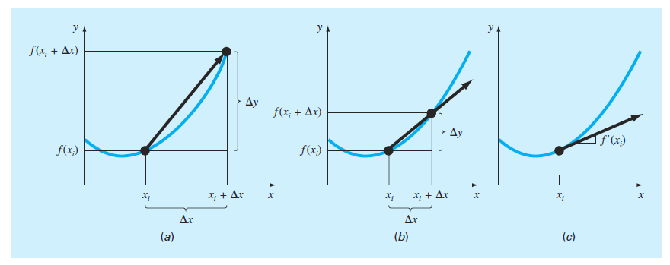
First derivative
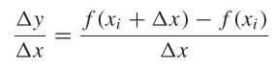
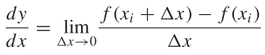
Partial derivative
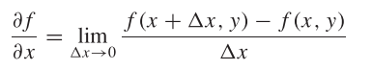
Second derivative – measure of curvature
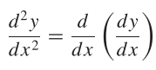
- Engineering (esp. ChemE) is all about rates:
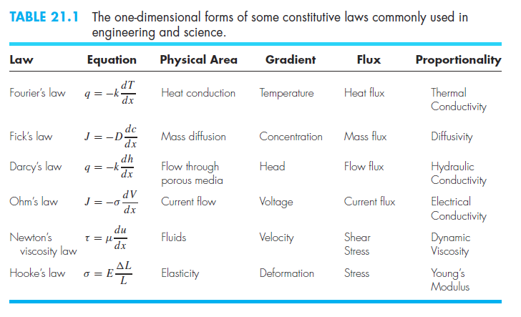
- Why do we need numerical differentiation?
- How do we make it more accurate?
- Taylor series – any smooth function can be approximated as a polynomial
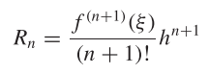
- Taylor series - analogy of the hill
- Big ‘O’ notation for truncation error
  - 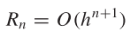
  - Error is proportional to step size ‘h’ raised to the (n+1)^{th} power
  - O(h) vs. O(h²), halving the step size?
- Derivation of numerical derivatives
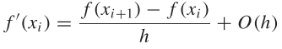 (forward)
$f^{'}\left(x_{i}\right)= \frac{f\left(x_{i}\right)-f(x_{i-1})}{h}+O(h)$ (backward)
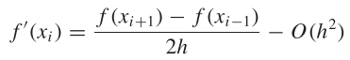(centered)
[does it make sense that our error would improve on centered? WHY?]
- Include MORE terms for even more exact finite differences (see tables 21.3-21.5 in Chapra)

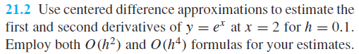

Real example: Rate of protein expression vs. time?

- What about data that is NOT sampled uniformly? (human collected)
  - Fit with an interpolating polynomial
  - You can do this directly w/ LaGrange

