**ChE 310 – Computational Methods in Chemical Engineering**

**Spring 2019**

**Midterm Exam #2 – DO NOT OPEN UNTIL INSTRUCTED**



**NAME: _______________________________________________**

By writing my name, I certify that I have abided by all  
academic honesty policies.

* This portion of the exam is closed book, closed course notes. No additional resources may be consulted to complete this portion of the exam.
* This portion of the exam is worth **20 points** (point value written by each problem).
* Write your answers to be graded in the space provided.
* You must turn in this portion of the exam before you will receive the free response portion, which is worth an additional **60 points**.

**Enjoy this comic while you wait:**



**Source: Foxtrot**

1. For the given function shown below complete the following tasks:
   1. **(2 pts)** Using the initial guess point (denoted by the black arrow) draw the path of a Newton Raphson method of root finding. Place a star on the root to which it will converge.
   2. **(2 pts)** If you used the bisect method on interval x = 6 to 14, what root would be found? Place a square on the root to which it will converge.

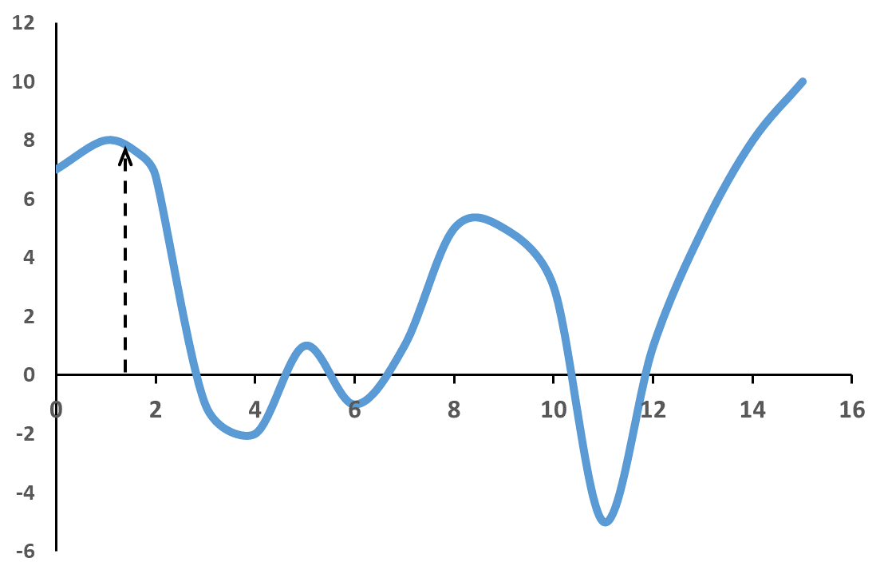

*Part A answer:*

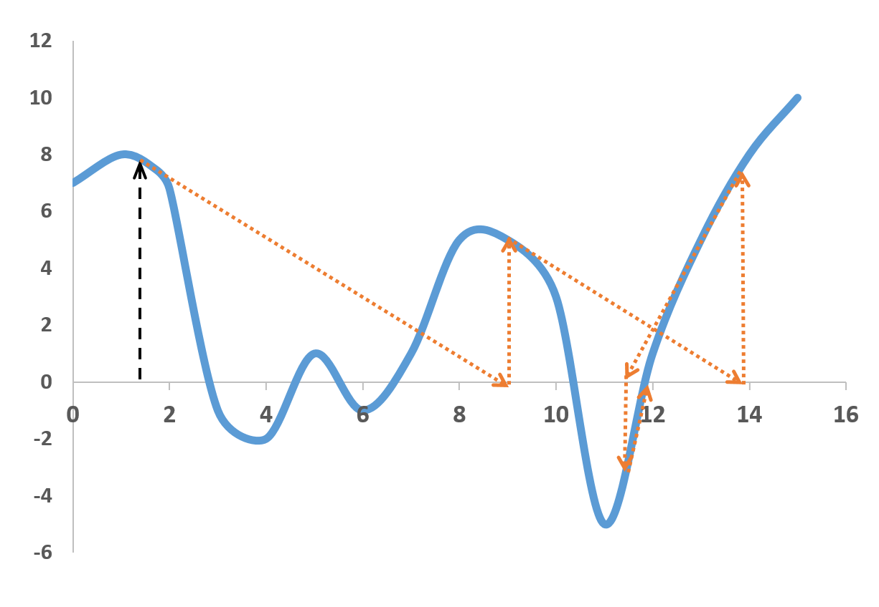*It will converge to root near 12*



*Part B answer:*

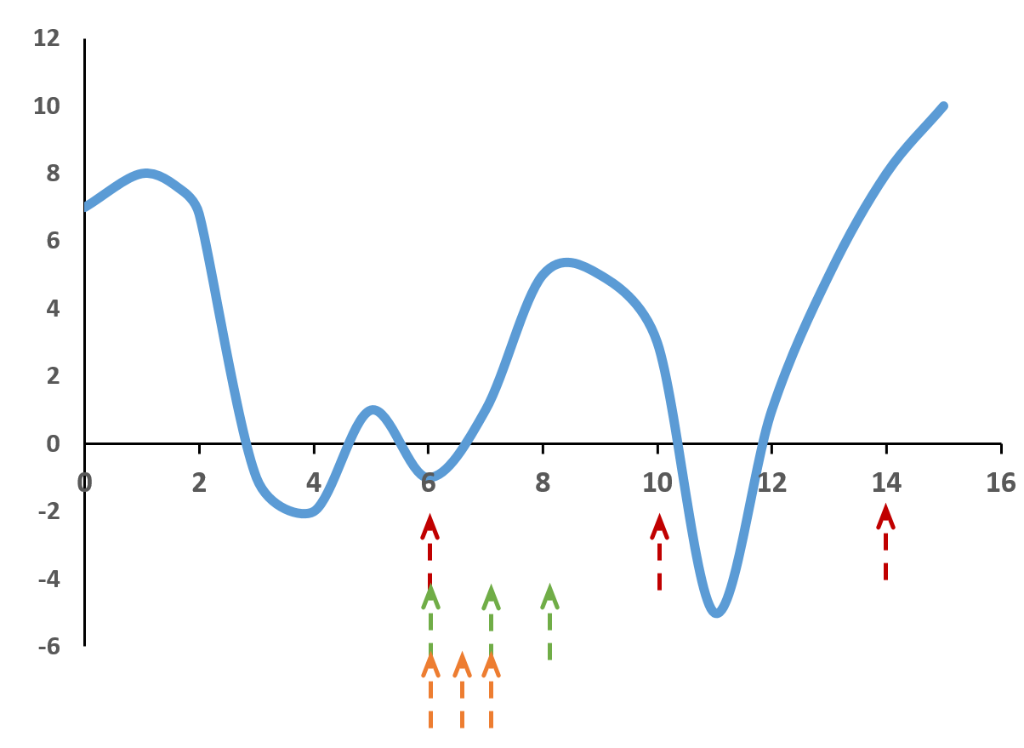*It will converge on root btwn. 6 and 8*



1. (**2 pts)** Match the following features and names for open vs. bracket methods for root finding. Write an ‘O’ next to the ones that correspond with open and ‘B’ to the ones that correspond to bracketed.

|  |  |
| --- | --- |
| **Feature** | **O or B?** |
| Need to supply one initial guess. | **O** |
| Need to supply two values for initial guess. | **B** |
| Has the potential to diverge. | **O** |
| Bisection is one example. | **B** |
| Modified secant method is one example. | **O** |

1. **(2 pts)** Consider three reactors that are perturbed by independent stimuli. You perform a mass balance on species B, determine a system of linear equations, find a coefficient matrix A and take the inverse which is shown below. How much would the level of species B drop in reactor 2 if the stimulus in reactor 3 is dropped by 5 units?
$$A^{-1}= \begin{matrix}2.3 & 5.1 & 1.7 \\ 3.9 & 1.4 & 9.2 \\ 5.2 & 2.8 & 3.1\end{matrix}$$

$$∆val=9.2×5=46$$

2. **(4 pts)** Write the Jacobian for the following set of two equations:
$$x=x^{2}y+12x$$

$$12=y^{2}x^{2}-yx+5x$$

$$J=\left[\begin{matrix}2xy+12-1 & x^{2} \\ 2xy^{2}-y+5 & 2yx^{2}-x\end{matrix}\right]$$

3. **(3 pts)** In Unit 2 we introduced the following three useful functions built into Matlab. For each explain (briefly) what it is used for and what differentiates it from the other two.

* **fzero – Used for solving systems of non-linear equations. It tries to find the solution of your function where f(x) = 0 (root)**
* **fminsearch – Use for optimization problems, where you are seeking the minimum or maximum of a function; unlike fzero that tries to force function to zero, fminsearch looks for lowest valuable possible; unlike fmincon it is NOT constrained and thus careful choice must be made on initial guess point as it can diverge (or look in places that are not meaningful to you)**
* **fmincon – Also used for optimization problems, like fminsearch, but this function accepts added input arguments to constrain the range of the independent variables that are searched (thus local minimum or maximum can be found).**

1. **(1 pt)** Define residual – **Difference between measured/observed values and the proposed fit or model (also referred to as ‘error’).**
2. **(2 pts)** What does it mean to have a singular system of equations? What would the determinant be for such a system? **A singular system has no solution or infinite number of solutions. The determinant would be zero.**
3. (**2 pts)** What is the meaning of the coefficient of determination? **R2 is a measure of how much of the sample variance is eliminated when fit by the given model. A value of 1 means 100% of the variability is removed, and thus the model is a perfect fit. A value of 0 means none of the variability is removed and that the fit is just as good as using an average value to describe the sample rather than the model.**

**ChE 310 S19 Exam 2 Free Response NAME____________________**

**[ONLY course webpage should be accessed online. Closed Internet, messaging resources, email, etc.]**

**Save each as separate m-files. Place name in header comments. Zip all files and submit to course website at end of class as a single file with your name in the filename. Turn in this sheet to the instructor when finished.**

**Free Response 1:** Jared Dopp (one of Dr. Reuel’s graduate students) has run experiments to determine the optimal growth time and time exposed to induction[1] agent for a special type of *E. coli* cells to produce high performing cell extract for his graduate thesis work. He fit this data to the following model:

$$Measured Output= -6.2×{10}^{6}+\left(2.2×{10}^{6}\right)x_{1}+\left(4.7×{10}^{5}\right)x_{2}-\left(1.9×{10}^{5}\right)x_{1}^{2}-\left(1.6× {10}^{5}\right)x_{2}^{2}$$

Where x1 is the cell extract growth time and x2 is the induction time.

**Part 1 –** Create a contour plot of this model within the experimental ranges used (5 to 7 hours for growth time and 1 to 2.5 hours for induction time). Don’t forget labels!

**Part 2 –** Find the optimal conditions for maximum measured output within the ranges of the data used for the plot above. Display the following to command line with accompanying text:

* Optimal growth time
* Optimal induction times
* Expected measured output at these values

Also plot the optimal point from Part 2 by placing any marker on the contour plot in Part 1.

% Free response (optimization) %2 pts making m file

% Midterm II and naming

% Coded by NFR on 3.30.19

%

F2 = @(x,y) -6.2e6 + 2.2e6*x + 4.7e5*y - 1.9e5*x.^2 - 1.6e5*y.^2; % 2 pts equation for plotting

xvec = linspace(5,7,100);

yvec = linspace(1,2.5,100);

[xmat, ymat] = meshgrid(xvec,yvec); % 4 pts correct method for plotting

zmat = F2(xmat, ymat);

contourf(xvec,yvec,zmat)

xlabel('Culture time (h)')

ylabel('Exposure time to induction agent (h)') % 2 pts for labels

%

% Part 2

% Write function in form to use one of the optimization functions

% NOTE: recall that we must invert to find the max

F1 = @(x) -1*(-6.2e6 + 2.2e6*x(1)+ 4.7e5*x(2) - 1.9e5*x(1)^2 - 1.6e5*x(2)^2); % 2 pts form for optimization

[xopt,feval] = fmincon(F1,[6 2],[],[],[],[],[5 1],[7 2.5]); % 2 pts correct use of fmincon

disp('Optimal culture time (h):')

xopt(1)

disp('Optimal exposure time to induction agent (h):')

xopt(2)

disp('Expected measured output at these values:') % 3 pts displayed outputs and solved

-1*feval % NOTE: we must multiply it again to invert back to (+) value % 1 pt remembering to invert

%

% Plot location

hold on

plot(xopt(1),xopt(2),'+') % 2 pts placing mark on plot

hold off

**Free Response 2:**

Consider the below series of reactors at steady state:

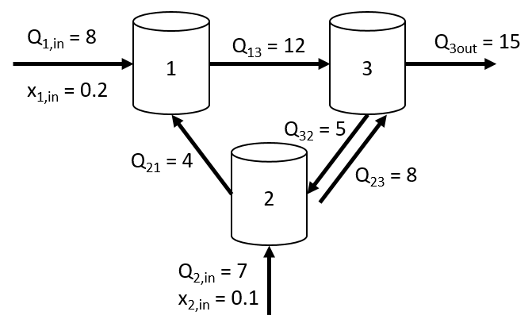

Total mass flow rates are given by $Q_{ij}$, and $x_{i}$ denotes the mass fraction of component *x* in tank *i*.

1. Write the mass balance equations for component *x* in each of the three reactors. Turn these in on paper or as comments in your m-file.
2. Solve for the mass fractions $x_{1}$, $x_{2}$, and $x_{3}$.
3. What increase in mass fraction $x_{1,in}$ to tank 1 must be added to increase the steady-state mass fraction $x_{2}$ ­ in tank 2 to 0.21?

%FR2.m

%Coded by Luke Roling on 4/1/19

%Header, creating m-file (2 points)

clear

%Mass balance equations: 6 points

%R1:

%x1_in * Q1in + Q21*x2 = Q13 *x1

%R2:

%x2_in* Q2in + Q32*x3 = Q21*x2 + Q23*x2

%R3:

%x1*Q13 + x2*Q23 = x3*Q32 + x3*Q3out

%Input constants, etc. 1 point

x1in = 0.2;

Q1in = 8;

Q13 = 12;

Q21 = 4;

Q32 = 5;

Q23 = 8;

Q2in = 7;

x2in = 0.1;

Q3out = 15;

%Set up A and b (2 points each)

A = [Q13 -Q21 0;

0 (Q21 + Q23) -Q32;

-Q13 -Q23 (Q32+Q3out)];

b = [x1in*Q1in;x2in*Q2in;0];

%Solve for concentrations (2 points)

x = A\b

Ainv = inv(A); %Calculate inverse (1 point)

%Identify correct matrix element (2 points)

%Solve for delta_x1 (2 points)

%0.21-x(2) = Ainv(2,1)*(delta_x1*Q1in)

delta_x1 = (0.21-x(2))/Ainv(2,1)/Q1in

**Free Response 3:**

Consider a series reaction in a batch reactor: $A\underset{→}{k_{1}}B\underset{→}{k_{2}}C$ with rate constants $k_{1}$ and $k_{2}$. We have an old sensor that can only measure component B. The sensor is not very precise, so there is a variance in the measurements.

The concentration of component B ($C_{B}$) at a given time $t$ can be derived from a rate expression:

$$C_{B}=α\left(e^{-k_{1}t}-e^{-k_{2}t}\right)$$

where $α$ is a constant ($α=-6.25$).

1. Use the data provided in FR3.xlsx (on the course webpage) to determine the values of $k_{1}$ and $k_{2}$.
2. Report the 95% confidence intervals for $k_{1}$ and $k_{2}$, and the coefficient of determination.
3. Use your results to determine the two values of $t$ at which $C_{B}=1.25$. If you did not obtain an answer for part (A), you may use $k_{1}=0.15$ and $k_{2}=0.03$.

%FR3.m

%Coded by Luke Roling on 4/1/19

%Header, creating m-file (1 point)

clear; clf

%Import/input data: 2 points

data = xlsread('FR3.xlsx');

t = data(:,1); Cb = data(:,2);

%Using nonlinear solver, cftool, etc.

%Partial credit unavailable for cftool unless outputs are given.

%Note: taking log will not work to linearize the model this time.

%Define model: 3 points

my_eqn = '-6.25*(exp(-k1*x)-exp(-k2*x))';

start_points = [0.15 0.03]; %Reading ahead, maybe this might be a good guess?

%Apply fit and get parameters: 3 points

[FIT, GOF] = fit(t,Cb,my_eqn,'Start',start_points);

k1 = FIT.k1

k2 = FIT.k2

%Get confint and r_2: 2 pts each

conf95 = confint(FIT,.95)

r_2 = GOF.rsquare

%Determining the roots

plot(t,Cb,'ko'); %optional plotting

hold on

Cb = @(t) -6.25*(exp(-k1*t)-exp(-k2*t));

fplot(Cb,[0 100])

%Create root-finding function with original parameters substituted back in

%(3 points)

f = @(t) Cb(t)-1.25;

%Solve for each root (2 points each)

root1 = fzero(f,5)

root2 = fzero(f,75)

1. Induction = adding a small molecule to the cells that triggers them to make an encoded protein, in this case an encoded chaperone protein