Exam 1 Report
[Unadjusted score is out of 76, highest unadjusted was 73, added +7 to all tests and made total points out of 80]
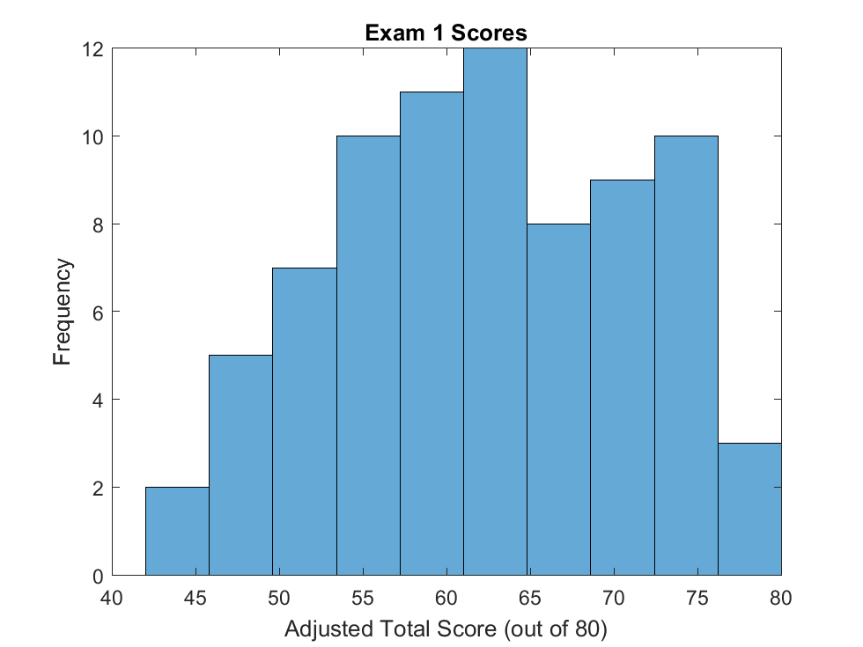
[These represent roughly the 10 grade buckets (A+, A, A-…C+, C, C-, F)]. Performance for each question:
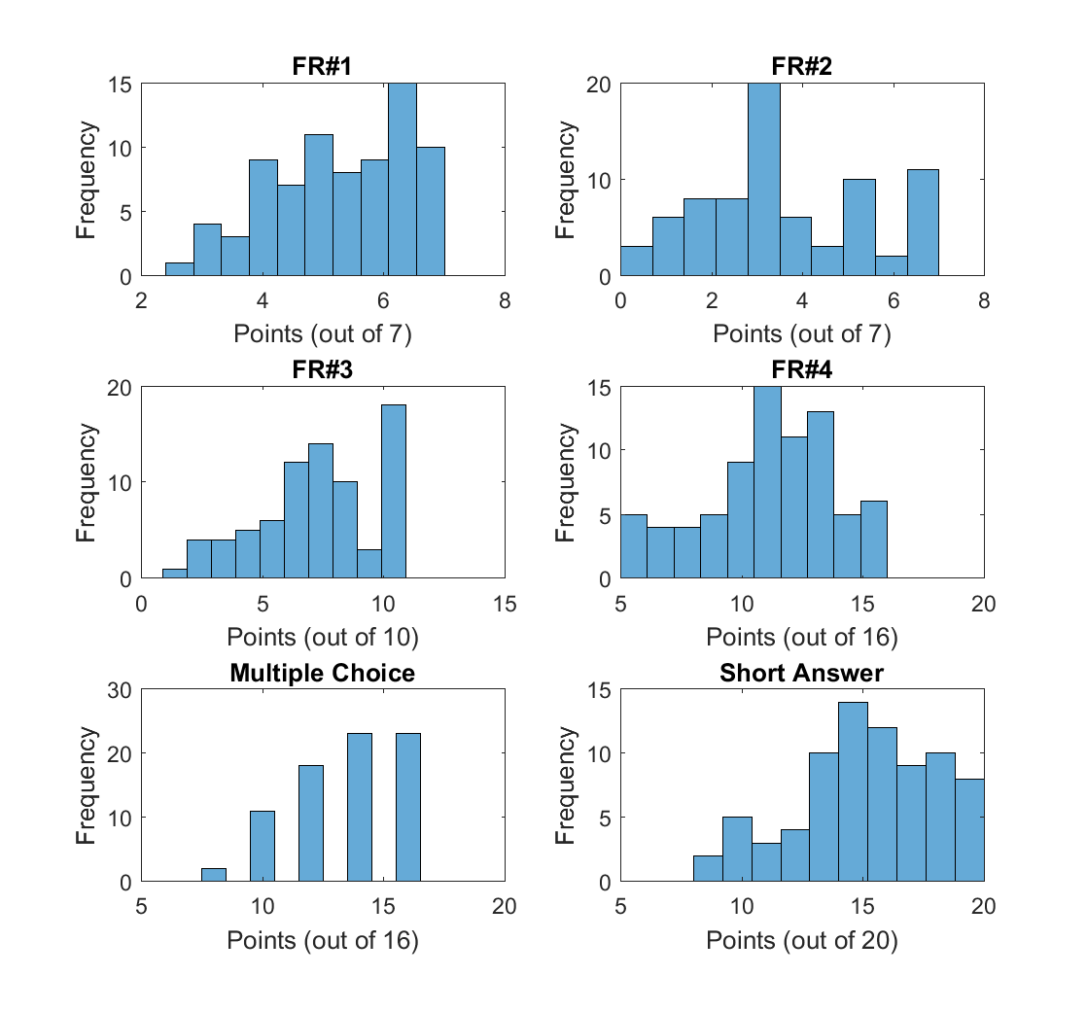
KEY

