Problem 4 (16 pts)
Consider a cylindrical hot tub that is heated by resistive elements in the sidewalls and is well mixed by jets. Initially the tub is only half full and very hot. You complain to your friend that it is too hot, so they run a hose over to the tub and start filling it with cold water.
- Draw a picture of this scenario. Identify controlled, manipulated, and any possible disturbance variables. What is the transmitter (aka sensor) and controller in this scenario?

- Is the system you sketched above feed back or feed forward control? Why?

- Draw a qualitative plot of height vs. time and temperature vs. time. [Hint: consider what happens when the tank is full and the hose is still running]

- Using standard variables we have used in class, derive models (ODEs) that describe the dynamic behavior of the water height up to point of tank fill and temperature behavior before and after tank overflow (three ODEs are expected. You can assume that there are no heat losses and that the heating elements transfer heat energy instantaneously to the hot tub water.

- What is the gain and time constant for the temp ODE after overflow?

Problem 2 (7 pts)
The response of a car’s velocity (output) to fractional extent of gas pedal pushing (input) can be modeled well with a FOPDT model. Plot the expected responses for these two cars to unit step of the input (depressing gas pedal the whole way at time zero) if the car is initially at rest. Use the following parameters:
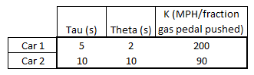
a) Plot the responses:
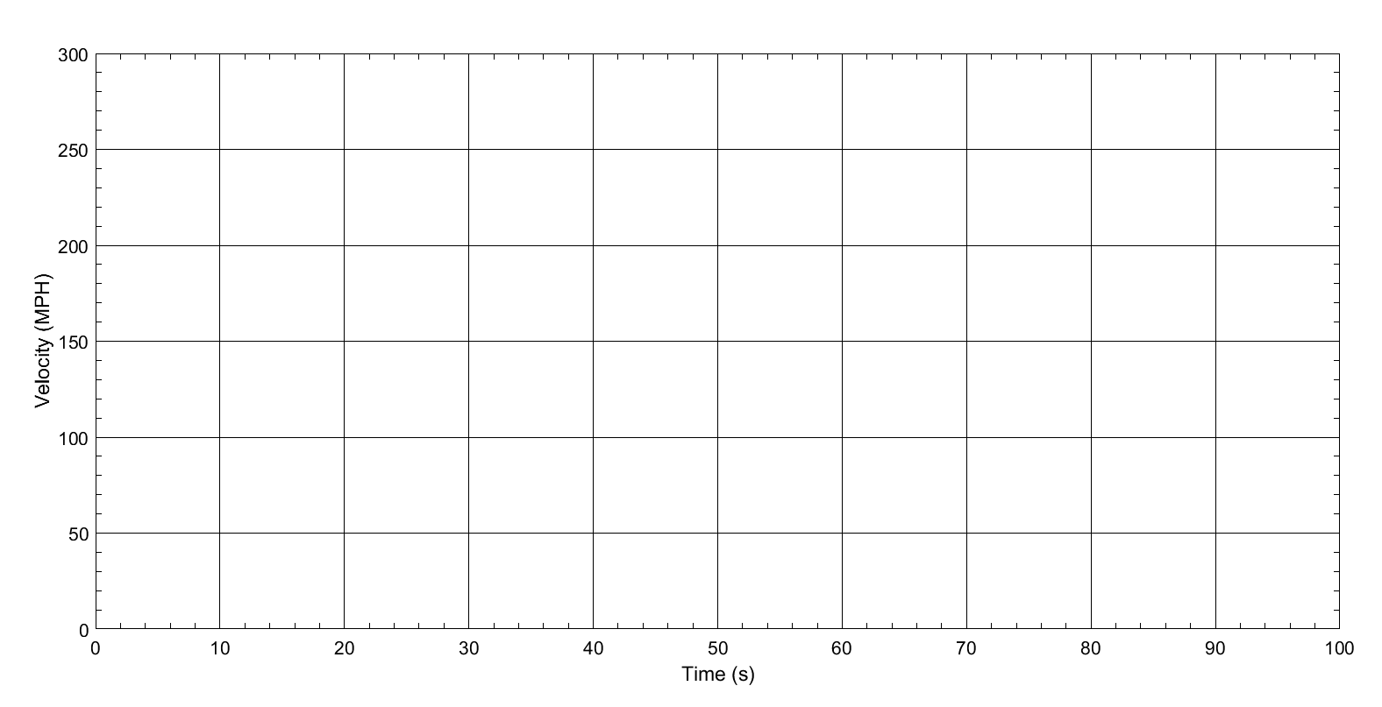

b) What is the physical meaning of the theta values? What would cause it?

Problem 3 (10 pts)
Consider the following ODE
$\frac{dy(t)}{dx }+2y\left(t\right)=4t$ where y(0) = 1
- What is the Laplace transform of this equation? [Do not use deviation variables]

b) What is the solution for this equation in the time domain expressed as y(t) = ? You can use deviation variables in this solution if that helps. Solve by hand. I want to see intermediary work so I know you didn’t use a calculator inverse Laplace solver.

Problem 1 (7 pts)
Consider a process governed by the following transfer function:
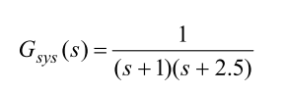
- What are the poles for this transfer function?

- Draw them on a pole plot and indicate the stable plane. What do they indicate about the system behavior?

- Consider the following forcing function. What is the equation for u(t), U(s), and Y(s) if this forcing function were applied to the process described by the transfer function above? [DO NOT solve for y(t)].
