2018 ChE 421 Lab Instructions – [work in your teams of 3-4 that were assigned at the start of class. See Dr. Reuel or Alma if you do not know who is on your team or you need their contact]
[1] 18th October watch videos to prepare – DONE
[2] 30th October go over lab assignment, get lab kit, connect, and acquire first data!
[A] Connect to the Temp Control Lab (TCL) via Matlab (PC preferred)
- Plug in USB to board and your computer
- Plug in power plug to the TOP BOARD BARREL JACK (not the jack on the the uno base board) and connect to usb on computer (this will power the board)
- Navigate to folder where you have saved the tclab.m script
- Run tclab.m script
- Open device manager
- Click on ‘Ports’ – determine which COM channel is being used for the USB serial
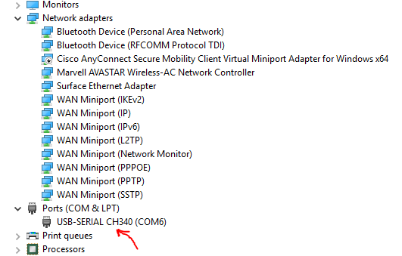
- At Matlab prompt insert the number you see (e.g. COM6 for the one I have on my laptop)
- If it is successful, it will print the port number, recognize the ‘Uno’ board.
- Test connectivity by running the test_LED.m script. This will blink and dim the LED on the board.
- Issues with connectivity? Try solutions here [it seems that PC might be the best bet] - http://apmonitor.com/pdc/index.php/Main/ArduinoSetup
[B] Collect some DATA!
- Example code is provided to show how to turn the heaters on and off and record/collect data
  - test_Heaters_avg.m
  - You set the heater level (ht1, ht2) by % of peak voltage [ 0 = 0 volts, 100 = 5.5 volts]
  - The default program demonstrates time delays and how to ramp to different values
    - Note: the program is set at 1 second intervals to handle averaging. You may need to change this if the run time of each step (printed to workspace) is longer than 1 second (see line 91).
    - Note: The wall wart provides a more stable power source; however, the power extent seems to be limited (I could only go up to 80% with mine – Fig 1 and 2)
- Remember these Matlab commands to save data (for regression to determine model param)
  - xlswrite
  - csvwrite
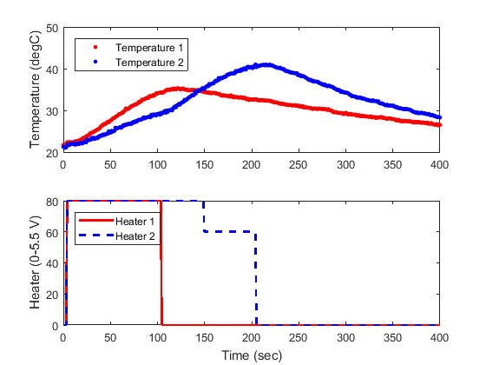
Figure 1 – With wall wart (max power is 80%)
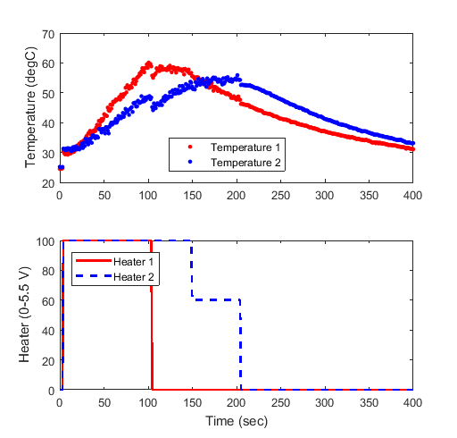
Figure 2 – From laptop USB, ramping to 100% as max power. Notice how the data is a bit noisier from the USB power source (has to do with the way your battery oscillates the power supply). If you want cleaner data, run your experiments from the wall wart provided.

Lab Assignment
You’ve moved into an old dormitory that has terrible plumbing. Every shower temperature fluctuates based on water usage, season, and number of toilets being flushed. You see a business opportunity! You will design heating elements that can be strapped to the cold copper pipe line leading to the bathroom that add heat to the incoming water locally based on the user preferred temperature. In order to gain financial backing for this business idea, you need to demonstrate to potential investors your ability to program control algorithms using a low cost microcontroller (Arduino). You will do this with the TCL module by completing the following tasks:
----- PHASE 1 ------------ Due 11/15 Midnight - End product for first phase is a 1 page Team Memo, describe the transfer function models you have tried and the reasoning on the ones you settled on. Provide concise figures. Attach all raw data used and Matlab scripts to the memo. Submit to Alma via email (cc. Dr. Reuel).
- Collect empirical data from the TCL. Develop transfer function models for each heater independently [there are two of them] (input = % power setting of heater, output = temperature setting). Address the following:
  - What forcing function(s) should you use to obtain the data for model fit?
  - What complexity of model describes the process data best?
  - What portion of the data should you fit? See Fig 1-2.
    - NOTE: I found that the wall wart provided for heater power ONLY provides enough amperage for 80% voltage.
  - Comment on why the models differ between the two heaters and why this matters for your business idea?
------- PHASE 2 --------- Due 12/6 Midnight – End product for this phase is a short Team Report that provides answers and plots for the questions below. Email to Alma (cc. Dr. Reuel) and attach raw data.
- Pick one heater that you wish to control via Matlab. Comment on why you selected this one.
- You are going to use Matlab to do REAL feedback control. Draw a block diagram. What are the units between transfer functions? What do you know, what can you assume?
- Determine a control transfer function for this problem.
- Simulate the response of this control problem to a set point change from ambient at t<0s and 30°C above ambient at t = 0s.
- Write an m-file that implements feedback control using the control transfer function defined in part 3. Test the control with a set point change, again from ambient to 30 °C above ambient. A few things to think about:
  - You are using a discrete, digital controller. You may want to look at chapter 8.4
  - What would benefit your control, a short time step with lots of noise or a longer time step with averaged sampling to reduce noise?
  - You may need to revisit part 3 and improve upon your control transfer function.
- What can you do to make your response time faster? Try it! This is real process tuning. Can you achieve the simulated response in part 4? Why do they differ.
- Once you think you have your best control m-file, that incorporates your transfer function and sampling rate, validate your control algorithm with two tests:
  - REGULATOR PROBLEM – maintain some set point temperature, and blow on the heater. Plot the response of the temperature and the heater setting. Indicate on the plot the areas where you blew on the system.
  - SERVO PROBLEM - Challenge the control algorithm with the following set point changes:
    - Start at ambient temp
    - T = 0s, set to 25°C
    - T = 100s, set to 50°C
    - T = 400s, set to 30°C
    - T = 800s, set to 40°C
    - Record data to 1200s [20 minute experiments!]
Provide the following:
    - Plot the dynamic responses (Tset point, Tmeasured, heater response)
    - What is the settling time (ts) after each set point change?
- End your report with comments on how this heater control system could be used for the shower heating application. Any limitations?

- The last deliverable for this project is a short 2 to 3-minute commercial/pitch that can be recorded and played or presented live to class on December 6. This should be a short summary of your ability to control temperature, highlighting the control strategy you use, and how well it performs. Your audience (the class) will be a group of investors who will determine which startup teams they will invest their money in (class allocated $$ will be a part of the grade).
Canceled! As I worked through this today, it will be plenty difficult to get this part done. We will use Dec. 6 as review and then study hall to finish your team projects.

