ChE 310 Problem Set 12 Due Wed 5/1/19

Collect all m-files in a single .zip file and upload the .zip file to the course webpage by midnight on Wednesday, May 1, 2019. Please note any collaborations in comments. Each student must upload their own unique copy of the work.
12_1. Solve Chapra problem 23.13. How many data points are generated by MATLAB when using ode45 vs. ode23s?
NOTE: There is a typo in the third differential equation in the book (has one extra (-) sign):
$$\frac{dc_{3}}{dt}=0.013c_{1}-1000c_{1}c_{3}-2500c_{2}c_{3}$$
12_2. Use MATLAB to solve example 6.10 in the Fogler text (pp. 352-355 of the attached PDF). NOTE: read the example closely, as it provides all of the needed constants, differential equations, and rate expressions. Create an identical figure to E6-10.1 (bottom of pg. 355 in PDF) as your output. (Note that the labeling positions, axis numbering, fonts, etc. don’t have to be perfectly identical, but the curves shown should match… and you should still provide sufficient labeling in some form!)
12_3. Solve Chapra problem 24.11. Plot the concentration of A as a function of distance.
12_4. Solve Chapra problem 24.18.

[Demonstrate collaboration on SLACK for group work points]

Challenge 12_5 (4 points extra credit)
We’re firing a cannon to land a projectile within a target zone. We define a coordinate system in which y is the direction toward the target zone (positive direction moves from us toward the target), x is the “left/right” direction when facing the target zone (positive direction to the right), and z is the direction normal to the ground (positive direction upward).
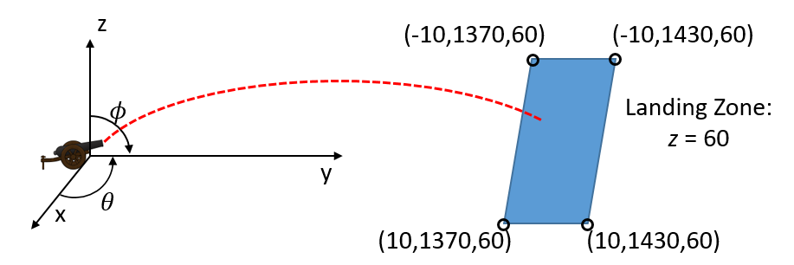
The movement of the projectile is governed by the following equations of motion:
$\frac{dx}{dt}=v_{x}$ $\frac{dy}{dt}=v_{y}$ $\frac{dz}{dt}=v_{z}$
$\frac{dv_{x}}{dt}=a_{x}$ $\frac{dv_{y}}{dt}=a_{y}$ $\frac{dz}{dt}=a_{z}$
The accelerations can be defined by the following equations:
$$a_{x}=\left[sign\left(v_{wind,x}-v_{x}\right)\right]\frac{C_{d}}{2}ρ_{air}{\left(v_{wind,x}-v_{x}\right)}^{2}A_{ref}/m_{ball}$$
$$a_{y}=\left[sign\left(v_{wind,y}-v_{y}\right)\right]\frac{C_{d}}{2}ρ_{air}{\left(v_{wind,y}-v_{y}\right)}^{2}A_{ref}/m_{ball}$$
$$a_{z}=\left[sign\left(v_{wind,z}-v_{z}\right)\right]\frac{C_{d}}{2}ρ_{air}{\left(v_{wind,z}-v_{z}\right)}^{2}A_{ref}/m_{ball}-g$$
Note the “sign” function, which can be used in MATLAB. This returns a (+1) or a (-1); this comes from air resistance opposing the direction of movement.
The appropriate $A_{ref}$ value for a sphere’s surface area is calculated as:
$$A_{ref}=\frac{π}{4}D_{ball}^{2}$$
For this problem, we consider the following physical constants:
$C_{d}=0.47$ $ρ_{air}=0.737\frac{kg}{m^{3}}$ $D_{ball}=0.254 m$ $m_{ball}=45 kg$ $g=9.81\frac{m}{s^{2}}$
We also consider the following initial position of the projectile:
$x\left(t=0\right)=0$ $y\left(0\right)=0$ $z\left(0\right)=0$
The initial velocities are determined by the following equations, as determined by the launch angles of the cannon:
$v_{x}\left(0\right)=v_{0}\sin\left(ϕ\right)\cos\left(θ\right)$ $v_{y}\left(0\right)=v_{0}\sin\left(ϕ\right)sin(θ)$ $v_{z}\left(0\right)=v_{0}cos⁡(ϕ)$
For this problem, $v_{0}$ is fixed at 142 m/s.
The target zone is located in a 10x10 square landing area defined by coordinates:
$$\left(-10,1370,60\right);\left(10,1370,60\right);\left(-10,1430,60\right);(10,1430,60)$$
- First consider the case in which $v_{wind,x}=0$ and $θ=90°$. (This corresponds to the case in which all x-components are 0.) Assume $v_{wind,z}=0$. For each of the following cases, find a value of $ϕ$ for which the projectile will land in the target zone.
  - $v_{wind,y}=0\frac{m}{s}$
  - $v_{wind,y}=-20\frac{m}{s}$ (wind in your face)
  - $v_{wind,y}=30\frac{m}{s}$
- There’s now a strong cross wind: $v_{wind,x}=-30$, $v_{wind,y}=-10$, $v_{wind,z}=0$. Find a pair of $θ$ and $ϕ$ such that your cannon will hit its target zone.

