ChE 310 Problem Set 8 Due Wed 3/27/19

Collect all m-files in a single .zip file and upload the .zip file to the course webpage by midnight on Wednesday, March 27, 2019. Please note any collaborations in comments. Each student must upload their own unique copy of the work.
8_1 Regression (use a method of your choice)
- Problem 15.18 from the textbook. Be sure to report the correct units on your calculated coefficients A₁ and A₂.
Solution:
%PS8_1A.m
%Chapra 15.18
clear
%data
P = [.985; 1.108; 1.363; 1.631]; %atm
V = [25000; 22200; 18000; 15000]; %mL
%constants
T = 303; %K
R = 82.05; %mL atm / K

%Let's group "known" dependent values into one vector y
y = P.*V/(R*T)-1;
%Use generalized linear least squares
g1 = @(x) 1./x; %pairs with A1
g2 = @(x) 1./x.^2; %pairs with A2

Z = [g1(V) g2(V)];

a = (Z'*Z)\Z'*y;
fprintf('The value of A1 is %4.4g mL.\n',a(1))
fprintf('The value of A2 is %4.4g mL^2.\n',a(2))

Output:
>> PS8_1A
The value of A1 is -231.7 mL.
The value of A2 is -1.05e+05 mL^2.

- Problem 15.23 from the textbook. Report c_{s}, k_{max}, and the requested growth rate, with correct units.
%PS8_1B
%Chapra 15.23
clear
%Nonlinear regression requested; we'll use fminsearch
%Known data
c = [0.5; 0.8; 1.5; 2.5; 4];
k = [1.1; 2.4; 5.3; 7.6; 8.9];

%a(1) = kmax; a(2) = cs
kstar = @(a) a(1)*c.^2./(a(2)+c.^2);
S_R = @(a) sum((k-kstar(a)).^2);
a_bestfit = fminsearch(S_R,[9 2]);
fprintf('The value of kmax is %4.4g /day.\n',a_bestfit(1))
fprintf('The value of cs is %4.4g mg^2/L^2.\n',a_bestfit(2))

k_2 = a_bestfit(1)*2.^2./(a_bestfit(2)+2.^2);
fprintf('The value of k at c=2 is %4.4g /day.\n',k_2)

Output:
>> PS8_1B
The value of kmax is 10.04 /day.
The value of cs is 2.018 mg^2/L^2.
The value of k at c=2 is 6.671 /day.

8_2 Linear vs. nonlinear regression
Solve Chapra problem 14.31. Determine B and D using both a linear regression technique (after linearizing the model) and using a nonlinear regression technique on the original model equation. Plot the corresponding best-fit functions along with the original data. Ensure your plot is labeled (axes, legend); the plot is the only necessary output. Keep in mind that Andrade’s equation takes temperatures in K, while the table provides temperatures in $°C$.
Solution:
%PS8_2.m
%Chapra 14.31
clear ; clf

%input known data
mu = [1.787; 1.519; 1.307; 1.002; 0.7975; 0.6529];
T_c = [0 ; 5; 10; 20; 30; 40];
T = T_c + 273.15;

%First, use general least squares.
%Linearize: ln(mu) = ln(D) + B*(1/T)
%Our output data are
y = log(mu);

%basis functions: g0 = 1 ; g1 = 1/T ;
Z = [ones(size(T)) 1./T];
a = (Z'*Z)\(Z'*y) ;
%Convert a(1) and a(2) to the original parameters D and B
D_lin = exp(a(1));
B_lin = a(2);

fprintf('The value of D using linearization is %4.4g mN*s/m^2.\n',D_lin)
fprintf('The value of B using linearization is %4.4g K.\n',B_lin)

%Now, let's use fminsearch
%Need to input B, D as one function to fminsearch. a = [B D]
mu_star = @(a) a(2)*exp(a(1)./T);
S_R = @(a) sum((mu_star(a)-mu).^2) ;
a_best = fminsearch(S_R,[2000 1e-5]) ;
B_nonlin = a_best(1);
D_nonlin = a_best(2);

fprintf('The value of D using nonlinear methods is %4.4g mN*s/m^2.\n',D_nonlin)
fprintf('The value of B using nonlinear methods is %4.4g K.\n',B_nonlin)

plot(T,mu,'ko')
hold on
fplot(@(T) D_lin*exp(B_lin./T),'r-')
fplot(@(T) D_nonlin*exp(B_nonlin./T),'b-')
xlim([270 320])
xlabel('T, K')
ylabel('\mu, mN*s/m^2')
legend('Measured data','Linear Regression','Nonlinear Regression')

Output
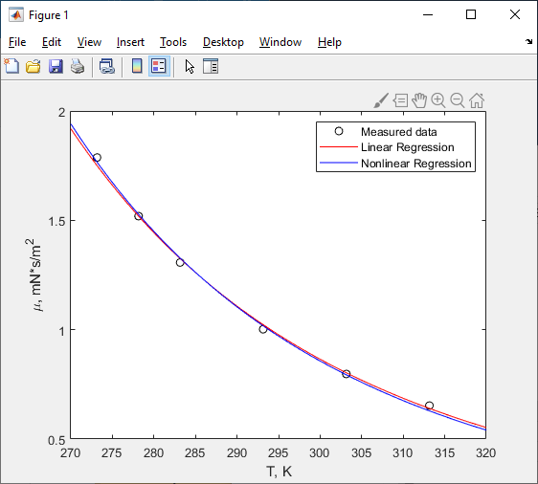
8_3
The kinetic rate of a chemical equation is dependent on temperature ($T$). The Arrhenius equation is used to show this dependence and when properly fitted also shows the activation energy ($E_{a}$) of the reaction:
$$k=Ae^{-E_{a}/(RT)}$$
where $k$ is the rate constant, $A$ is the pre-exponential factor, and $R$ is the universal gas constant.
Eleven experiments were conducted to determine the activation energy of the following reaction:
$$CO+O_{2}→CO_{2}+O∙$$
The data from these experiments are contained in the ‘kinetics’ zipped folder. Each experiment is its own *.csv file with the first column = temperature (K) and the second column = reaction rate or k(T) in cm³/(molecule*s) (Note: units matter!). Plot the raw data with the model fits (one subplot for each of the 11 experiments). Determine the activation energy (kJ/mole) for each experiment and report the average over all 11 experiments along with the associated 95% confidence interval; assume a normal distribution applies to the activation energy data.
For this problem you can linearize the equation or solve in the non-linear form. Which is better? Note: you can automate reading in the file name with the help of the num2str and strcat commands for the file name.
Solution
% PS8_3.m
% Coded by Nigel F. Reuel
% This function solves question 5 on the problem set
%
% METHOD 1: Linearizing (how I solved it in 2016)
% Create an outer loop to step through the 11 data files
Ea_vec = zeros(11,1);
for i = 1:11
Data = csvread(['R',num2str(i),'.csv']);
T = Data(:,1);
k = Data(:,2);
lnk = log(k);
InvT = 1./T;
R = 8.3144598; %J/K/mol
RkJ = R/1000; %kJ/K/mol
% Linearizing and rearranging the arrhenius equation we can get this
% Y = mx*b form
% ln(k) = -Ea/R*(1/T) + ln(A)
x = -InvT./RkJ;
p = polyfit(x,lnk,1); % NOTE: another way to do linear fit, returns the parameters directly
Ea_vec(i,1) = p(1); % Units should be kJ/mol
end
% Print out the 11 values and the statistics
disp('For linearization followed by fit')
Ea_vec
Avg = mean(Ea_vec);
Conf = std(Ea_vec)*2;
fprintf('The average activation energy is %4.2fkJ/mol with +/- %4.2fkJ/mol for 95 percent confidence interval\n',Avg,Conf)
% Method 2 - Linearizing fits error of ln residuals. Not as
% accurate a fit as using the non-linear form. Let's do this!
Ea_vec2 = zeros(11,1);
for i = 1:11
Data = csvread(['R',num2str(i),'.csv']);
T = Data(:,1);
k = Data(:,2);
R = 8.3144598; %J/K/mol
RkJ = R/1000; %kJ/K/mol
% The non-linear model
% k = A*exp(-Ea/R*(1/T))
% build in exp1 function is A*exp(b*x), so b = -Ea/R and x = 1/T
x = 1./T;
ExpFit = fit(x,k,'exp1');
MyCoeffs = coeffvalues(ExpFit);
Ea_vec2(i,1) = MyCoeffs(2)*-1*RkJ; % Units should be kJ/mol
subplot(3,4,i)
plot(T,k,'o')
hold on
funcfit = @(T) MyCoeffs(1)*exp(MyCoeffs(2)./T);
fplot(funcfit,[T(1) T(end)])
xlabel('Temp')
ylabel('k')
legend('Measured Points','Model Fit','Location','northwest')
hold off
end
disp('For non-linear fit')
Ea_vec2
Avg = mean(Ea_vec2);
Conf = std(Ea_vec2)*2;
fprintf('The average activation energy is %4.2fkJ/mol with +/- %4.2fkJ/mol for 95 percent confidence interval\n',Avg,Conf)
disp('Note: the non-linear fit is a better route and in this case also gives tighter confidence interval.')

Output:
>> PS8_3
For linearization followed by fit
Ea_vec =
197.0224
264.3459
146.3205
158.7910
251.1172
171.3110
209.5324
251.1172
127.1643
213.7842
100.5027
The average activation energy is 190.09kJ/mol with +/- 108.04kJ/mol for 95 percent confidence interval
For non-linear fit
Ea_vec2 =
176.2948
195.9645
124.2051
133.2853
227.7555
152.6589
203.9686
227.7555
120.7660
204.8221
98.2187
The average activation energy is 169.61kJ/mol with +/- 91.81kJ/mol for 95 percent confidence interval
Note: the non-linear fit is a better route and in this case also gives tighter confidence interval.
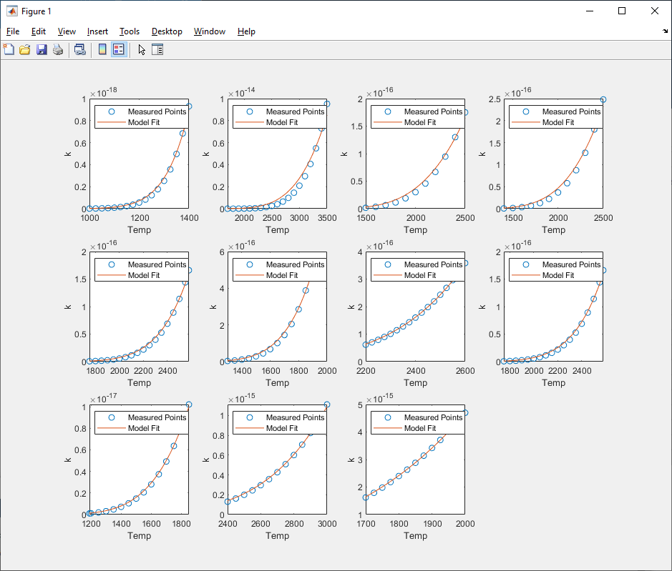
8_4 Multivariable regression
Background. As part of Dr. Roling’s postdoctoral research, he used linear regression to parameterize the energies of metal atoms in nanoparticles. These models fit 20 parameters corresponding to 20 independent variables in a 140-point alloy data set; this was done for each of 21 bimetallic combinations. Here, we’ll focus on a smaller subset of data.
In this model, each bond formed by a metal atom is considered to have its own unique energy. The total energy of nanoparticle is then determined by the sum of all its bond energies $α_{i}$. For example, a metal dimer (two isolated bonded atoms) is composed of two atoms, each with a single bond; the energy of a metal dimer is therefore calculated as $E_{dimer}=α_{1}*2$. A triangular arrangement of three atoms (each bound to two other atoms) has an energy calculated as $E_{triangle}=α_{1}*3+α_{2}*3$.
Problem Statement. We seek a model to calculate the energy $E$ of a small cluster of metal atoms as:
$$E\left(n_{1},n_{2},n_{3}\right)=α_{1}n_{1}+α_{2}n_{2}+α_{3}n_{3}$$
where $α_{i}$ are parameters and $n_{i}$ are independent variables denoting the number of each type of bond in a configuration. The following data were collected using density functional theory calculations for Pt clusters:
Geometry Type | $$n_{1}$$ | $$n_{2}$$ | $$n_{3}$$ | $E$ (kJ/mol)
dimer | 2 | 0 | 0 | -255.3
3-atom triangle | 3 | 3 | 0 | -603.2
3-atom line | 3 | 1 | 0 | -475.0
5-atom line | 5 | 3 | 0 | -865.6
4-atom tetrahedron | 4 | 4 | 4 | -969.7
4-atm trigonal planar | 4 | 1 | 1 | -655.2
4-atom square | 4 | 4 | 0 | -858.7
4-atom diamond | 4 | 4 | 2 | -911.5
6-atom rectangle | 6 | 6 | 2 | -1481.9
6-atom pair of triangles | 6 | 6 | 2 | -1333.4

Use linear regression to find the best-fit values of $α_{1}$, $α_{2}$, and $α_{3}$; also report the corresponding R² value.

Solution
%PS8_4.m
clear;

%We'll solve this using general linear least squares:
%E = g1*alpha1 + g2*alpha2 + g3*alpha3
%g1(n1,n2,n3) = n1; g2(n1,n2,n3) = n2; g3(n1,n2,n3) = n3
Z = [2 0 0;
3 3 0;
3 1 0;
5 3 0;
4 4 4;
4 1 1;
4 4 0;
4 4 2;
6 6 2;
6 6 2];

%y contains known energies
y = [-255.3 -603.2 -475 -865.6 -969.7 -655.2 -858.7 -911.5 -1481.9 -1333.4]';
a = (Z'*Z)\Z'*y;

alpha1 = a(1)
alpha2 = a(2)
alpha3 = a(3)

SR = sum((Z*a-y).^2); ST = sum((y-mean(y)).^2);
r2 = 1-SR/ST

Output
>> PS8_4
alpha1 =
-127.3095
alpha2 =
-89.0633
alpha3 =
-34.6003
r2 =
0.9838

L. T. Roling, T. Choksi, F. Abild-Pedersen, “A coordination-based model for transition metal alloy nanoparticles”, Nanoscale 11, 4438-4452 (2019), https://dx.doi.org/10.1039/C9NR00959K

