PSET 1 – Due at 12:45 PM on Aug 28
- Sign into SLACK and setup a profile with a picture so Dr. Reuel can remember your name. We will use SLACK to collaborate in class and out of class. See email from Dr. Reuel for the sign up link.

- Consider the following PID diagram for a distillation column. How many control loops are there? For each, identify the controlled variable, the manipulated variable, the type of sensor, and the final control element. What are some possible disturbance variables?
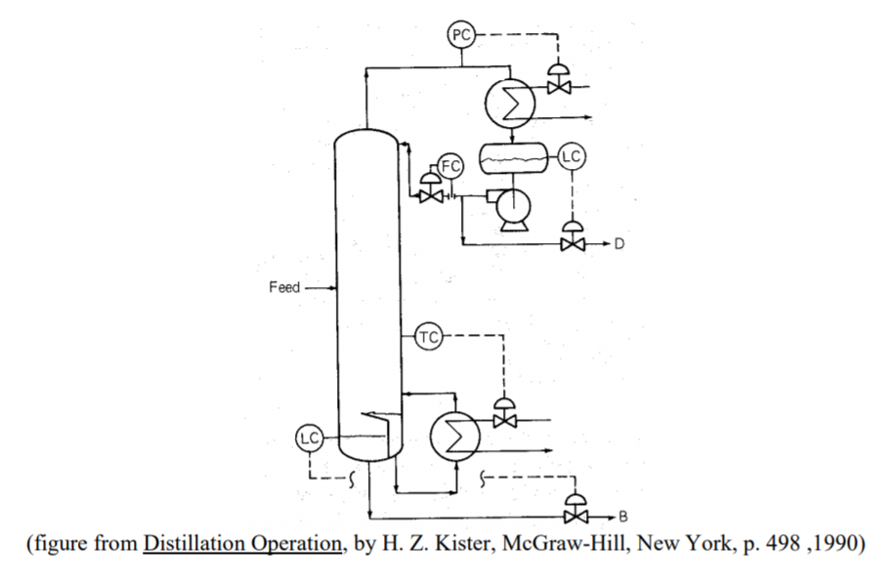
- What is the purpose of a controller? How does it operate?

- Refresh your memory on how MATLAB can solve ODE problems. What functions are available and what does the syntax look like?

- Form a team of 3-4 people. This will be for the class LAB + team homework problems. Record your team here for Dillon (our TA) to manage. If you cannot find a team, please email Dillon (dghurd@iastate.edu) and he’ll help you out.

https://docs.google.com/spreadsheets/d/13eIqJsnzHsw46DnWJ_IzEvRoqqoOSj2JM4CATiEvajs/edit?usp=sharing

