PSET 10 – Due 11.6.2018 at start of class
NOTE: This is the last PSET for UNIT 1. EXAM 2 will be given on Nov 13 in class. It will cover chapters 8, 9, 10, 11, 12, and 14.
Question 1:
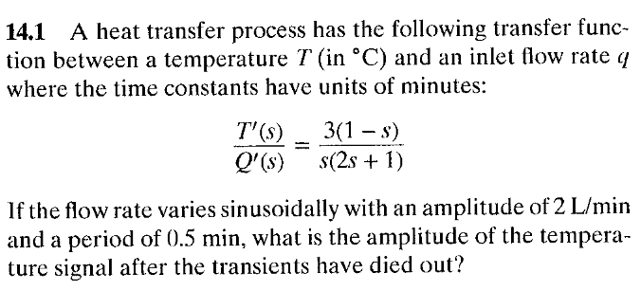

Question 2:
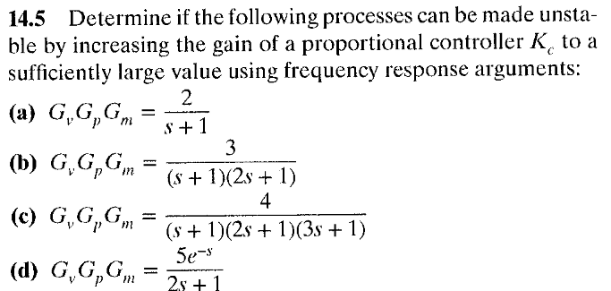

Question 3:
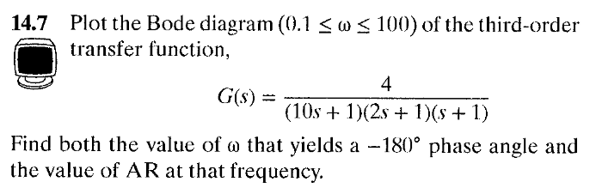

Question 4:
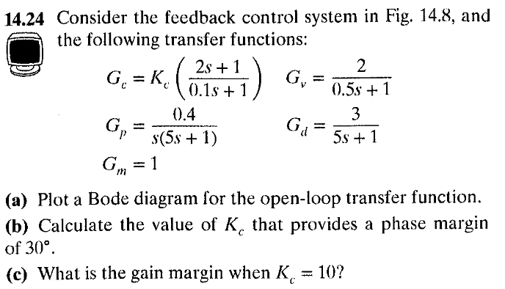

Question 5:
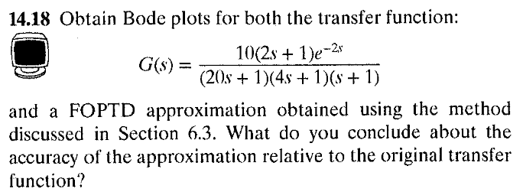

Group Problem 1:
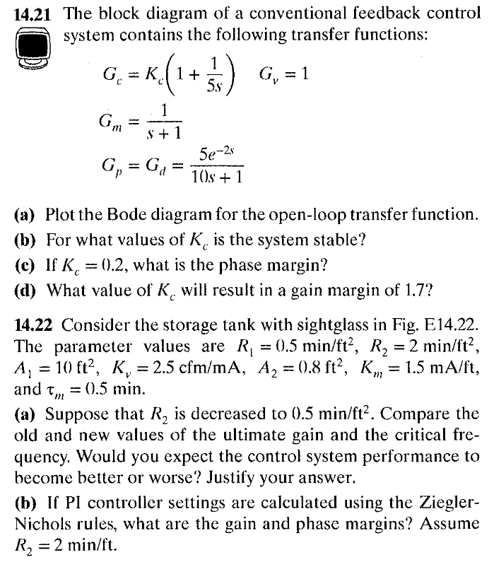
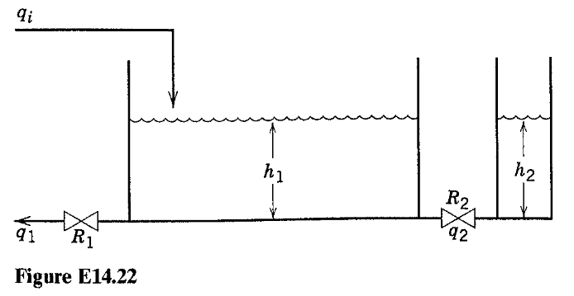
Group Problem 2:
