PSET 10 – Due 11.6.2018 at start of class
NOTE: This is the last PSET for UNIT 1. EXAM 2 will be given on Nov 13 in class. It will cover chapters 8, 9, 10, 11, 12, and 14.
Question 1:
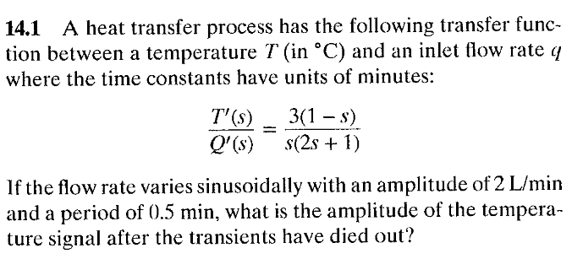
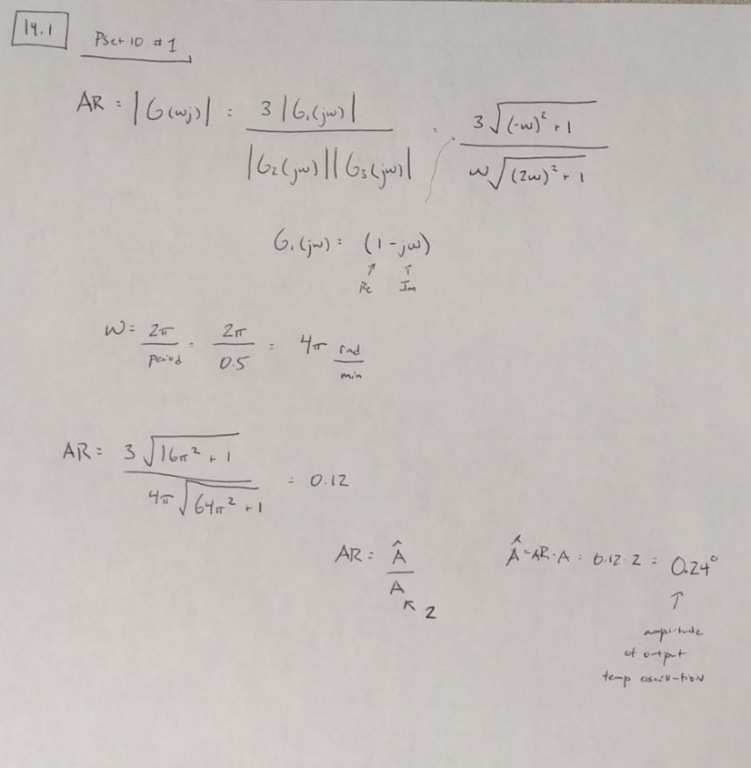

Question 2:
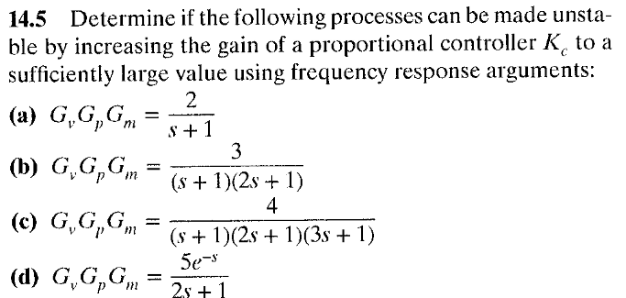
My answer – plot BODE diagrams with increasing Kc values…
- Phase angle never reaches -180
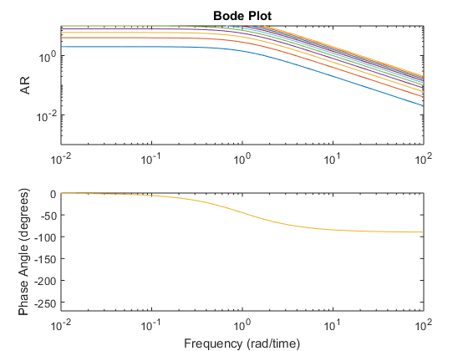
- Phase angle never quite reaches -180’, looks like very large AR never > 1 even at high Kc values
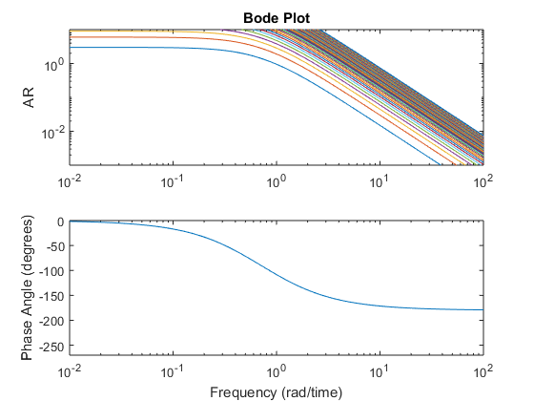
c) Critical frequency is 1rad/time, at this frequency AR can go above one, so this system can be made unstable with sufficiently large Kc values
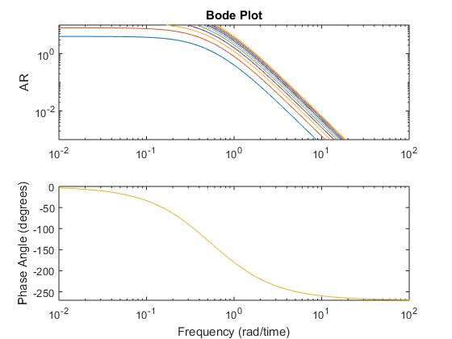
d) Yes, this can be made unstable with increasing Kc values
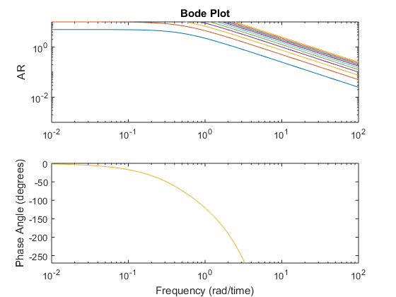

Question 3:
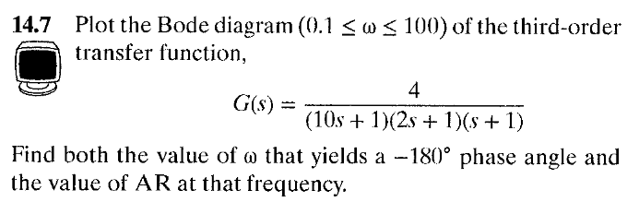
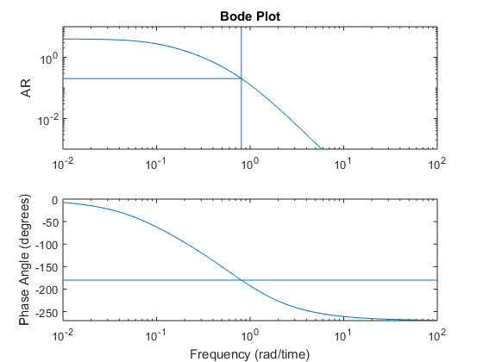
By inspection
Critical frequency = 0.806 rad/time
AR = 0.202
[Note: this system is stable!]

Question 4:
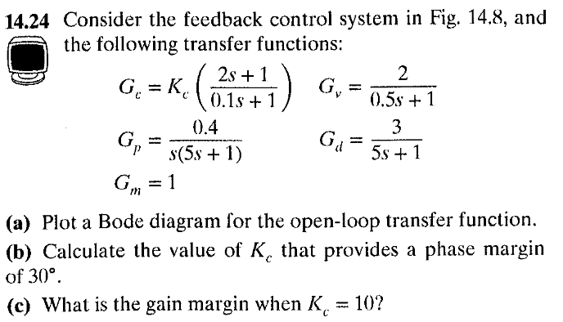
- Bode plot. Note that we do NOT use the disturbance variable transfer function in G –open loop
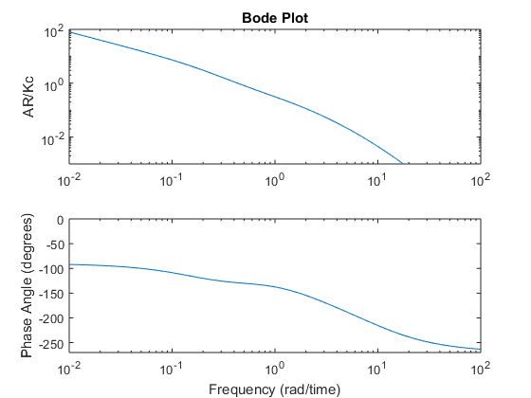
Part (b) I used fminunc to solve for Kc where PM = 30, code for this:
Kc_opt = fminunc(@func1,1)

Where fminunc is defined as:
function F = func1(Kc)
s = tf('s');
G = Kc*(2*s+1)/(0.1*s+1)*2/(0.5*s+1)*(0.4/s/(5*s+1))*1;
[GM, PM, Wc, Wg] = margin(G);
F = (PM-30)^2;
end

Part (c) Solve graphically with BODE plot or use the margin function in Matlab.
GM = 3.0673
Question 5:
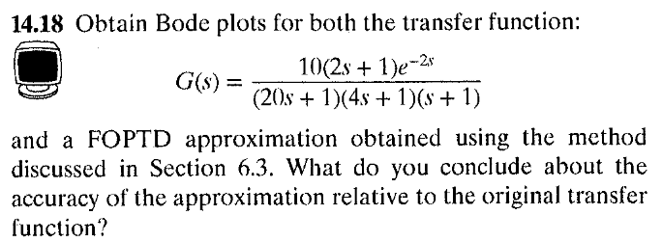
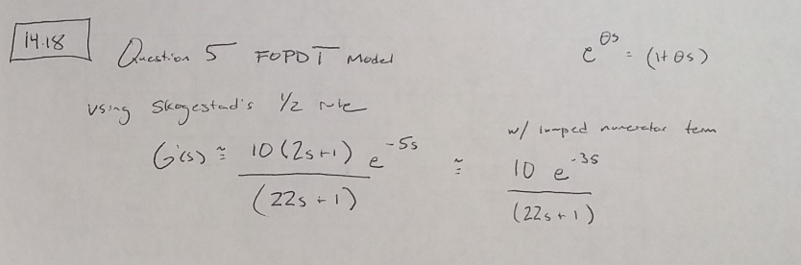
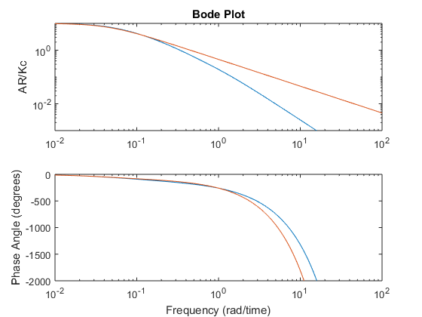
The approximation is good at low frequencies but NOT high frequencies.

Group Problem 1:
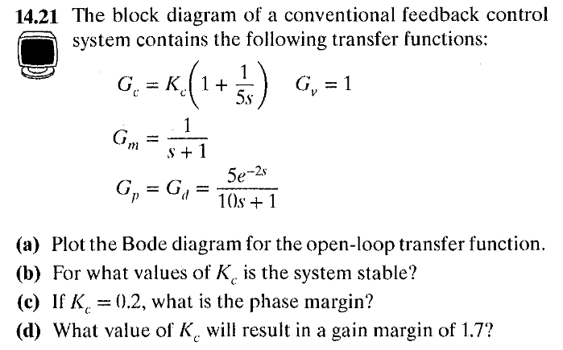
Part a)
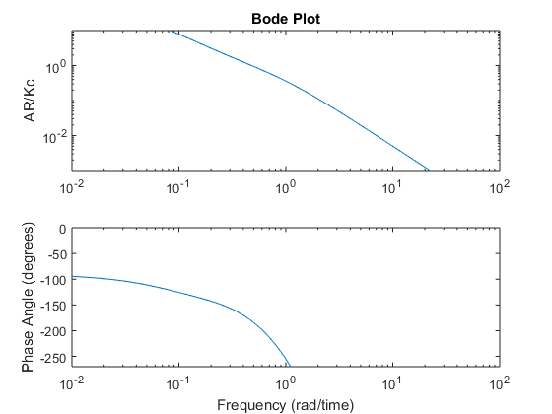
Part b) Kc < 0.9753 the system is stable
Part c) With Kc = 0.2, the phase margin is 46.5°
Part d) Use fminunc to solve (like in problem 4), Kc = 0.57

Group Problem 2:
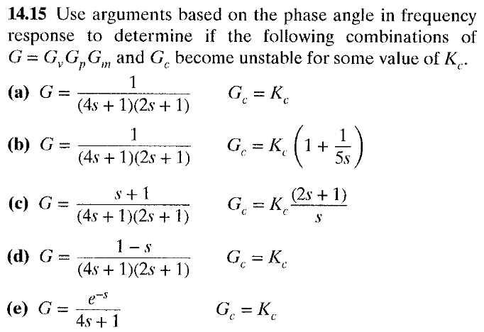
Answer – plot response to Kc values ranging from 0.1 to 10:
Part a) The phase angle never reaches -180’ for any Kc, so it is always stable.
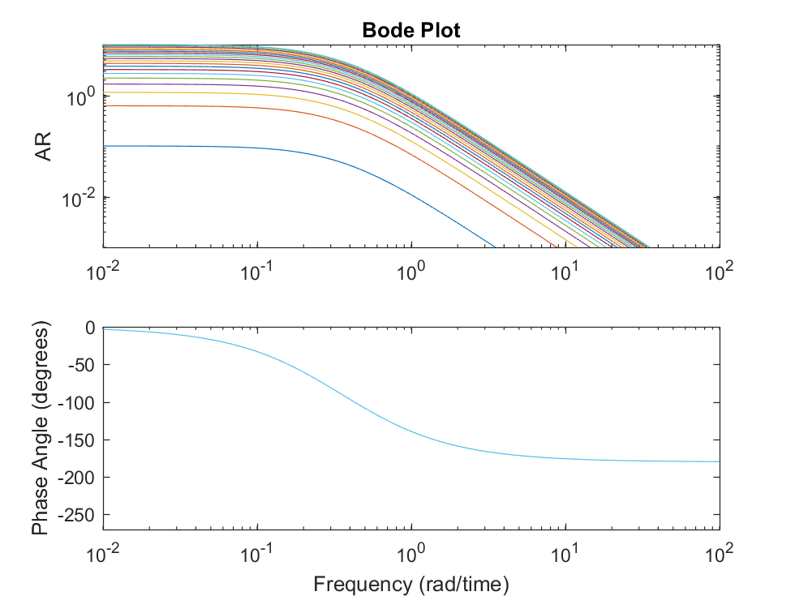
Part b) Same reason as above. Always stable.
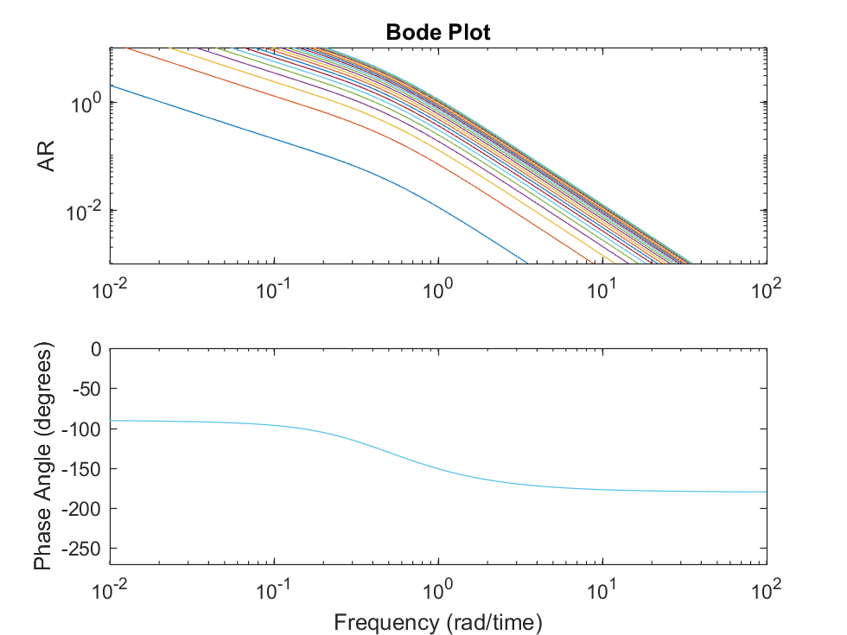
Part c) Again, the phase angle never reaches -180’, so it is stable for all Kc
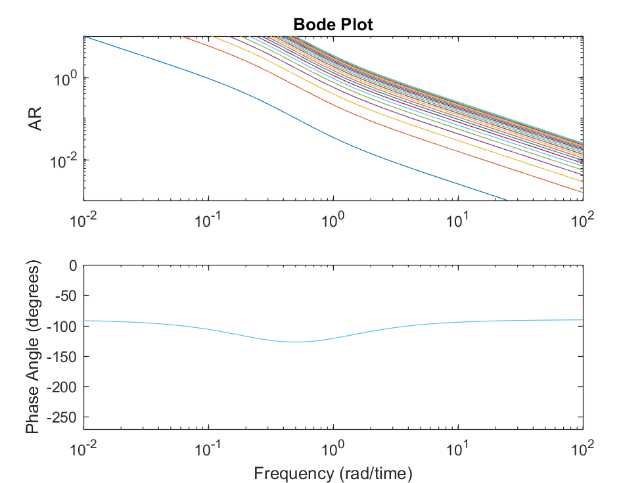
Part d) Very high phase angle, not close to the -180’ marl for any of the Kc values
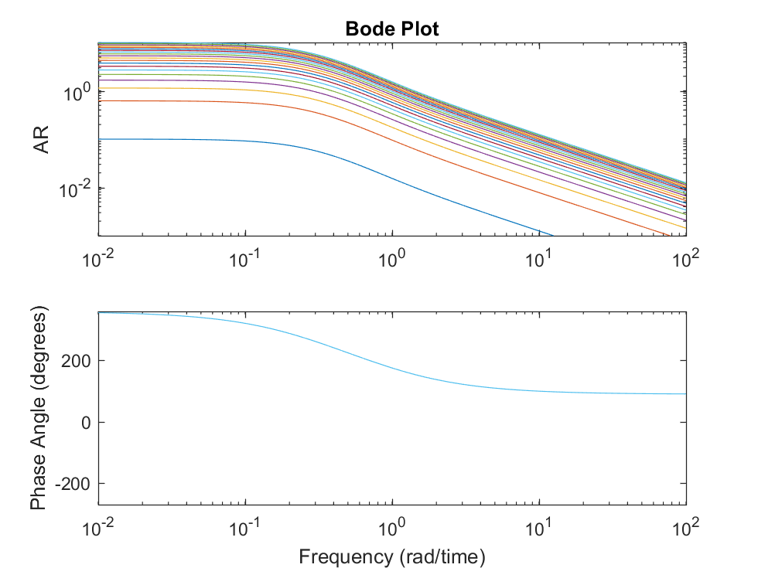
Part e) Yes! At phase angle = -180’, thee are Kc values that can make this system unstable.
