PSET 11 – Due 11.27.2018 at start of class
Individual Problem 1:
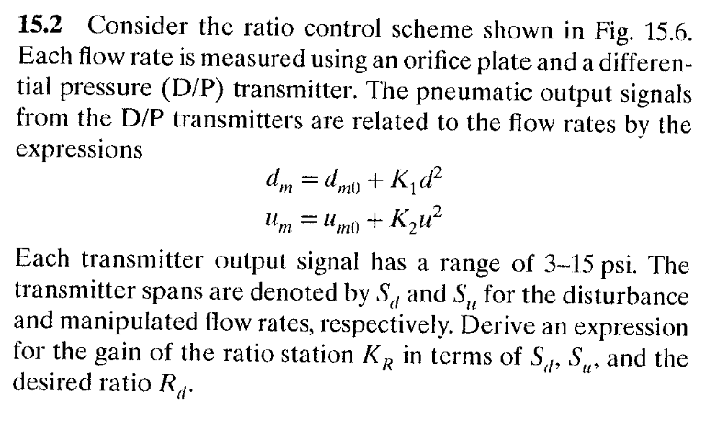
Individual Problem 2:
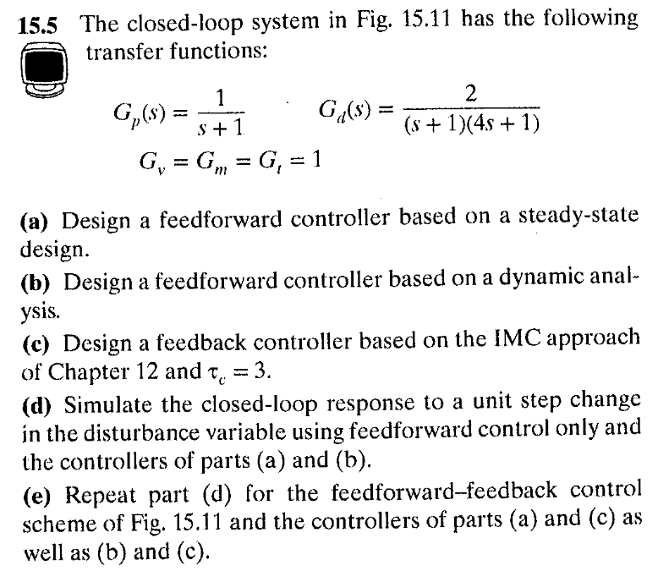
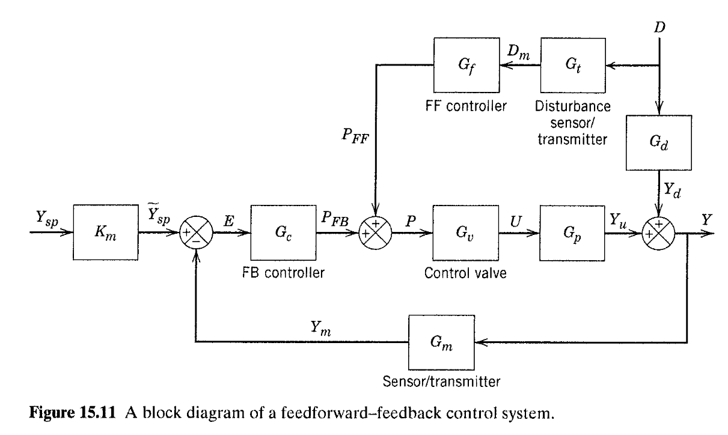
Individual Problem 3:
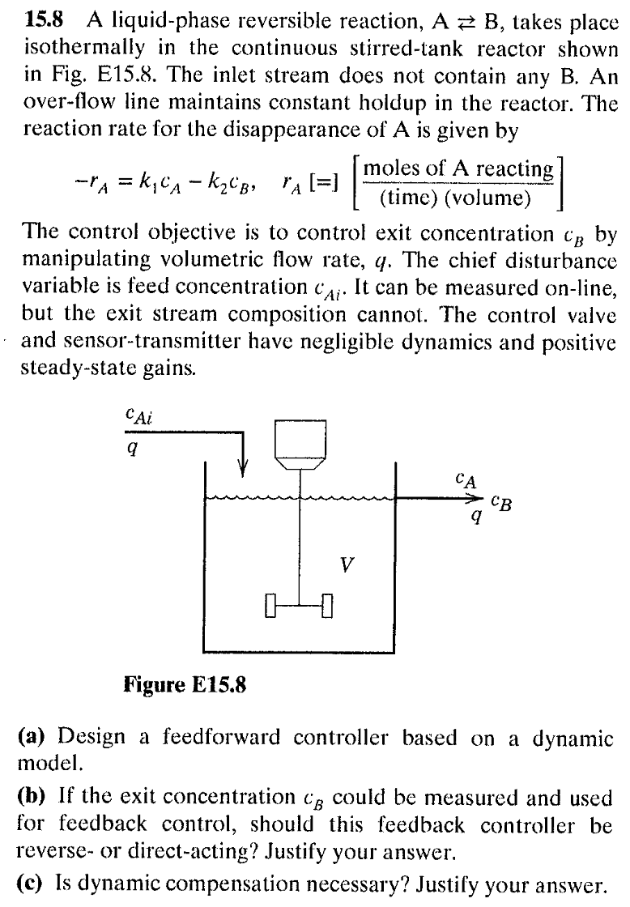

Group Problem 1:
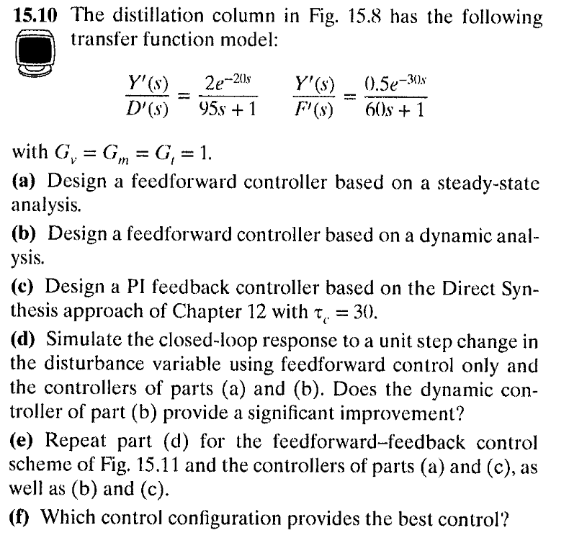NOTE: I will give clue on part (c) after 11.23 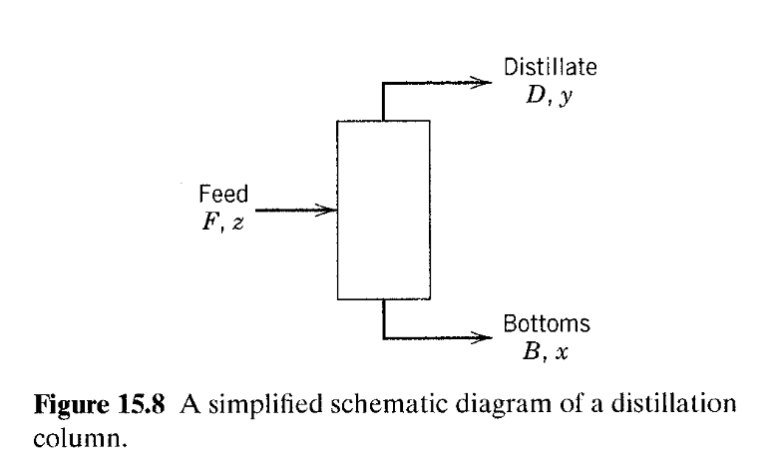

Group Problem 2: Work on your lab!

