PSET 12 (the last one! Due start of class on 12.6.18)
Individual Problem 1:
Copy the standard block diagram for cascade control. Derive the full cascade loop servo and regulatory transfer functions using block algebra. Compare with what was presented in class.
Individual Problem 2:
Consider a SOPDT process with the following parameters: Kp = 1.2, Tau1 = 10, Tau2 = 7
That is controlled by a PI controller with the following parameters: Kc = 1.7, TauI = 13.7
(Assume all other transfer functions, such as Gm, Km, Kip, etc. are = 1).
- Model the effect of changing the SOPDT theta from 0 to 5min to a unit step input change.
- Over what theta value does the process become unstable?
- Implement the smith predictor transfer function with theta of 5 min. How does this improve the response time (compare to (a)).
Individual Problem 3:
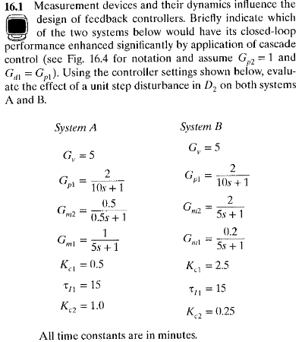

Group Problem 1 -
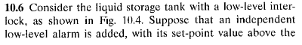
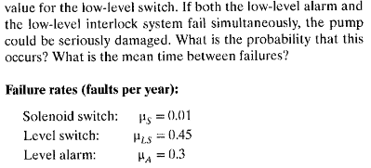
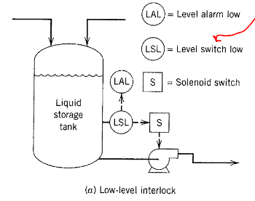

Group Problem 2 –
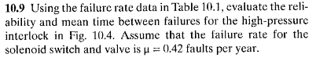
[Figures and tables on next page]
