PSET 2 – ChE 421 Fall 2018 – Due Sept 4, 2018
Individual Problems (turn in at start of class Tuesday)
- CSTR:
  - Derive, with the help of your book, the general dynamic model equations that govern a CSTR with a simple liquid phase, irreversible chemical reaction where chemical species A reacts to form species B. The reaction can be written as AB. Assume reaction is first order. Assume CSTR is perfectly mixed. Also assume that the mass density of the feed and product streams are equal and constant. Also assume that the volume of the reactor is held constant (with an overflow line).
  - The book considers a CSTR with the following parameters: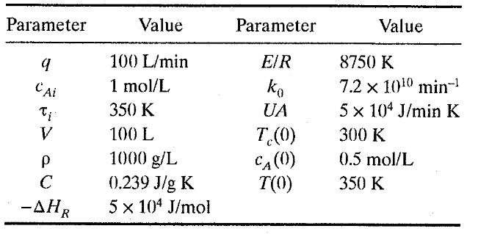
Show that you can solve the models found in (a) with these parameters for step changes in the cooling water temperature from 300 to 305K and 300 to 290K. Plot the dynamic response of the reactor temperature and reactant A concentration due to these step changes (you will want to solve this numerically).

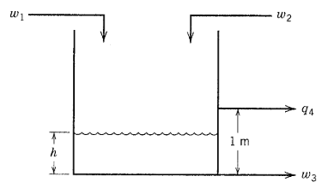
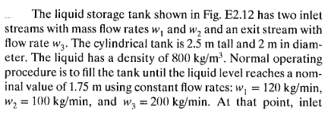
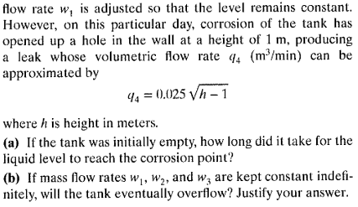

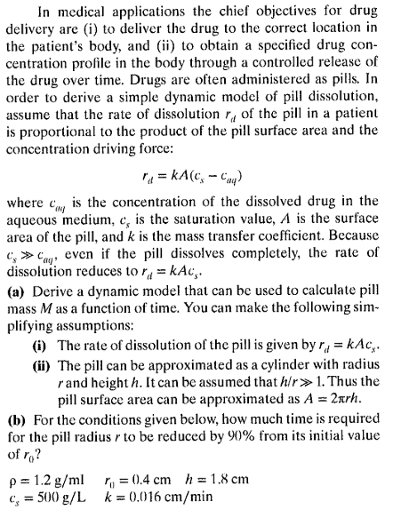

- Solve:
Model the temperature response of an electrically heated stirred-tank process (held at constant volume) that experiences a sudden change in water temperature of the inlet stream – changing from 10°C to 15°C. Plot the response of tank temp and heating element wall temp as a function of time until it reaches a new steady state. The system has the following process parameters:
- Mass of copper heating element = 500g
- Heat capacity of heating element = 0.385J/(g⋅°C)
- Area of heating element = 1.2m³
- Resistance of heating element = 2kΩ
- Current through heating element = 1A
- Water in tank – density = 1 g/cm³
- Volume of tank = 100L
- Heat transfer coefficient = 400 (W/(m²⋅K))
- Flow rate through tank = 100mL/s
- Heat capacity of water = 4.186 J/(g⋅°C)
- Temperature of water coming in before perturbation = 10°C

- Practice Laplace transforms
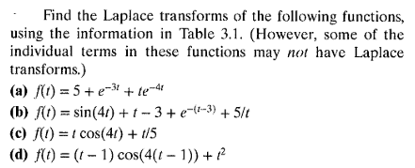
- Solve:
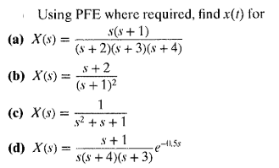
- Solve:
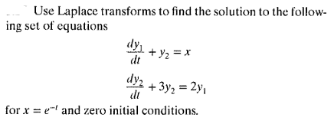
- Solve:
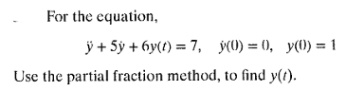

Group Problems (submit a copy of your solution to Dillon via SLACK)

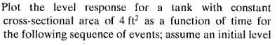
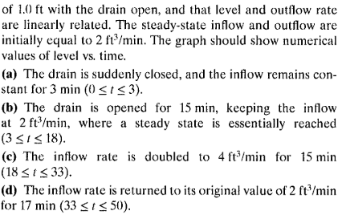
- Solve:
