PSET 3 – ChE 421 – Due Sept 11 at start of class (12:45 sharp, box is removed)
- Recall the tank draining model in which the exit flow rate was proportional to (h)^{-1/2}, such that
$$q_{out}=C\sqrt{h}$$
  - Develop an ODE model for the change in height as a function of time
  - Plot time response from 0 to 10 min for given parameters using a numerical solver:
qi = 0.2m³/min
ho = 2m
A = 1.3m²
C = 0.5 (constant for valve would have units of m^{2.5}/min to work out)
  - Linearize the nonlinear term in the ODE
  - Solve the linearized form of the ODE using Laplace Transform
  - Plot the linearized solution with the numerical solution from part (b). How do they compare?

- Let’s model the response of a process governed by the following ODE:
$$τ\frac{dy}{dt}+y(t)=Ku(t)$$
Where u(t) (the input variable) is subjected to a ‘doublet test’ that looks like the following:
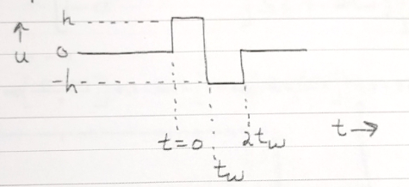
  - Write a mathematical equation for the forcing function (u(t)) in the time domain.
  - Insert the forcing function in the ODE and transform to Laplace domain.
  - Find the solution for y(t) by taking the inverse Laplace.
  - Plot the solution using the following parameters:
K = 1
H = 1
tau = 2
tw = 10

- Derive Laplace transforms of the input signals shown below by summing component functions found in Table 3.1. How could these be described as forcing functions in time domain...e.g. how would you write f(t) and u(t) such that they could be plotted?
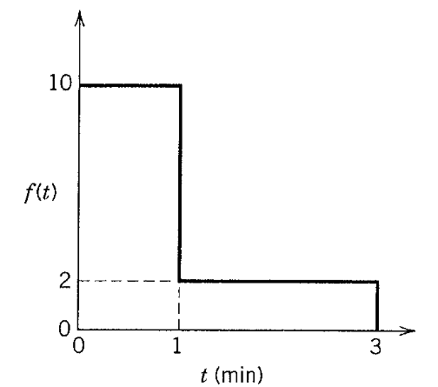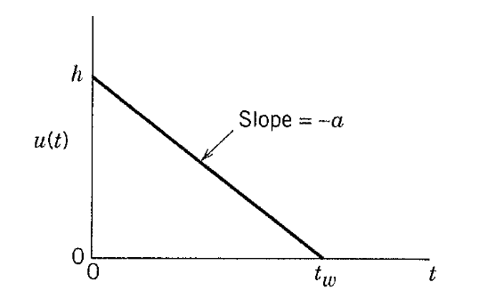

- Solve the following:

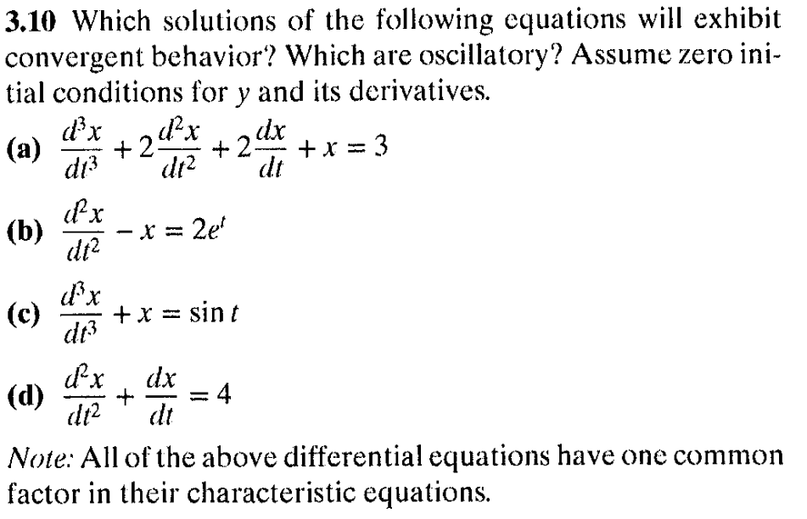

- Solve the following:

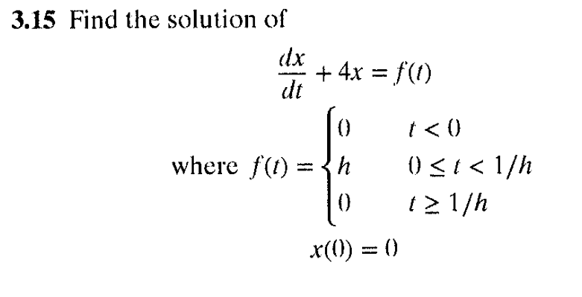

- Solve the following:
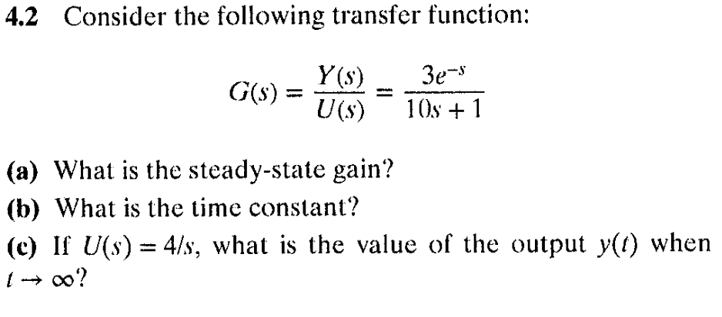

- NEW GROUP PROBLEM Solve the following: [Solve these last two problems in your small groups and submit your answers to Dillon directly via SLACK].
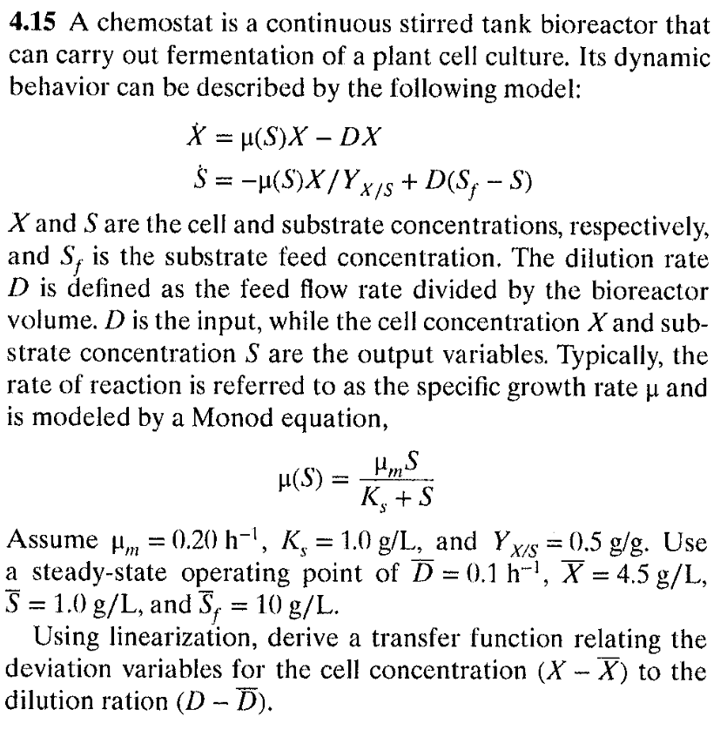
[NOTE: the copy of this problem is bad, this should show X and S with derivative notations:
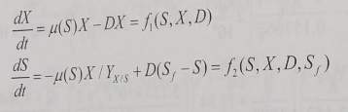

- Don’t DO THIS ONE Solve the following: [Solve these last two problems in your small groups and submit your answers to Dillon directly via SLACK]. POORLY Worded…don’t do this one.
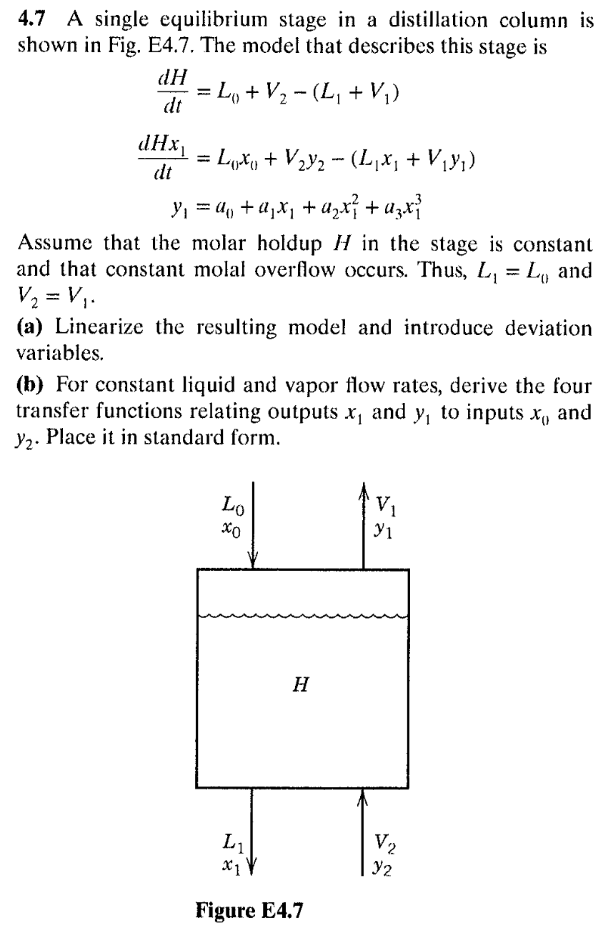

- GROUP PROBLEM Solve the following:
