PSET 5 – ChE 421 – Due 9.25.2018 at 12:45PM
NOTE: there will be no class on 9.25 due to Career Fair; submit your individual problem set electronically as a single PDF with the following naming structure LastName_FirstName_PSET5 as an attachment to the following email address:
ChE_421.lxwnpe5nhn5rmtjl@u.box.com
The group problems should be sent to Dillon via SLACK.
These problems will help us practice the content in Chapter 7:
Individual Problems

Problem 1 –
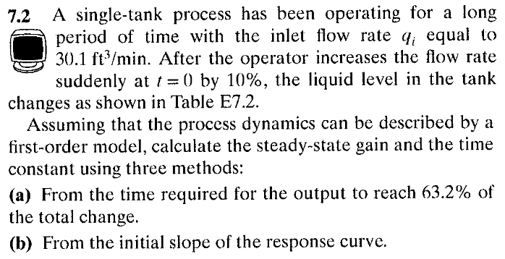
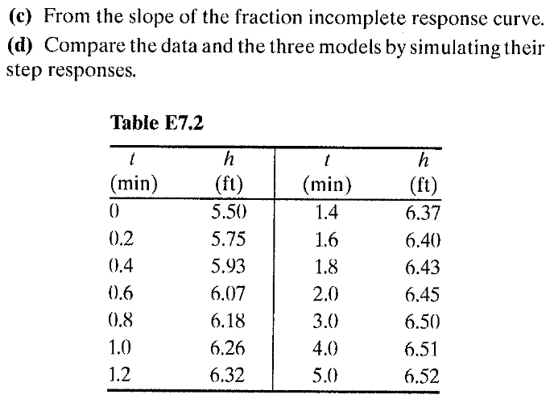

Problem 2
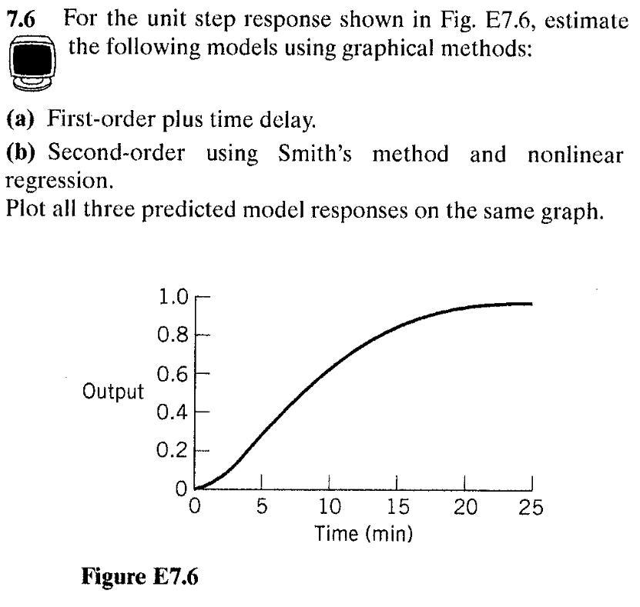

Problem 3
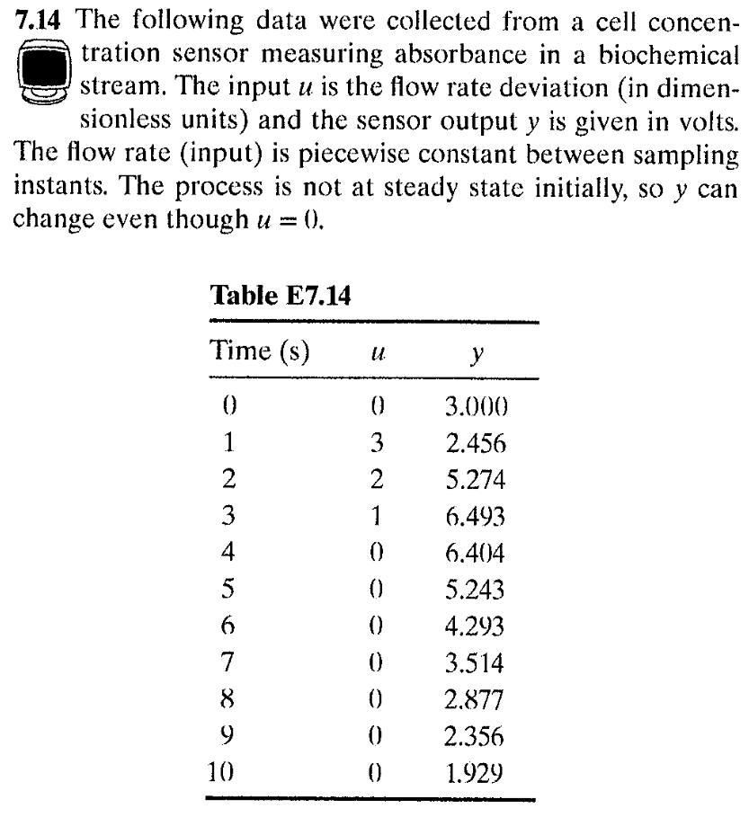
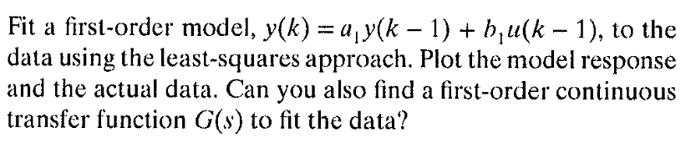

Problem 4
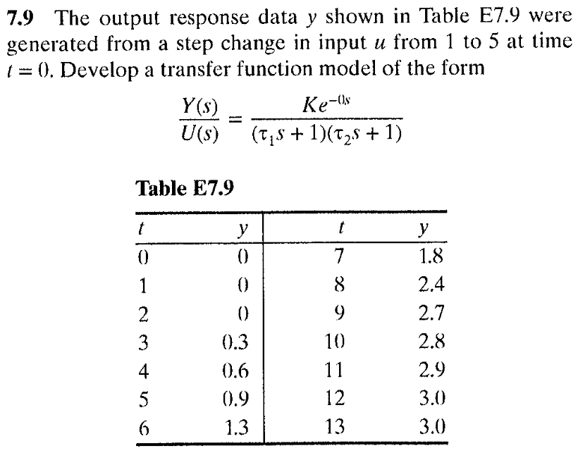

Group Problem 1
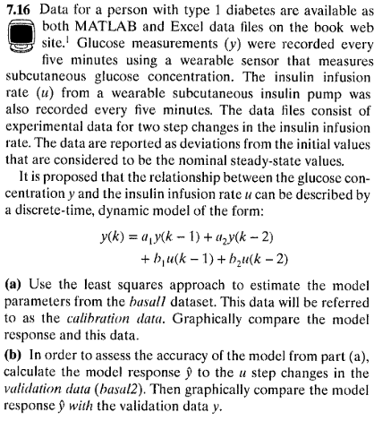
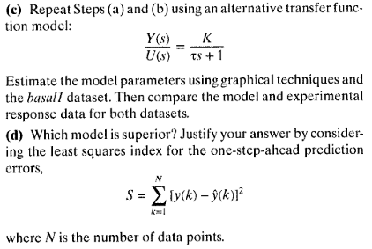

Group Problem 2
