**PSET 6 – Due Oct 9, 2018 at start of class (12:45 am)**

**Problem 1**

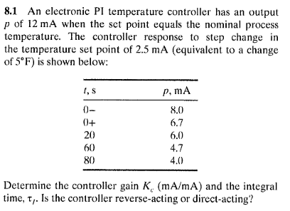

**Problem 2**

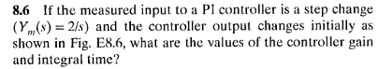

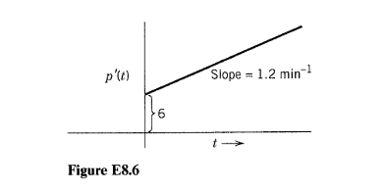

**Problem 3**

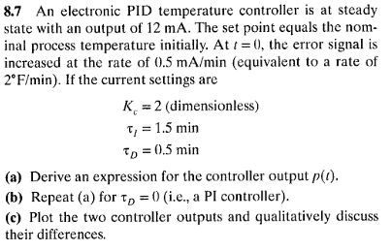

**Group Problems** Answer the questions on these four processes. Note: you might need to google a few terms.

