PSET 6 – Due Oct 9, 2018 at start of class (12:45 am)
Problem 1
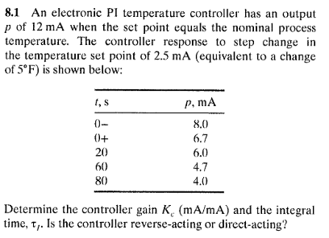
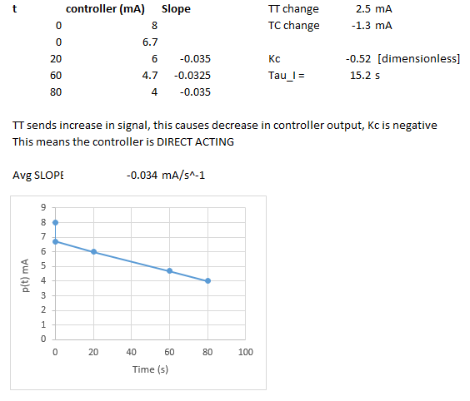
[Updated on 11.8.2018]

Problem 2
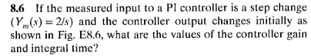
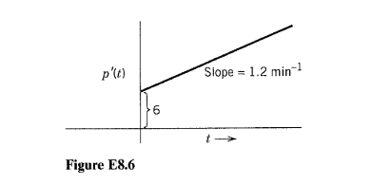
Answer:
e(t) = ysp – ym = 0 – 2 = -2
[Update 11.8.18 – this is a little confusing as written in the problem statement. Clearer would be. ‘After a step change, your new set point is set at zero and the measured response (Ym) is two.’ This would yield the negative error, and thus the negative gain.]
Gain = 6/(-2) = -3
Integral time = 6/(1.2) = 5 minutes
NOTE: Integral time is how long it takes for integral term to provide the same amount of change output as the controller term at time zero.

Problem 3
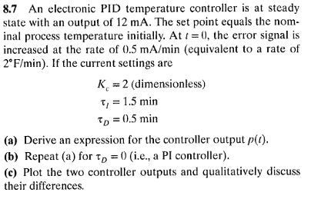
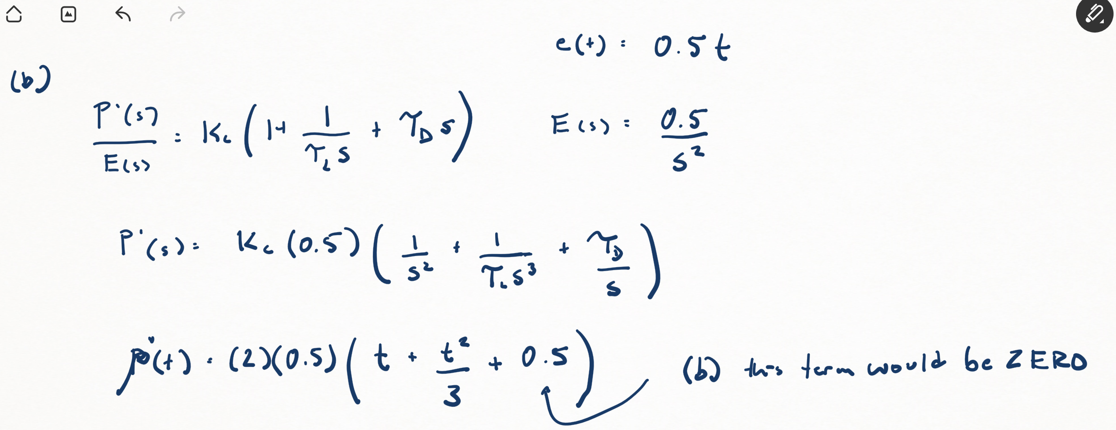
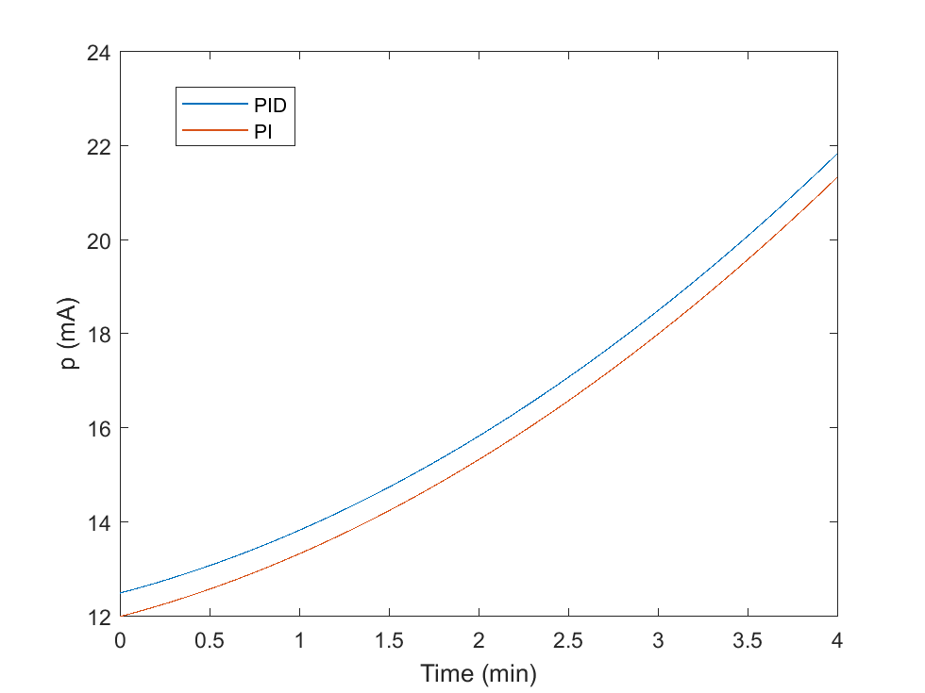

Group Problems Answer the questions on these four processes. Note: you might need to google a few terms.
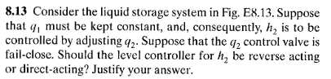
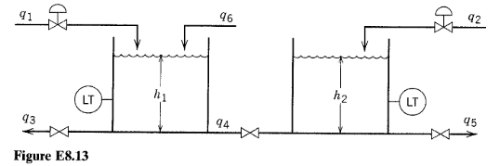
If the control valve on h2 is fail close (air needed to open), when the measured height is going higher than the set point, we want to close the valve or decrease the signal (air pressure) going to the valve. This is achieved with a REVERSE ACTING controller.
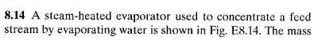
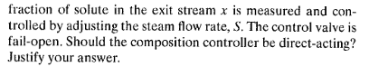
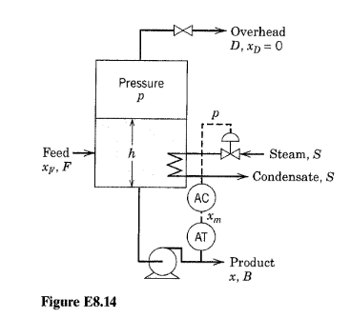
The control valve is fail open (requires air signal to close). If you increase the flow rate of steam, it boils off more water and concentrates the product. Thus, if the product spec is going ABOVE the desired set point (getting TOO concentrated) we would want to reduce the steam flow (boil of less) and close the valve. This is done by INCREASING the signal to the valve. In this case we want a DIRECT acting controller.
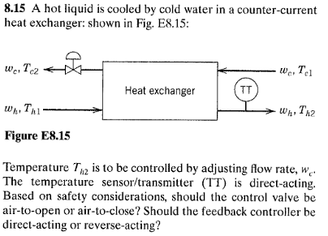
Trying to control the hot stream exit temp. If it goes up, the signal from TT goes up. Based on safety we would want the valve to be FAIL OPEN or ‘air to close.’ Thus, if the TT signal goes above set point, we would want to increase the cool stream flow rate and open the valve more; this would require a DECREASE in signal to the control valve. Thus this would be a REVERSE ACTING controller.
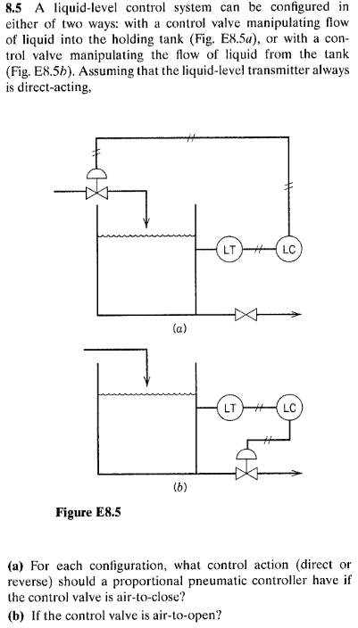
LT is direct acting (when liquid level goes up, signal output from sensor goes up).
[A] air to close : for (a) we want to close the incoming stream if we go above set point – this would be DIRECT acting. For (b) we would want to open the valve, which is done by decreasing the controller signal, thus REVERSE acting
[B] air to open, this would simply invert the situation – for (a) we would want a REVERSE and for (b) you would want a DIRECT.

