PSET 7 – Due at the start of class 10.16.2018
[NOTE: Chp 9. Covered on Tuesday lecture, Chp. 11 we will cover (or at least start) on Thursday.
Individual Problems:
Problem 1
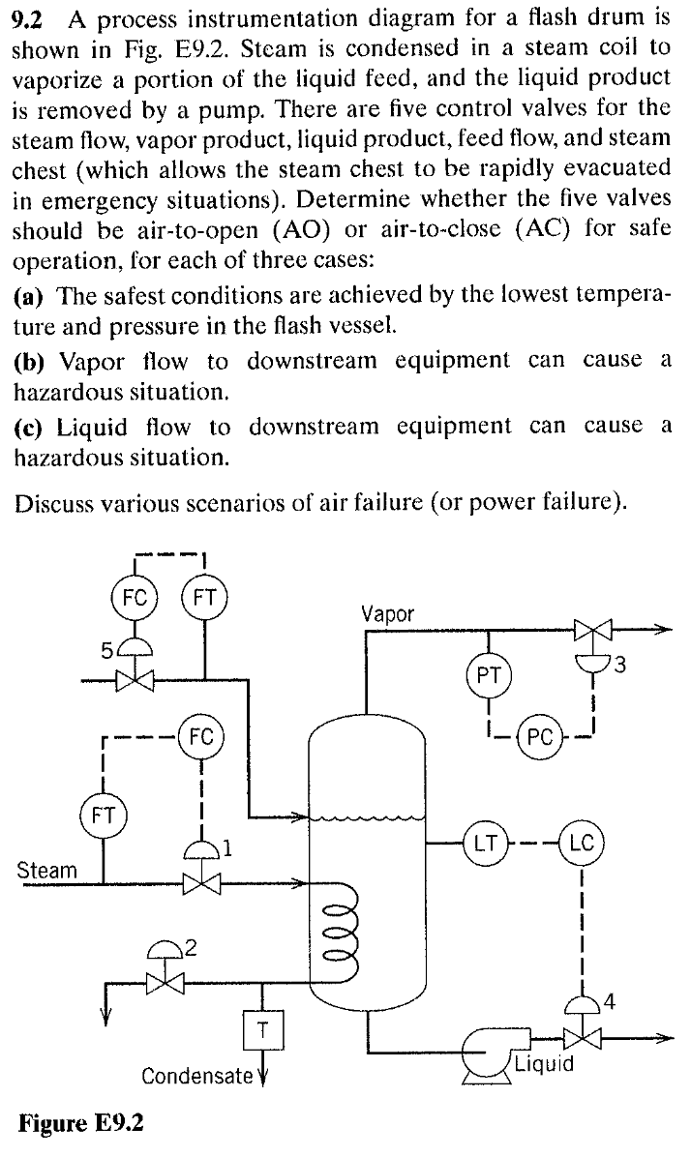

Problem 2
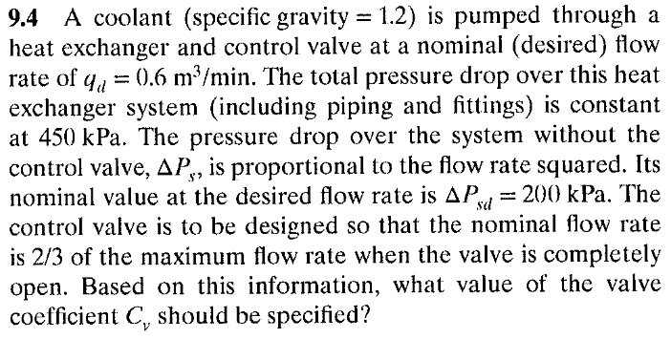
Problem 3
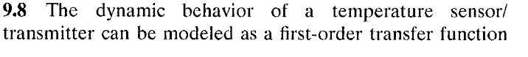
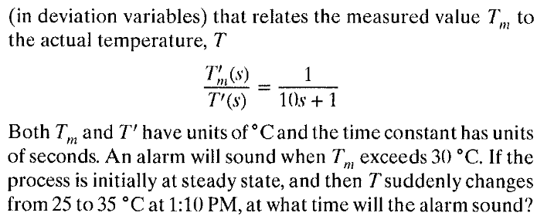

Problem 4
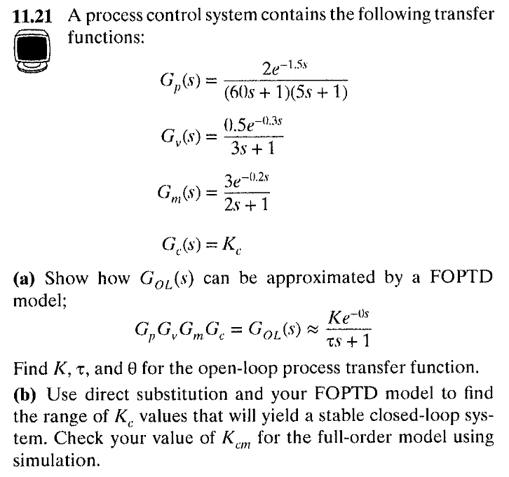

Problem 5
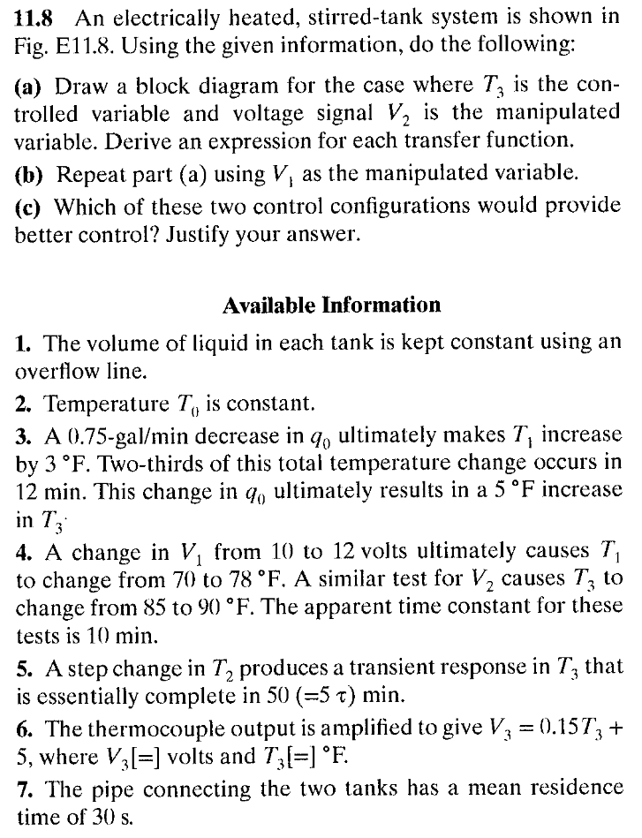
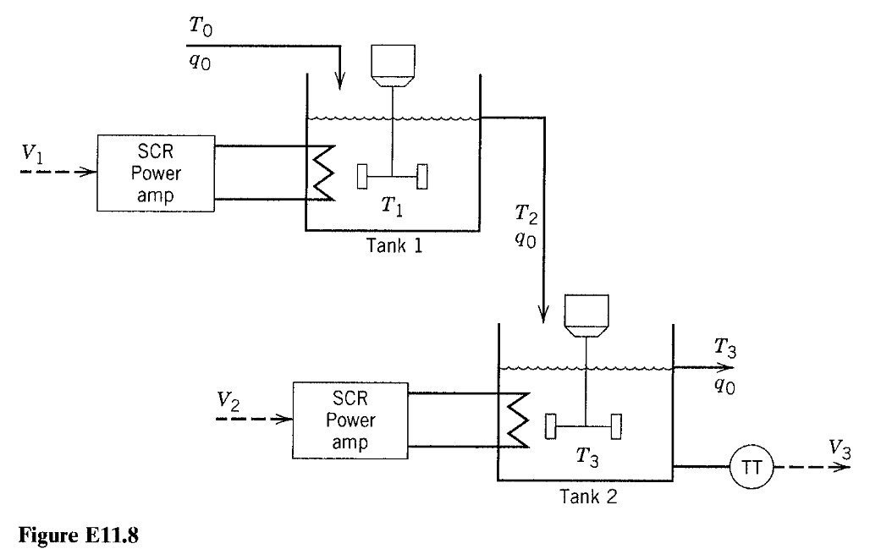

Problem 6
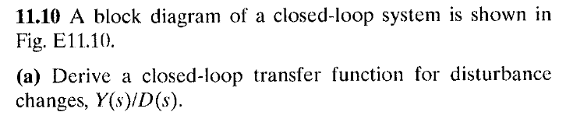
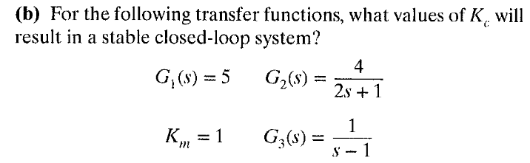
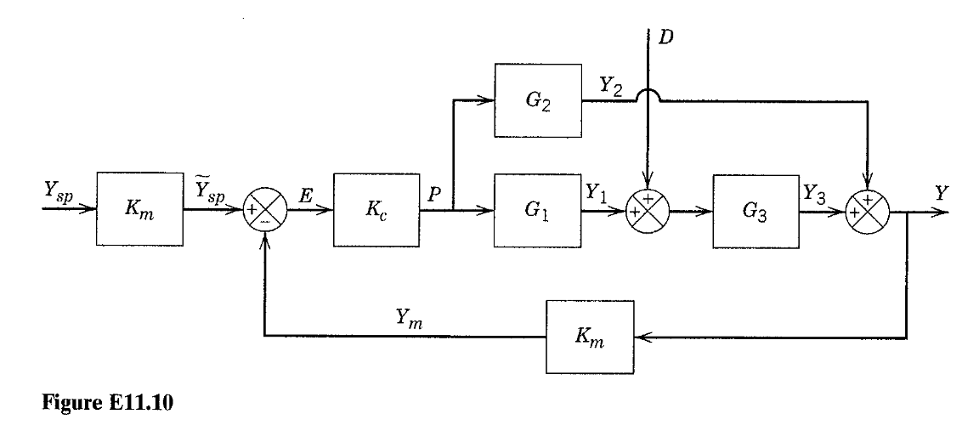
GROUP Problem
Help the class learn about sensors! Your group has been assigned a few sensors to describe at the following link:
https://docs.google.com/presentation/d/1mc2byFLaMfH3ZYMFrfWHCOmLsCjTx4jK2mSmrFUKDic/edit?usp=sharing
Provide a few slides in the deck that describe your sensors and how they work. Find pictures, animations, and videos to support your text. The intended audience is your class.
The TA will access this slide deck to assign grades.

