PSET 7 – ChE 310 – Assigned on 3.7.2019, Due MIDNIGHT on 3.13.19
Submit as a single zip file to the course website. Acknowledge collaborations in the comments section.
Problem 1 - 11.15 from book – there is a mismatch in the flow rates and concentrations given in the text and in the figure. Let’s use the constants given in the figure to solve the problem. Include a scanned image of part (a) and (b) work or write it all out in the comments section. For part (c) use the LU matrices to find the inverse and check your answer with the build in inv function.
Problem 2 - 11.18 from book – Part (a) show work by including a scanned/photo image of your paper work. Check your answer for part c by making the proposed change to your system of equations and then solving again. Feel free to use built in Matlab functions to find inverted matrix for this problem.
Problem 3 – Practice iterative methods
Part 1 - 12.5 from book – compare your Gauss Seidel solution to another method we have learned for systems of linear equations.
Part 2 - 12.9 from book.
Problem 4 - Solve the following system of non-linear equations. Use MATLAB to solve. Also specify which set of initial conditions below gives you realistic answers. (note: I used initial condition of 1 for the other variables that are not specified below).
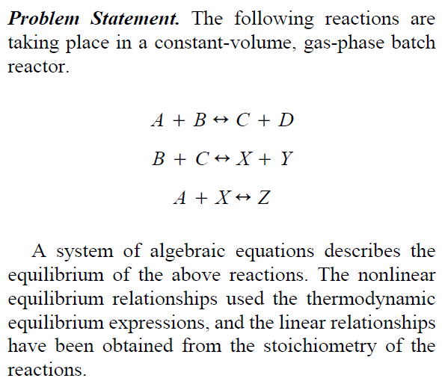
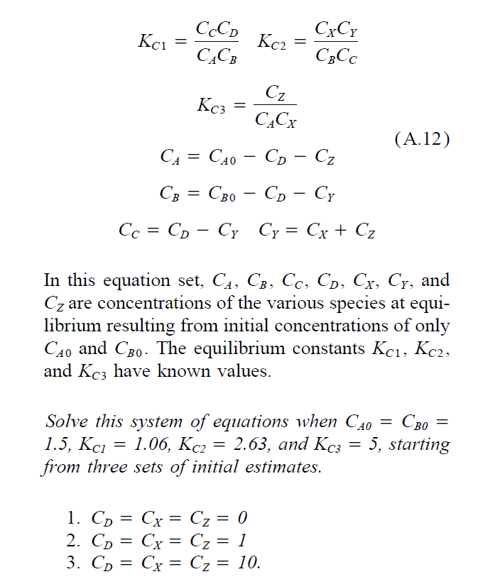
GROUP POINTS – Demonstrate collaboration on slack.

