PSET 8 – Due 10.23.18 at the Start of Class
Problem 1
- Look through the SENSOR guide completed by the class. Pick your favorite sensor for each of the 5 categories [temperature, flow, pressure, level, and composition] and explain how it works. What is sensor input? What is the output?
https://docs.google.com/presentation/d/1mc2byFLaMfH3ZYMFrfWHCOmLsCjTx4jK2mSmrFUKDic/edit?usp=sharing
- Show a full block diagram of a feed-back control system using one of these sensors. Note on your diagram what the signal is going in and out of each transfer function (mA, mV, psi, T, etc…)

Problem 2
- Now do part (b) of problem 4 in the last Pset (the part we skipped). This asks for the range of Kc values that yield a stable closed-loop system. Don’t use direct substitution. Instead, use the Pade approximation that we have used in class. This is what I got for the FOPDT in part (a):
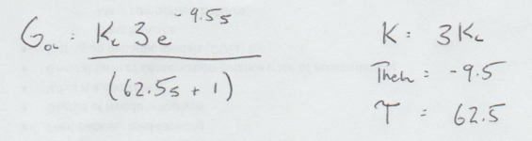

- For the ‘check model’ part, please plot the response of this system (full, not approximate) to a unit step change of the input if the system is under control at the middle point between the extents of Kc found in part (a). Assume that Y(s)/Ysp(s) = GoL / (1 + GoL) (this is the case where the transfer function describing your measurement system is the same as the transfer function that governs your set point.
HINT: Look up these Matlab functions: ‘tf’ and ‘step’
Problem 3
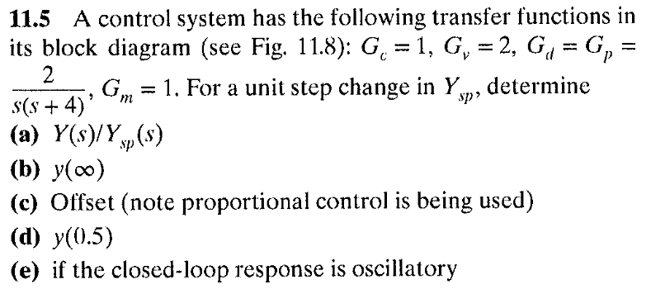
Problem 4
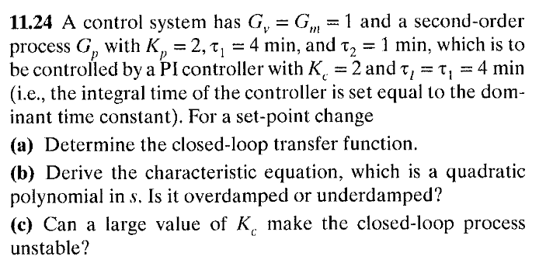
Problem 5 + [USE Thursday Class Time to Watch Movies]
We have no class on 10.18 due to Dr. Reuel’s NIH trip. Please watch the following in the place of class time and answer these questions:
[1] Overview of common mechanical components in a control system: https://www.youtube.com/watch?v=tiyOHzgSa-s
Definition of an actuator:
What are the three types of actuators?
Example of a rotary valve:
What are parts of the globe valve?
What is the positioner for?
[3] PID Controller https://www.youtube.com/watch?v=UR0hOmjaHp0
What is the goal of control system?
[4] PID Car Example https://www.youtube.com/watch?v=XfAt6hNV8XM
Explain this analogy in your own words.
[5] PID Car Example 2 [from my buddy’s lab at MIT] - https://www.youtube.com/watch?v=4Y7zG48uHRo
What are the examples of disturbances?
What are some examples of instability?
[6] Exothermic Runway - https://www.youtube.com/watch?v=C561PCq5E1g
What should have this company done for their control system to have avoided this problem?
Also watch these videos to prepare for our Oct 30 lab kick-off!
[5] Overview of control and intro to temp control lab system https://www.youtube.com/watch?v=Mbx5IMICS_Y
[6] Hooking up the temperature control lab in Matlab (what you will do on Oct 30 in class!)
https://www.youtube.com/watch?v=kyYnLFy9OMc
[Group problems below…]

Group Problem 1 (let’s try this one…hopefully it is not crazy…)
This problem takes some thinking. To help you out. These are the transfer functions I get for the valve, process, and disturbance
Gv = 0.082/(0.2s+1)
Gp = 93.3/(0.67s+1)
Gd = 0.93/(0.67s+1)
Please show your work as you make these attempts!
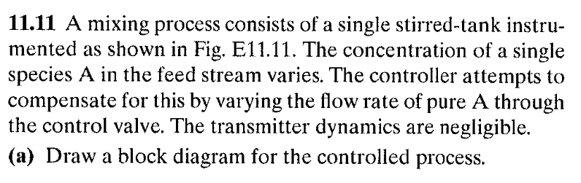
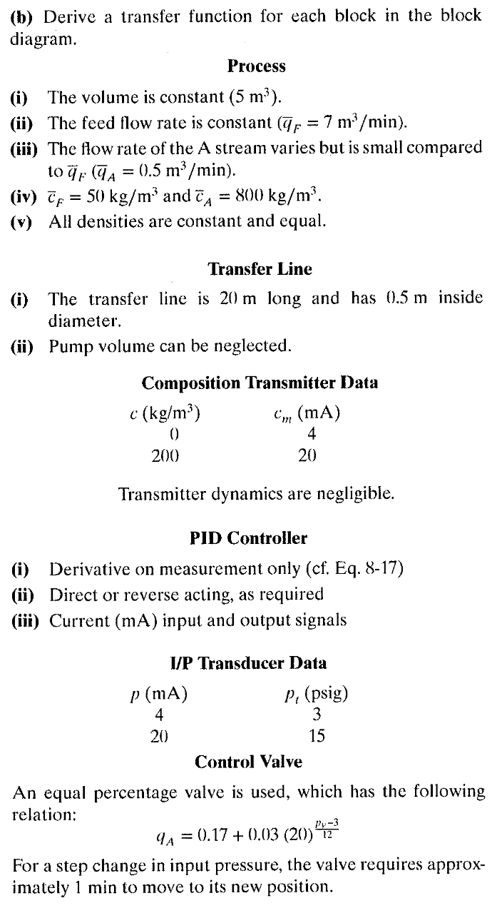
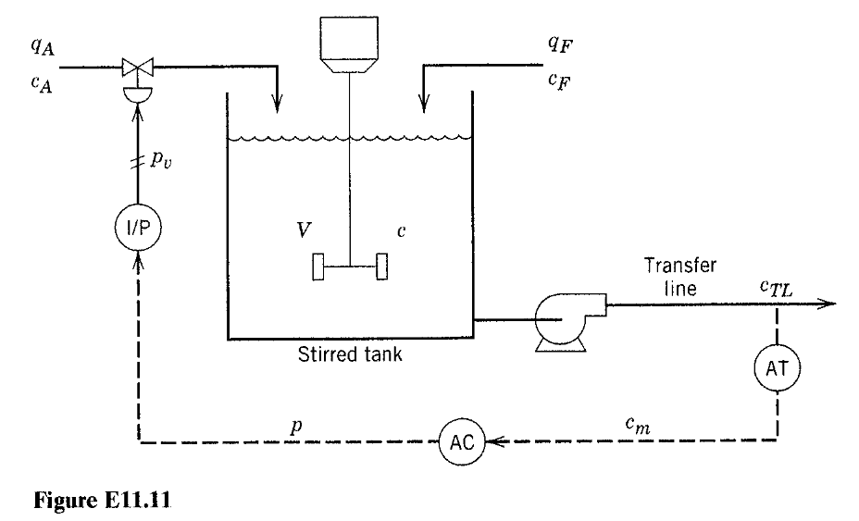
Group Problem 2
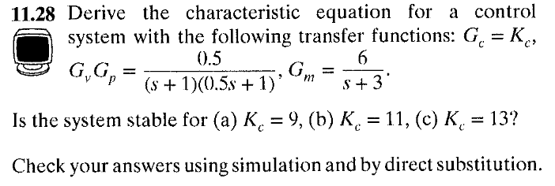
[NOTE: you only have to check answer with simulation]
HINT: Use the Routh Array method and this one is straightforward!

