PSET 8 – Due 10.23.18 at the Start of Class
Problem 1
- Look through the SENSOR guide completed by the class. Pick your favorite sensor for each of the 5 categories [temperature, flow, pressure, level, and composition] and explain how it works. What is sensor input? What is the output?

- Temperature sensor - A thermocouple is a temperature sensor that consists of two wires of different metals that are joined at one end creating a measuring junction, with another junction at a reference temperature. When the junction of the two metals is heated or cooled, a differential in potential converts the difference in temperature into a voltage input. The sensor input is read by a transmitter and converted into a temperature measurement output.

https://docs.google.com/presentation/d/1mc2byFLaMfH3ZYMFrfWHCOmLsCjTx4jK2mSmrFUKDic/edit?usp=sharing
- Show a full block diagram of a feed-back control system using this sensor. Note on your diagram what the signal is going in and out of each transfer function (mA, mV, psi, T, etc…)

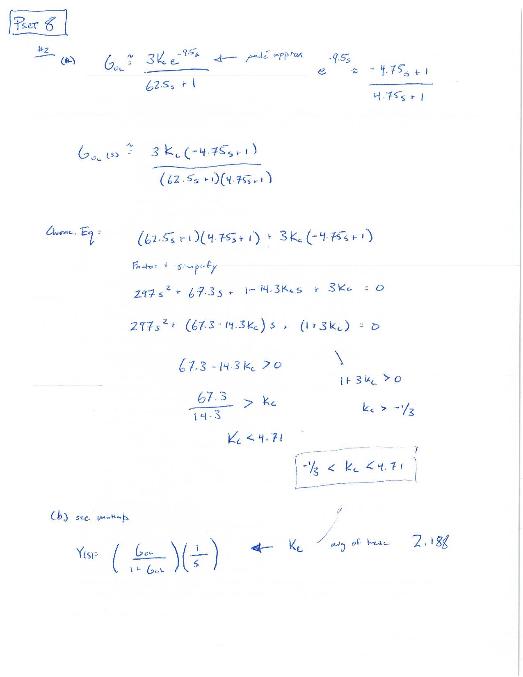

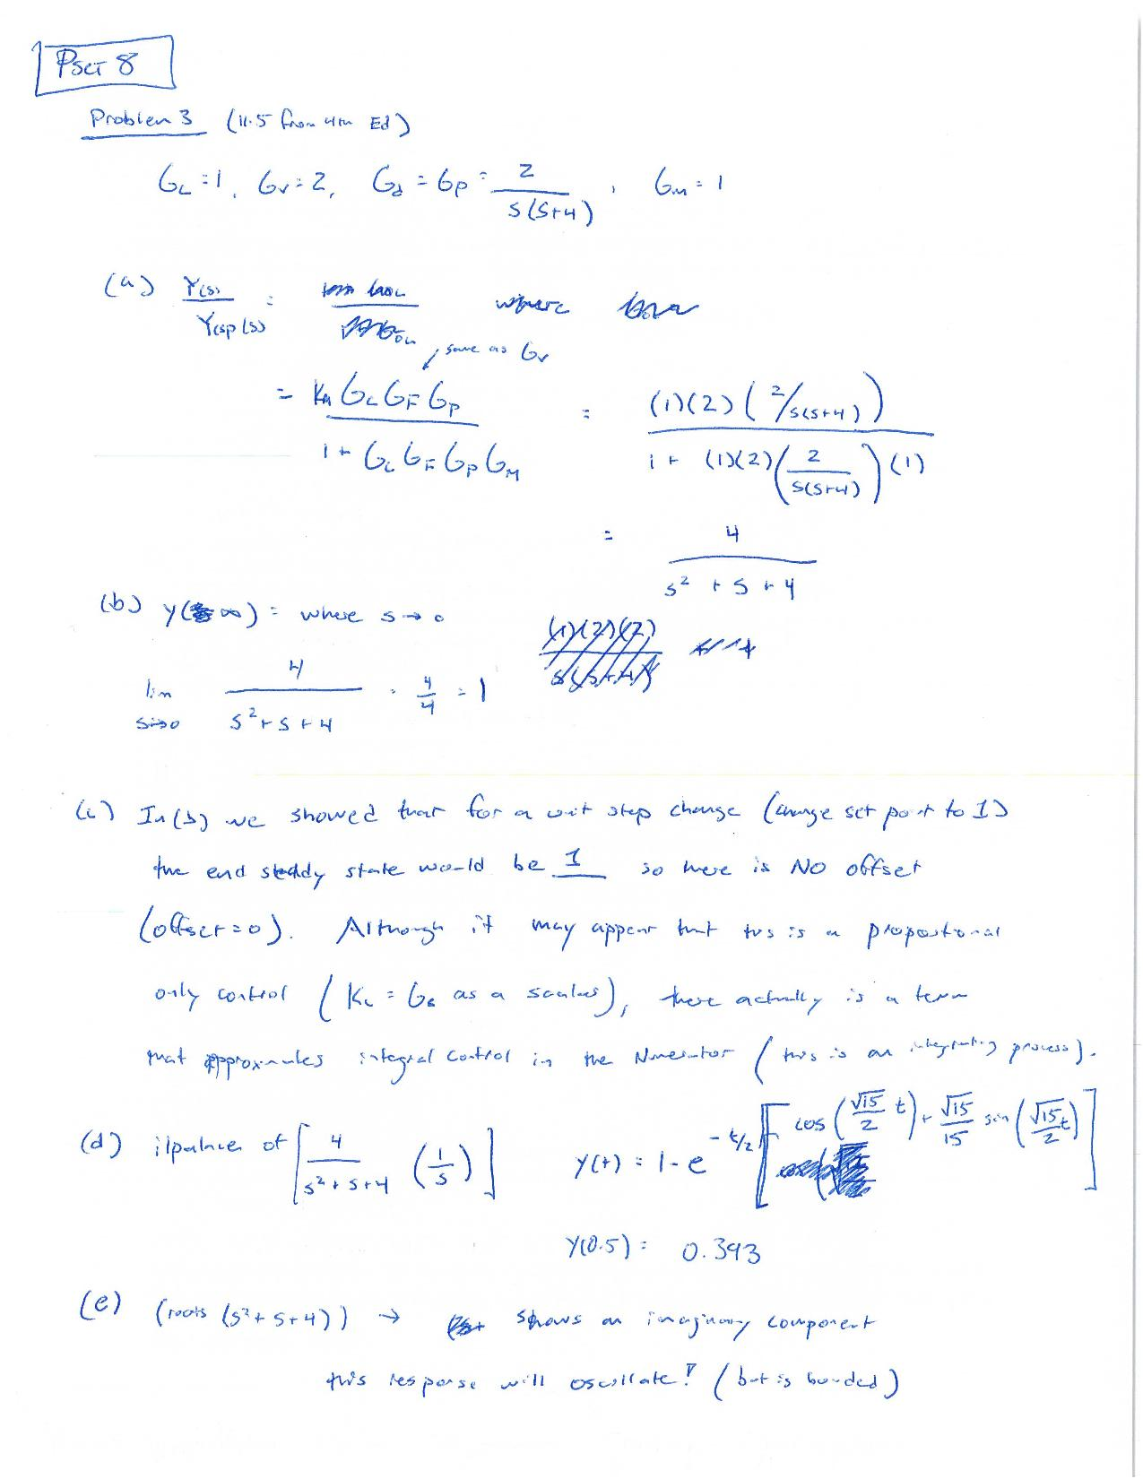

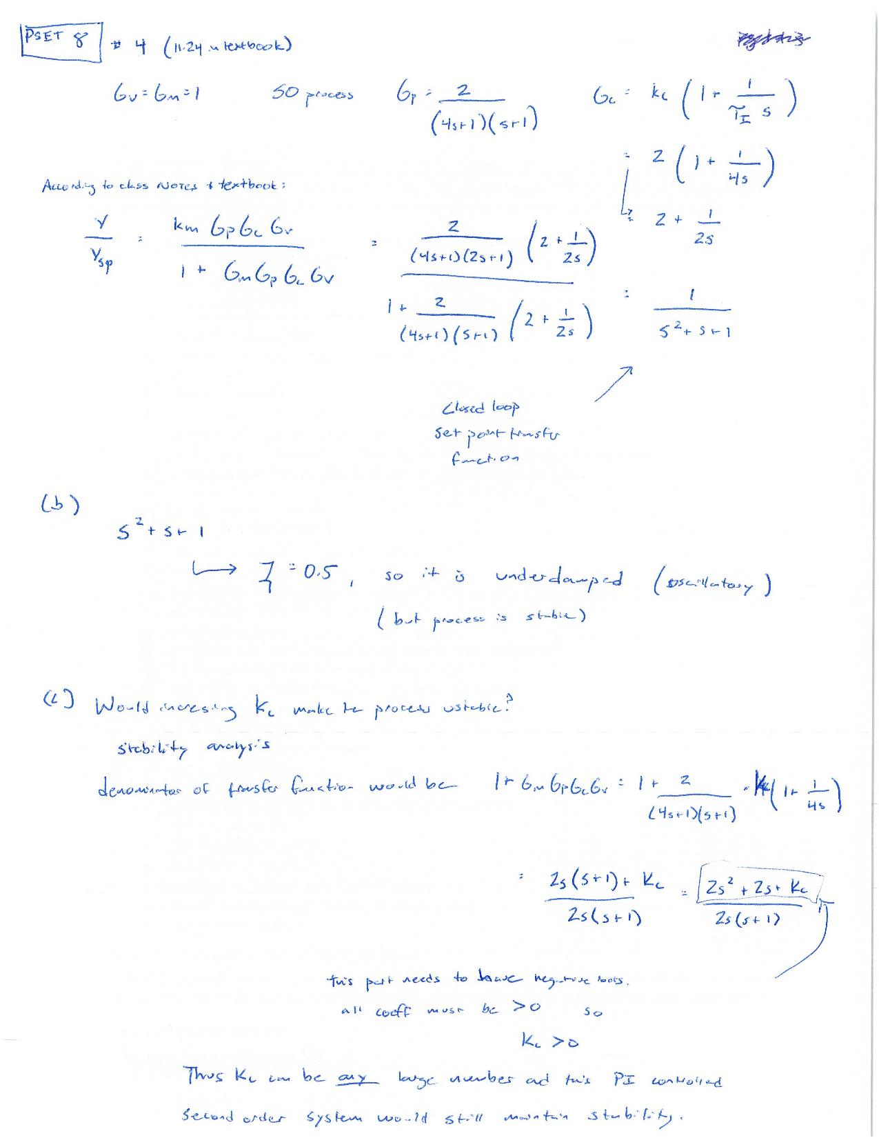

Problem 5 + [USE Thursday Class Time to Watch Movies]
[1] Overview of common mechanical components in a control system:
Definition of an actuator: An actuator is a mechanism that moves or controls a device
What are the three types of actuators? Pneumatic, hydraulic and electric actuators.
Example of a rotary valve: Butterfly valves, which open or close with a 90° turn.
What are parts of the globe valve? The parts of a globe valve include a valve body, disk, seat, bonnet, stem, and a packing assembly.
What is the positioner for? The purpose of a positioner is to add air to one side of the diaphragm and bleed it off the other side to ensure accurate positioning.

[3] PID Controller
What is the goal of control system? The goal is to design a controller such that, as the time progresses the error is driven to zero.

[4] PID Car Example
In this car PID example the angle at which we step on the pedal controls the velocity of the car. The proportional control example involves only reaching a speed limit. By applying a large change in the gas pedal the error between the car’s speed and the speed limit gets reduced. When the car gets close to the speed limit the error approaches zero and we would need to reduce the change in the gas pedal to maintain it at zero. If the change in the gas pedal is too high (gain) the control of the car’s speed becomes unstable.
The proportional-derivative example involves getting to a second stop light. In this case, instead of controlling the velocity of the car, we need to control the position. Using only a proportional control, we would move too quickly and go too far from the stop light and try to come back and forth to reduce the amount of error. With a derivative addition we are also able to control the rate of change in pedal reducing the error between the position of the car and the stop light.
The addition of an integral control allows us to drive right beside another car. Using only proportional and derivative control, we can only shorten the distance between our car and the other and once the two cars are at the same position we let go of the pedal, reducing the speed of our car forcing us to start the process again. The integral control would allow us to not let go of the pedal by building steady state error.
[5] PID Car Example 2 [from my buddy’s lab at MIT]
What are the examples of disturbances? Environmental factors and mechanical defects such a crosswind.
What are some examples of instability? A trajectory with high gain or large offset.
[6] Exothermic Runway
What should have this company done for their control system to have avoided this problem?
The company should have used a quench control system where temperature controllers maintain the temperature at stable set point inside the tank. The company should have also used a pressure relief system that allowed pressure sensors and controllers to send a signal to a pressure valve to reduce the pressure in the vessel as well.

