PSET 9 Key (10.29.2018)
Problem 1:
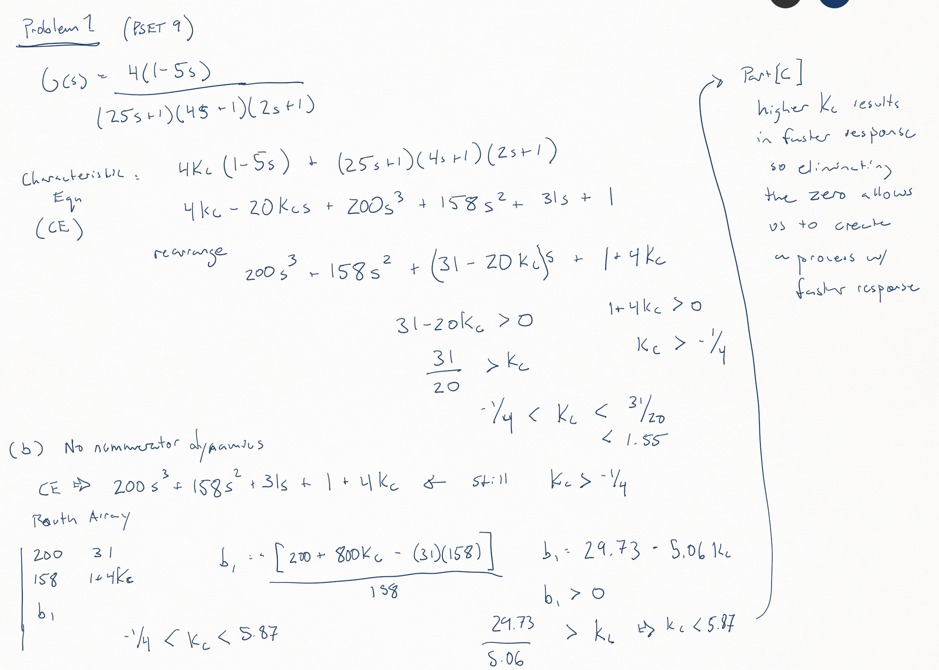

Problem 2:
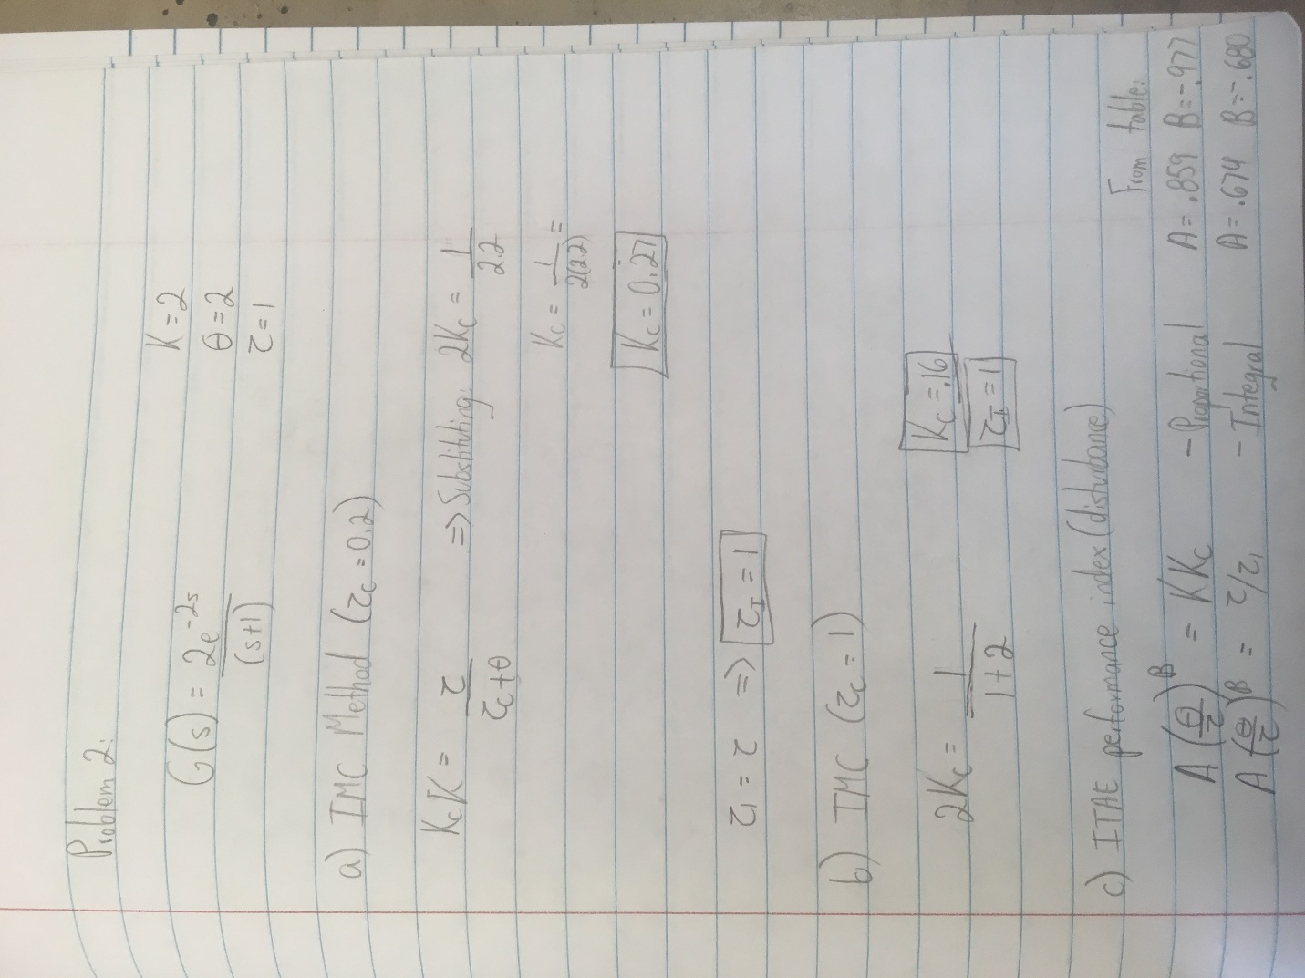
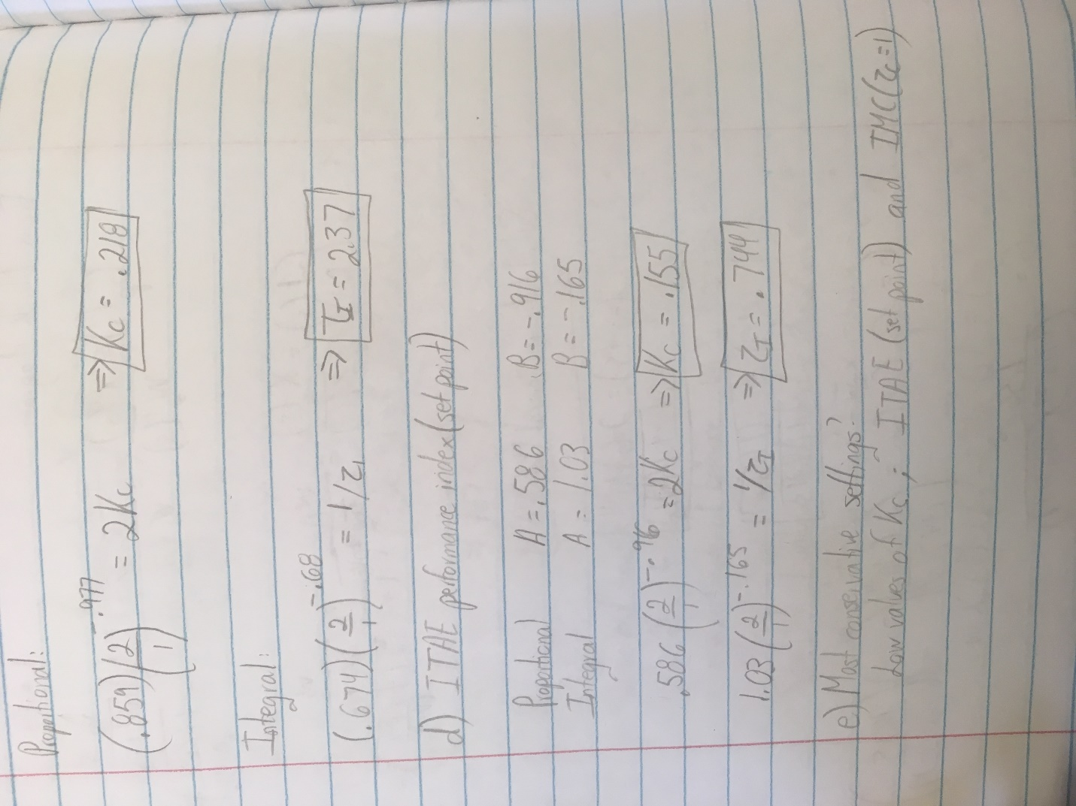
Part f) Use impulse command in Matlab. Here is the code I used:
s = tf('s')
G = 2*exp(-2*s)/(s+1)
Gc = 0.155*(1+1/(0.744*s)) [using the ITAE set point values from above]
impulse(pade(G)/(1+pade(G)*Gc)) [note the pade approx. is invoked for Matlab impuse function]
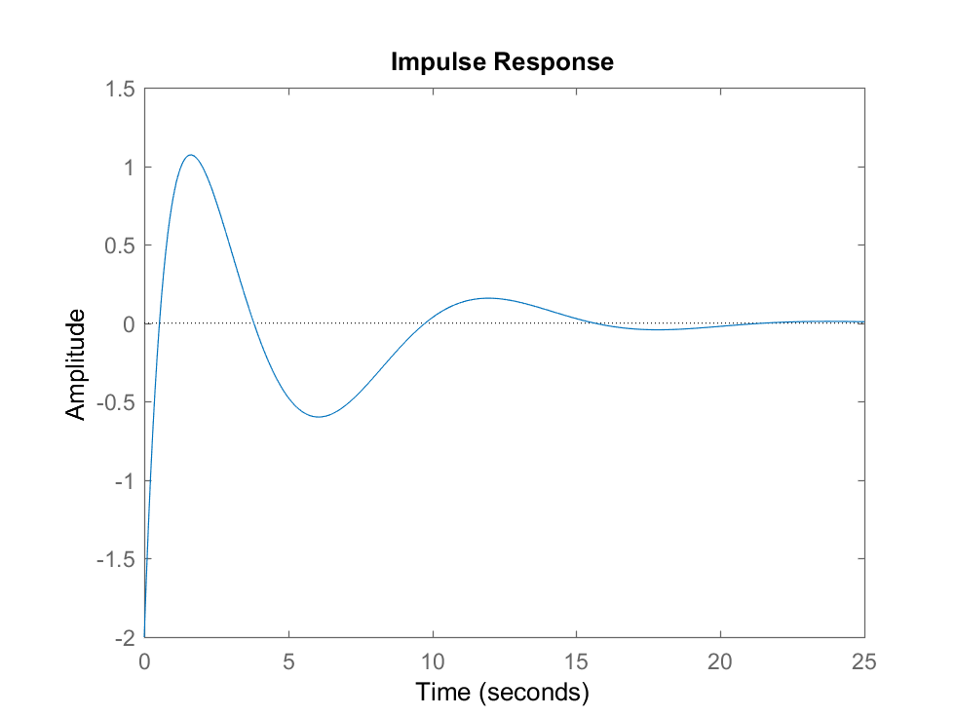ITAE Set Point
Change transfer function for IMC values:
Gc = 0.16*(1+1/(1*s))
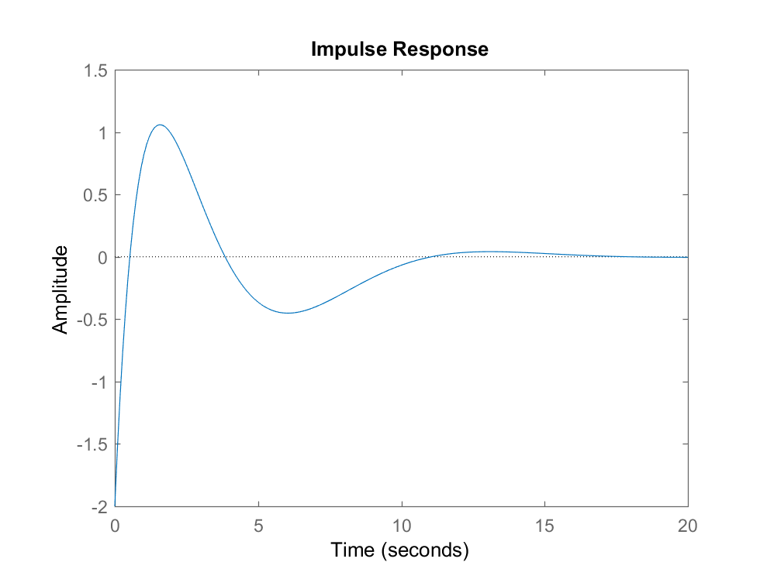IMC (where Tau_c = 1)

Problem 3:
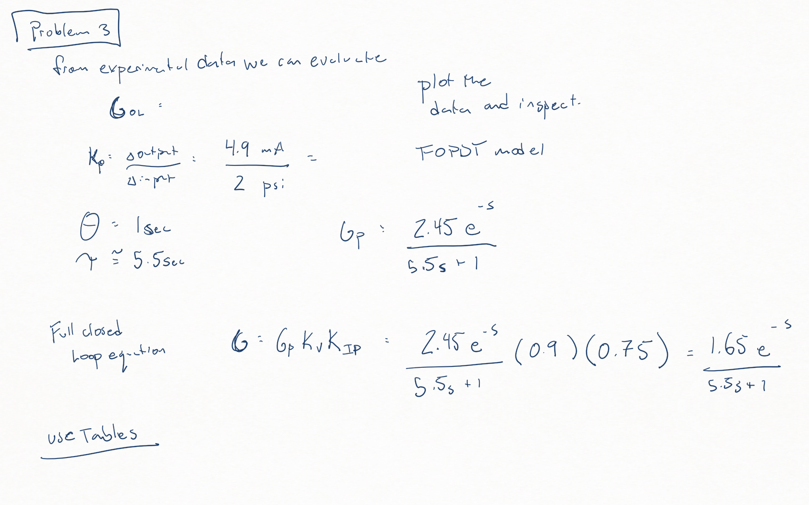
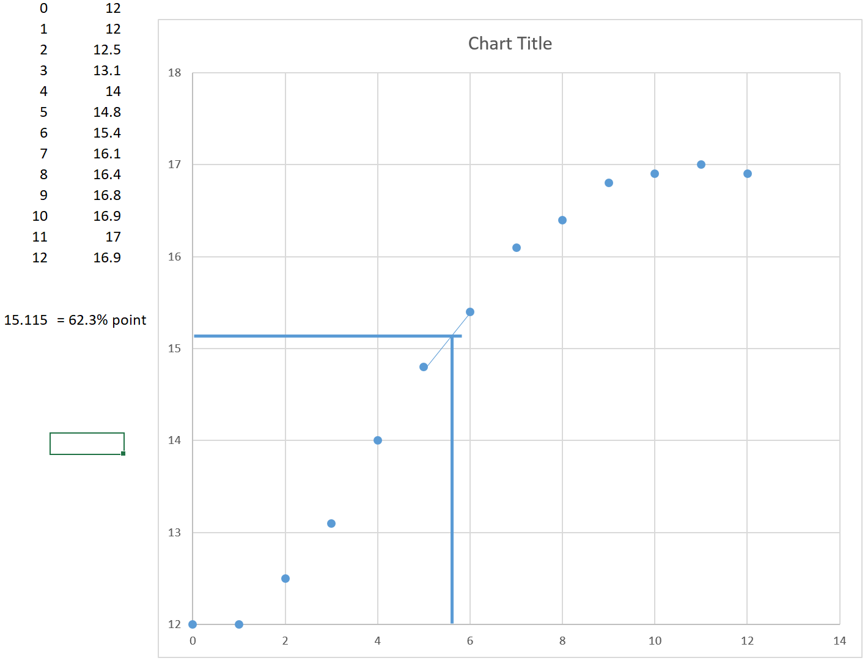
NOTE: this one is not worked out to the end, you then use the tables to determine the controller

Problem 4: Follow tables
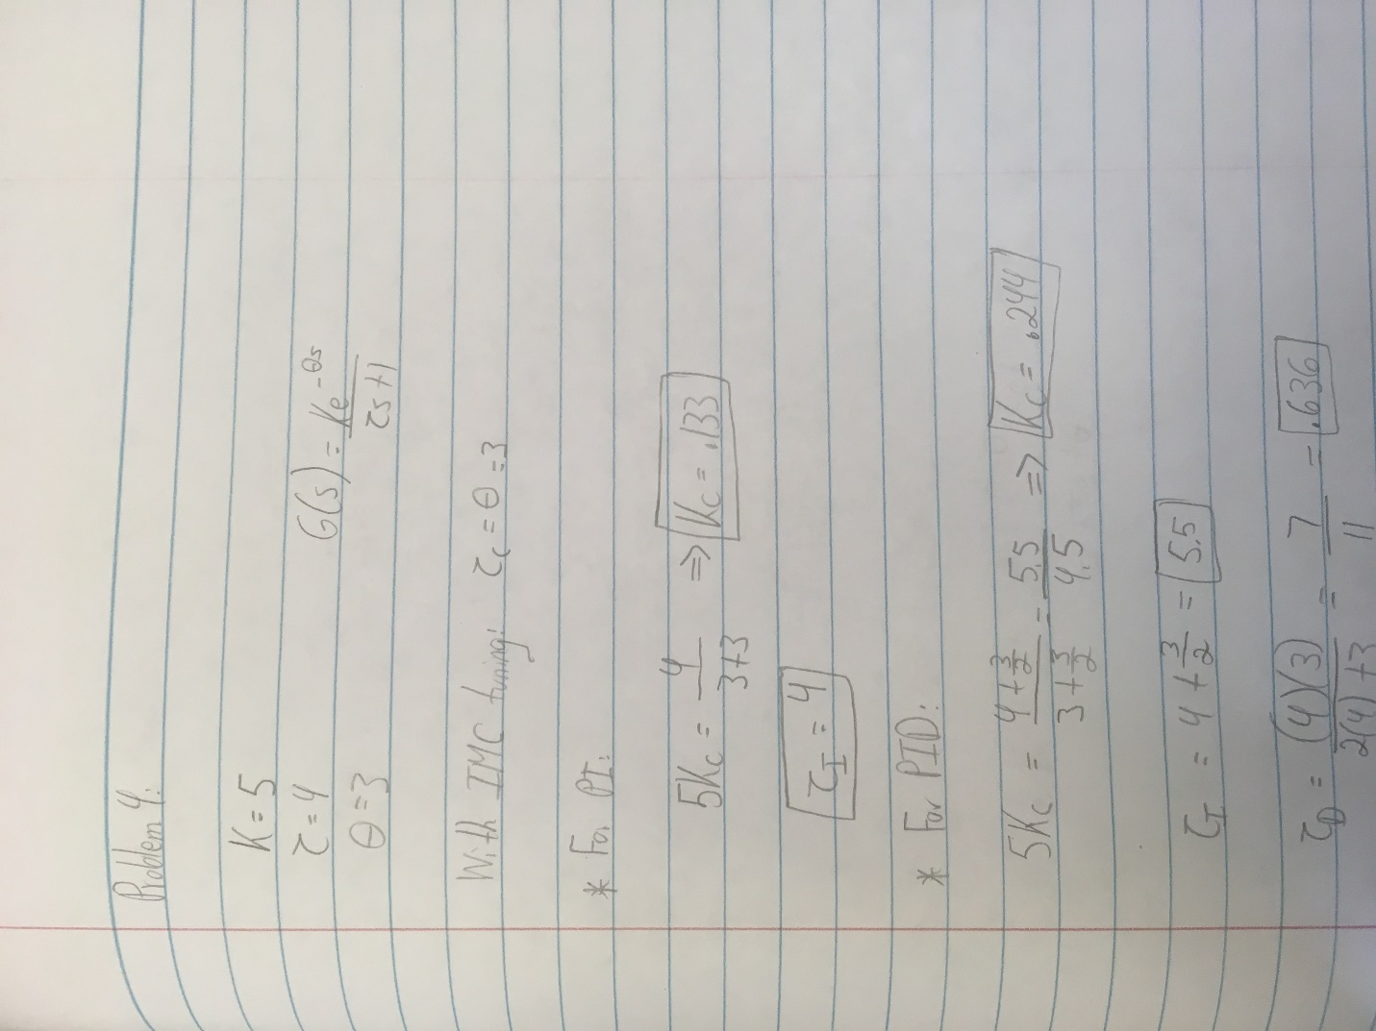

Group Problem 1: Follow IMC table in book for second order form, then plot with Matlab step command
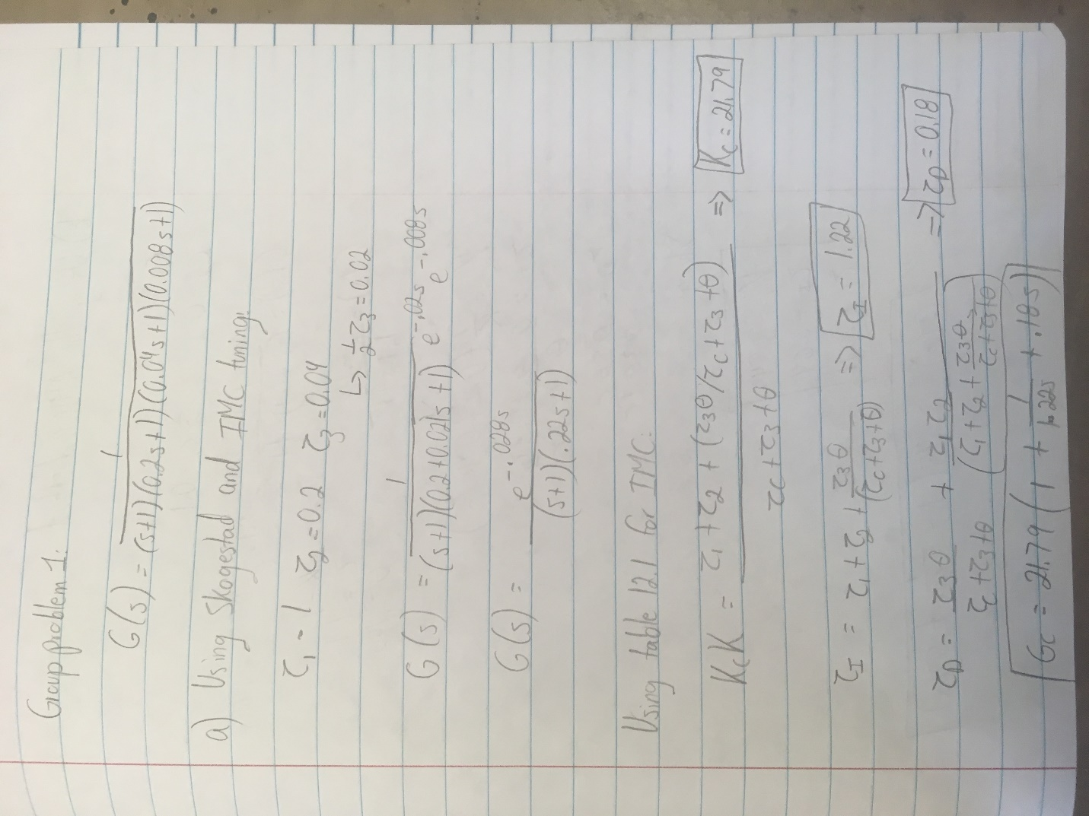

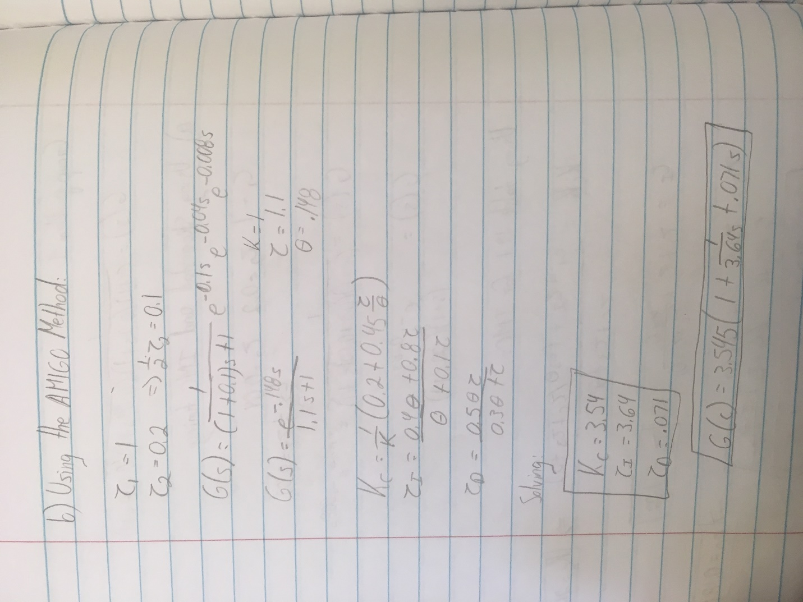

Group problem 2 [ Dr. Reuel will check this result on 11.5.2018]

