COURSE INFORMATION
Course Number and Title | CH E 310: Computational Methods in Chemical Engineering  Section 2
Semester | Fall 2019
Class Meetings | T R 2:10 – 3:30 pm, Durham 0171
Instructor Philosophy Statement | Welcome to ChE 310! This course will focus on the numerical (computer) tools that will help you solve the bulk of your engineering problems. It is my goal to give you a full toolbox to use for your remaining time at IA State and, more importantly, as you enter the workforce. In industry there is no clean answer key and no single solution method to a problem; instead there are pressing deadlines and a lot of messy data that needs to be transformed into accurate, data-based decisions. As such, in this course you will find a lot of the exam questions are open-ended as to the method you use to derive an answer. My goal is to strengthen your ability and speed to chart a course to a satisfactory answer.  As you progress in your career at Iowa State and beyond, I would be very interested to hear about any difficult engineering problems that were not addressed by the tools you acquired in this course. It will be my task to take this feedback and update the tool set we give future students, so they will be better prepared.  I am looking forward to a great semester with you. – Dr. Reuel
Course Description | Numerical methods for solving systems of linear and nonlinear equations, ordinary differential equations, numerical differentiation and integration, and nonlinear regression using chemical engineering examples.
Learning Outcomes | By the end of this course you should be able to:  - Write algorithms to solve chemical engineering problems  - Convert differential equations to finite differences approximations  - Apply root-finding methods to solve chemical engineering problems  - Solve systems of linear and nonlinear equations numerically  - Fit curves to data  - Apply numerical integration to solve chemical engineering problems  - Apply numerical differentiation to solve chemical engineering problems
Prerequisites | The prerequisites for this course are CH E 160, CH E 205, CH E 210, and MATH 265.  Course prerequisites will be enforced according to University policy: http://catalog.iastate.edu/informationaboutcourses/#prerequisitetext. This means that students who are enrolled in this course but have not met the prerequisite requirements must drop the course. The instructor will not grade any coursework submitted by a student who has not met the course prerequisites and if the student does not drop this course, the student will earn an “F” grade for this course.  Students who do not meet prerequisites but do have equivalent preparation may submit a request for a prerequisite waiver to the instructor. Waivers are available on the CBE website.
Section Changes | Multiple sections of this course are being offered this semester. If you are contemplating changing sections, the deadline for doing so is Friday, September 6. No section changes will be permitted after this date.
INSTRUCTOR INFORMATION
Primary Instructor | Dr. Nigel F. Reuel  3051 Sweeney Hall  reuel@iastate.edu  515-294-4592  Office hours: Tuesday 3:30 to 5:30 (2126 Sweeney), Friday by apt.
Teaching Assistant | Adam Carr  acarr4@iastate.edu  Office hours: Wed 4:00 to 6:00 (2126 Sweeney)  **Additional Office hours by Dr. Roling Monday 2:30-4 (2126 Sweeney)
TEXTBOOKS AND SUPPLIES
Required Textbooks | Applied Numerical Methods with MATLAB for Engineers and Scientists, Steven C. Chapra, McGraw Hill Third Edition, 2012; newer versions are also fine. This version is on reserve for your use at the library.
Required Supplies | Laptop computer: Each student needs a laptop computer capable of running MATLAB to participate in class exercises. Laptops should be brought to class each day, charged and ready for use. If you are unable to provide your own laptop, one may be borrowed for the semester from the CBE department. (Please contact Colin Richey, crichey@iastate.edu, as soon as possible if one is needed.)  MATLAB: MATLAB is available as a free download for student use from ISU (https://www.it.iastate.edu/services/software-students/matlab). The instructor will use version R2019a for this semester.  Excel: Microsoft Excel is available as part of Microsoft Office 365, which is free for students at ISU (https://www.it.iastate.edu/services/software-students) and must be installed on your laptop computer.
Web Access | All course content will be managed on the following class webpage:  http://www.reuelgroup.org/numerical-methods-che-310.html  We will be using a preferred program of tech startups for team collaboration and code sharing in class – Slack. You will need to join the class team here and create a profile with a current photo. Adam and I will be using this to grade the in class assignments and term project. Also, this allows you to get help on problem sets outside of office hours.
ASSIGNMENTS AND EVALUATION
In-Class Problems | A simple problem will be given at the start of each course period to reinforce the assigned reading for that day and connect to the previous lecture. A new hyperlink to submit answers will be written on the board. No late submissions will be accepted (i.e. must come to class on time, have computer up and running and submit answers by 2:25). If you have read through the materials, the answers will be obvious and 10-15 minutes will be sufficient. I will drop the lowest TWO quiz scores to accommodate absences and tech mishaps. These are often done in your groups.  Additionally, during the class, we will create VERY USEFUL code (m-files and scripts) that can be used in your problem sets and exams. This code is not turned in at the end of class, but it would behoove you to attend all of class and understand how the algorithms work. In this manner the pieces of code become tools in your toolbox to tackle future problems.
Homework | One problem set is assigned (2-5 problems) per week. It will be posted on the course website at 5:00 PM each Thursday and will be due the following Wed by midnight. These problems will reinforce the materials from the previous lectures, so you can get started on them immediately after they are posted on course website (no need to wait for Tuesday lecture).  Submission is done electronically via BOX link. Submit a separate M-file or Excel file for each problem. These should all be placed in a folder, zipped, and then uploaded to the link shown in the PSET (one zipped file submission per student). There will be no hard copy submissions for this course. Materials will be graded and commented on electronically as well.  If your M-file program is unable to derive the answer (e.g. MATLAB m-file is not running correctly), first seek help from others (see collaboration note below and office hours above). If you still cannot get the program to run, write up WHY you think it is not working by using comment lines within your code. Detail the mental process you are trying to accomplish computationally to get to the answer. This is the only way partial credit will be assigned.  If an Excel solution is submitted, the VBA scripts, macros should be contained in the file submitted and the answer clearly shown. If steps were taken (e.g. using a solver) to derive an answer in a cell, specify with text what was done.
Teamwork/ Collaboration | In your career, you will rarely work independently. (Sorry, Simon and Garfunkel enthusiasts—no, “I am a rock, I am an island” in real life.) You should get used to breaking a large problem into parts for group application, as well as seeking and giving help in a group. As such, from the first day of class you will be assigned to a 5 member ‘company.’ I will try and group you as best I can according to the industry you want to join after graduation. You will sit together in classes and work together on in-class examples. In addition, you will have one weekly problem to collaborate on and one end of term project (see schedule below). The term project should be a NEW set of code that solves a pressing numerical problem in your field of interest. This is intentionally very open-ended and we will discuss more as the class progresses.  For all group tasks, Adam and I will be using Slack (link here) to evaluate each member’s level of participation. I will demo how this platform can be used during the first class.  Your involvement as a group and use of Slack can extend beyond assigned group tasks. I encourage students to work together on ALL problem sets but not to copy letter for letter the same program code. Use each other as sounding boards, lifelines, and guides when you undoubtedly get stuck or your code doesn’t run properly.  A lot of the tools (i.e. code) will be written together in class and copied throughout your problem set M-files. However,our in-class tools are only pieces of the larger solution. An individual’s final problem set M-file should bear unique features (syntax, variable naming, code conciseness, etc.). Thus, I will be able to detect very quickly if a problem set file has been copied in its entirety from one person to the next. If this is detected, we will meet to discuss the similarities. Those found cheating on homework will receive a zero. So, write your own solution, run it on your own computer, and turn it in as your own work. This will only help you on exams where you will be tested on your own proficiency to weave together pieces of code. Plus, the points matter a whole lot more when you’re flying solo (see break down below).
Midterms | Two in-class midterm exams will be given during the semester. The dates for these exams are provided on the tentative course schedule. Exams will consist of a shorter closed-content section on paper followed by an open-book, open-note problem solving section using laptops (closed internet, closed neighbors). Any exam makeups must include a valid excuse (e.g. doctor’s or instructor’s note) and the instructor must be notified ASAP of the planned absence.
Final Exam | The final exam will be comprehensive. The exam time is scheduled by the Registrar based on the first contact hour for the course (Thursday, Dec. 19, 7:30 – 9:30 AM for this class). Note that students who have three or more finals on the same calendar day may request to reschedule a final. To reschedule, the student must notify the instructor before Dec. 6 in accordance with Iowa State University policy. An instructor may not give a final exam prior to final exam week nor change the published final exam time as it appears in the final exam schedule. Permission to change the time for which a final exam is scheduled may only be given by the Dean of the College of Engineering.
Grading | Start of Class Problems  Project  Homework  Midterm Exam 1  Midterm Exam 2  Final Exam  Total |  | 5%  10%  15%  20%  20%  30%  100%
 | Minimum guaranteed grade assignments according to your individual performance will be as follows; however, the instructor reserves the right to adjust this scale in your favor depending on the overall class performance:
 | Letter Grade Coursework Average  A 93.0-100.0%  A- 90.0-92.9%  B+ 87.0-89.9%  B 83.0-86.9%  B- 80.0-82.9% | Letter Grade Coursework Average  C+ 77.0-79.9%  C 73.0-76.9%  C- 67.0-71.9%  F < 67.0%
COURSE POLICIES
Attendance | Attendance is not formally taken; however, graded in-class problems or short quizzes are assigned each class. If you cannot attend class, please notify the primary instructor by email as soon as possible to ensure that you understand the material that you have missed and to help you complete missed assignments.
Late Assignments | Not accepted. You have a full week to submit. The deadline for each problem set is Wed at midnight for each week. If there are extenuating circumstances, please contact me ahead of time and I will do my best to accommodate.
Requests for Regrading | All requests for regrading must be submitted in writing at least 24 hours and no more than 7 days after grades for each assignment are posted. Requests for regrading will not be considered beyond this deadline. Please list the problem number and your reason for requesting regrading when submitting your request.
Computer Use | Computers are to be used only for coursework. Do not peruse the internet, use email, Facebook or any other social network, play games, or other distracting activities. It is to your advantage to participate in class activities and develop toolkits useful for homework and exams.
General Expectations | - You are expected to spend an average of nine hours per week preparing for class and completing homework assignments.  - Complete reading assignments prior to class  - Have your laptop fully charged and ready to go at the start of each class  - Ask questions if you do not understand the material  - Be on time for class  - Mute cell phones and other electronic devices
UNIVERSITY POLICIES
Academic Dishonesty | You are expected to practice academic integrity in every aspect of this course and all other courses. Familiarize yourself with the ISU Student Disciplinary Regulations (Student Conduct Code), especially the section on academic misconduct, at http://www.policy.iastate.edu/policy/SDR. Students who engage in academic misconduct are subject to university disciplinary procedures, as well as consequences with regard to this course. ISU has created a brief video guide to its policies: https://www.youtube.com/watch?v=U3DxTWybvlQ  Consulting a solution manual, solutions from a previous semester, or using any unauthorized assistance from other people or resources (including the internet) is strictly prohibited. You are encouraged to seek help from the primary instructor and/or the teaching assistant, and collaborate with your classmates to complete homework assignments and in-class problems. All collaboration must be noted on the assignment submissions. Those found in violation of these policies will receive a zero on the assignment/exam in question.
Disruptive Classroom Behavior | Disruptive conduct, including excessive talking, arriving late to class, sleeping, reading newspapers, or using unauthorized electronic devices during class is not permitted. Repetitive or seriously disruptive behavior, e.g., fighting, using profanity, personal or physical threats or insults, damaging property, may result in your removal from class in accordance with policies and procedures outlined in the ISU’s Code of Student Conduct and in consultation with the Office of Student Conduct in the Dean of Student’s Office.
Dead Week | This class follows the Iowa State University Dead Week policy as noted in section 10.6.4 of the Faculty Handbook. Course projects will be presented on the Tuesday of Dead Week.
Student Accessibility Services | Iowa State University is committed to assuring that all educational activities are free from discrimination and harassment based on disability status. Students requesting accommodations for a documented disability are required to work directly with staff in Student Accessibility Services (SAS) to establish eligibility and learn about related processes before accommodations will be identified. After eligibility is established, SAS staff will create and issue a Notification Letter for each course listing approved reasonable accommodations. This document will be made available to the student and instructor either electronically or in hard-copy every semester. Students and instructors are encouraged to review contents of the Notification Letters as early in the semester as possible to identify a specific, timely plan to deliver/receive the indicated accommodations. Reasonable accommodations are not retroactive in nature and are not intended to be an unfair advantage. Additional information or assistance is available online at www.sas.dso.iastate.edu, by contacting SAS staff by email at accessibility@iastate.edu, or by calling 515-294-7220. Student Accessibility Services is a unit in the Dean of Students Office located at 1076 Student Services Building.
Discrimination and Harassment | Iowa State University does not discriminate on the basis of race, color, age, ethnicity, religion, national origin, pregnancy, sexual orientation, gender identity, genetic information, sex, marital status, disability, or status as a U.S. Veteran. Inquiries regarding non-discrimination policies may be directed to Office of Equal Opportunity, 3410 Beardshear Hall, 515 Morrill Road, Ames, Iowa 50011, Tel. 515-294-7612, Hotline 515-294-1222, email eooffice@iastate.edu
Religious Accommodations | Iowa State University welcomes diversity of religious beliefs and practices, recognizing the contributions differing experiences and viewpoints can bring to the community. There may be times when an academic requirement conflicts with religious observances and practices. If that happens, students may request reasonable accommodation for religious practices. In all cases, you must put your request in writing. The instructor will review the situation in an effort to provide a reasonable accommodation when possible to do so without fundamentally altering a course. For students, you should first discuss the conflict and your requested accommodation with your professor at the earliest possible time. You or your instructor may also seek assistance from the Dean of Students Office at 515-294-1020 or the Office of Equal Opportunity at 515-294-7612.
Class Schedule | See next page for tentative schedule

TENTATIVE COURSE SCHEDULE

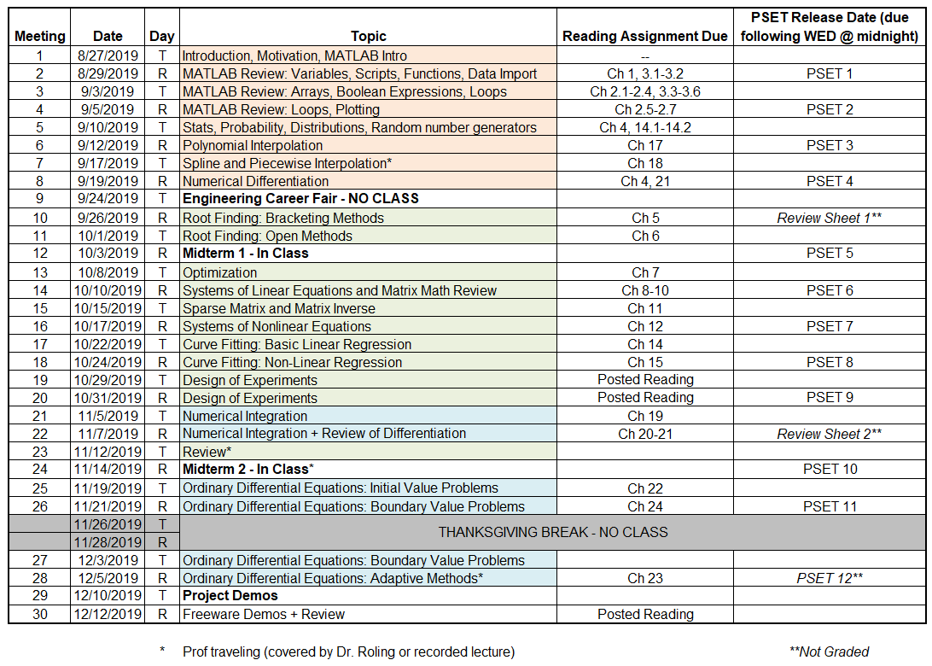

Due Dates for Term Project:

Phase 1 Memo: Tuesday 10/1 by Midnight
Phase 2 Memo: Tuesday 11/12 by Midnight
Phase 3 Demonstration: Tuesday 12/10 class period

