Solve this problem using excel solver!
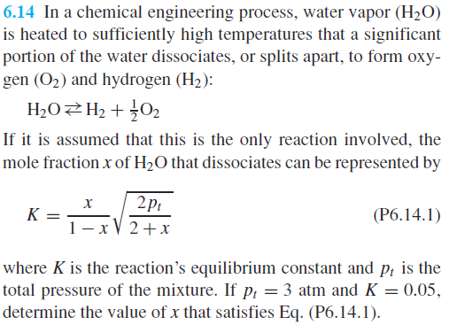
- Enable excel solver (if you have not used it before):
  - FileOptionsAdd-insSolver Add-inOK
- Set up equation in your sheet
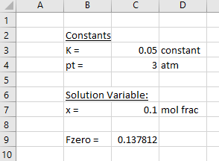
The equation for Fzero in this sheet is = C7/(1-C7)*SQRT(2*C4/(2+C7))-C3 (Note: subtract LHS)
- Use Excel Solver to drive C9 cell to zero by changing C7 initial guess value [Data ribbonSolver]
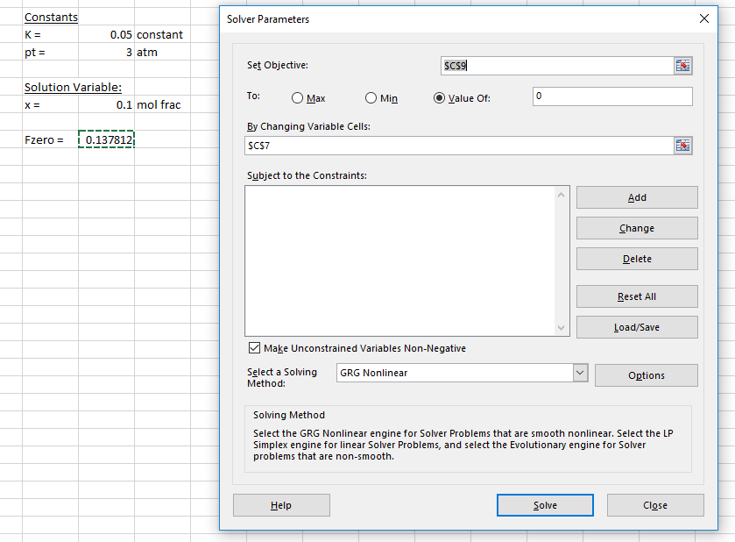 Click ‘Solve’, x = 0.0282

